Beer Neighbourhood Plan

2014-2031

Referendum Version

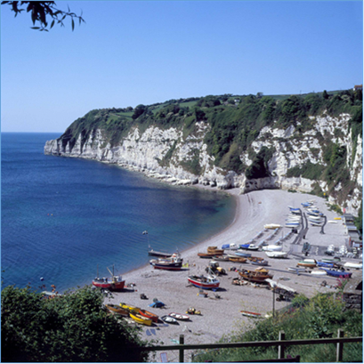
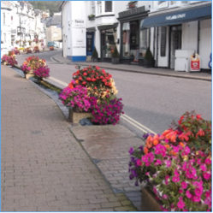
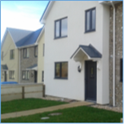

Web : www.beerparishcouncil.org.uk/
Email: clerk@beer.eastdevon.gov.uk

Beer Parish Council
August 2018

Date of Plan versions
Consultants’ 1st draft for Steering Group comments | 15th September 2015
Consultants’ 2nd draft for Steering Group | 28th April 2016
1st draft for informal community consultation | 11th June 2016
Pre-submission version | October 2017
Submission version | February 2018
Referendum version | August 2018
Approved version (made)

Contents

Page

Acknowledgements 4
Foreword 5

OUR STORY: ABOUT THE BEER NEIGHBOURHOOD PLAN
Introduction
The Community’s Plan 7
The Plan Area 8
How have we got here? 16
Our Evidence Base 16
Strategic Environmental Assessment 16
The Plan’s Status 17
Sustainable Development 18
Our Vision 19

OUR AIMS, OBJECTIVES AND POLICIES
Natural Environment 21
Maritime and Shoreline 31
Heritage and Built Environment 37
Housing 48
Transport and Parking 63
Business and Jobs 68
Community Facilities and Services 73
Sports and Recreation 76
Tourism 82

Monitoring and Review 87

Appendix 1 - Community Actions 88

Acknowledgements

The Parish Council would like to thank everyone who helped with the production of this document including those who participated in the consultation exercises.
Photographs copyright of East Devon AONB Partnership.
Additional photographs by kind permission of Ursula Makepeace and John Scott.

Foreword

The Neighbourhood Plan (NP) for Beer has been developed following the Government's Localism Policy. To quote the policy “we think that power should be exercised at the lowest practical level - close to the people who are affected by decisions”. The objective being to enable Beer to have a direct and strong say in the way the village and wider parish develops through the creation of a set of policies and community actions tailored to the demands, concerns and desires of the people of Beer parish.

The Neighbourhood Plan will be the fundamental tool by which Beer can direct, promote and control development with regard to the built and natural environment, how it is used, how it evolves and how it should be protected. It will not be the only document or set of policies and has to work in conjunction with and not contradict the district Local Plan (LP) and the National Planning Policy Framework (NPPF). This plan has been written to ensure it complies with all LP and NPPF requirements while recognising the particular characteristics, desires and demands of Beer.

The plan has been prepared by Beer Parish Council, NP Steering Group over a two-year period informed by a series of public meetings, consultations and parish surveys. Through this process we have gathered and prioritised ideas and issues and created a series of aims and objectives that reflect the desires of the community. The end result being a set of policies and community actions that are based on evidence and can be used to direct and inform development in Beer until 2031.

The Neighbourhood Plan builds on earlier village documents such as the Village Design Statement. It also references local and national policies and that of statutory bodies such as Natural England and AONB. The plan process has also collated a body of evidence, where appropriate, supporting decisions and policies. In order to ensure compliance and logical structure the plan has been prepared by an experienced planning consultant.

This Neighbourhood Plan now provides a single and powerful set of policies and community actions, set out in a logical and usable format that can be used by residents, businesses, organisations and the Parish and District Councils to ensure that the development of Beer follows a consistent and community supported strategy into the future.

OUR STORY:

ABOUT THE BEER NEIGHBOURHOOD PLAN
Introduction

The Community’s Plan

This Neighbourhood Plan is the community’s plan. It represents the community’s vision and priorities for how they would like to see the local area change in the coming years and in doing so it sets out our local planning policies which will be taken into account as and when any proposals for development come forward in the parish.

Our aims and objectives have been developed from local consultation and analysis of other evidence. Rather than constrain the development of our objectives solely to planning issues, our discussion with the community remained open so that many of the important issues identified were not excluded as a consequence of the limitations of the planning system to deliver action in response. However, we are clear that there are a number of objectives which cannot be delivered through planning policies. We have, therefore, developed a number of community actions which the Parish Council will work to deliver with the community and other partners. These are appended to this plan for completeness.

The plan is therefore not a plan which can cover every issue identified as being important to the community: it has (and must have, by law) a focus on responding to proposals for development and the appropriate use of land. It puts us, as a community, in the driving seat when it comes to having a say over what, how and where development should take place where it requires planning permission.

For each of our planning policies we set out:
- our justification for why we need the policy;
- the policy;
- the other planning policies in national and district-wide planning documents which relate to that policy; and,
- links to key supporting evidence.

Our Neighbourhood Plan’s planning policies are designed to provide a framework which will be used, alongside national and district planning policies, by local authority development management officers and Councillors (elected Members) when considering planning applications for development. Those proposing development in the parish will also need to refer to them to understand the local policy parameters against which their proposal will be tested. It is important to note that, while we have packaged policies under topic headings, when development proposals are being assessed, the whole plan (i.e. all policies) should be considered.
The plan covers the period between 2014 and 2031, and is therefore in sync with the Local Plan produced by the District Council as the local planning authority. During the plan production period, the EDDC Local Plan was refined and adopted introducing policy (Strategy 35) that prescribed what and when development should be permitted within villages. During this period, a significant planning application for Beer was submitted to the LPA and refused primarily on the application of Strategy 35 within the newly adopted Local Plan. The planning application had broad support within the community because it was felt that any perceived visual or environmental harm would be outweighed by the delivery of a significant proportion of affordable housing. The community support was evidenced by earlier Built Up Area Boundary consultation which took place in November 2012, on proposed Strategic Housing Land Availability Assessment sites.
In assessment of the application it was accepted that there was significant community support in that it would provide much needed affordable housing but a decision to refuse was given in line with the new policy and the lack of any other policy arguments. Following consultation with officers it was decided that there should be further documented consultation within the community to identify support for any specific development potential. The consultation was undertaken during July August and September 2016 alongside final consultation on NP Aims and Policies. A section on Housing Allocation has been included in the plan giving explicit support for the preferred site.

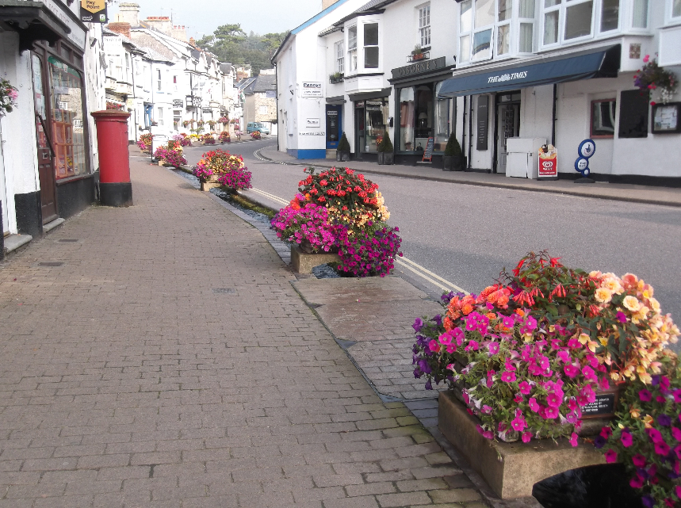
The Plan Area

Beer is a rural coastal parish on the south coast of East Devon district with an historic fishing village at its heart. Seaton is in close proximity to the north-east. To the north of Beer mixed farmland stretches to the A3052, the main trunk road from Lyme Regis to Exeter. To the west, towards Branscombe, between the sea and the A3052 there are significant tracts of land used mainly for general agriculture. Beer’s stunning location and setting, at the centre of the Jurassic Coast, not only make it a very pleasant and desirable place to live and work but also attracts thousands of tourists every year. Our challenge is to ensure that the area develops in a way that protects and enhances all that is special whilst continuing to provide for the needs and demands of the community and visitors in the most sustainable way possible.

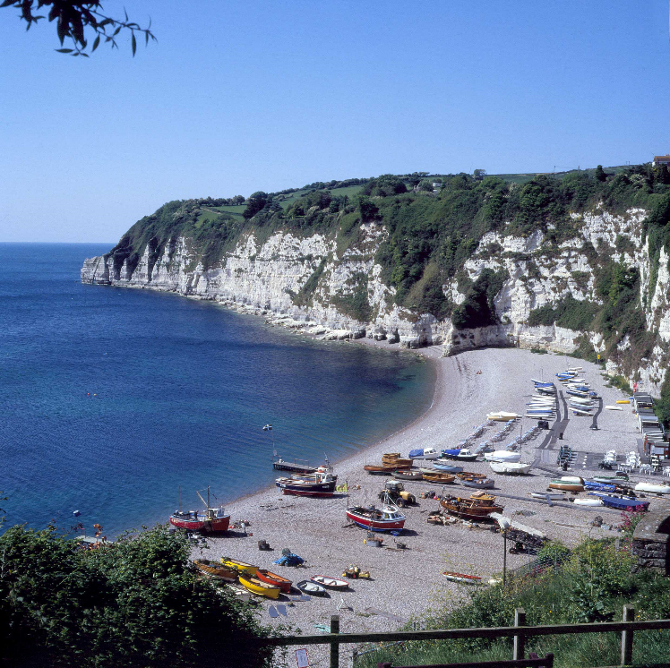
There are several layers of protection in place (see Figure 1). Much of the village of Beer itself is designated as a Conservation Area (covering 246 properties). A good proportion of the Parish lies within the East Devon Area of Outstanding Natural Beauty (AONB), with areas designated as Coastal Preservation Zone, Sites of Special Scientific Interest and Special Areas of Conservation. Moreover, the shoreline and cliffs are part of a designated World Heritage Site. These designations acknowledge how special but also how vulnerable our Neighbourhood Plan area is. The East Devon Local Plan along with a number of area-based management plans (such as the East Devon AONB Management Plan and the Shoreline Management Plan) provide a strategic context that goes a long way to establishing the planning framework we require in response to the prevailing National Planning Policy Framework.

The Beer Neighbourhood Plan is the community’s planning manifesto which provides the additional detail we believe is necessary to shape existing planning policy and to help to plug a few gaps, which we have identified through a process of community consultation.

Our Neighbourhood Plan is topic based. The themes, aims and objectives for each topic reflect the physical and social context of the neighbourhood area and the issues and opportunities we have determined should be addressed.

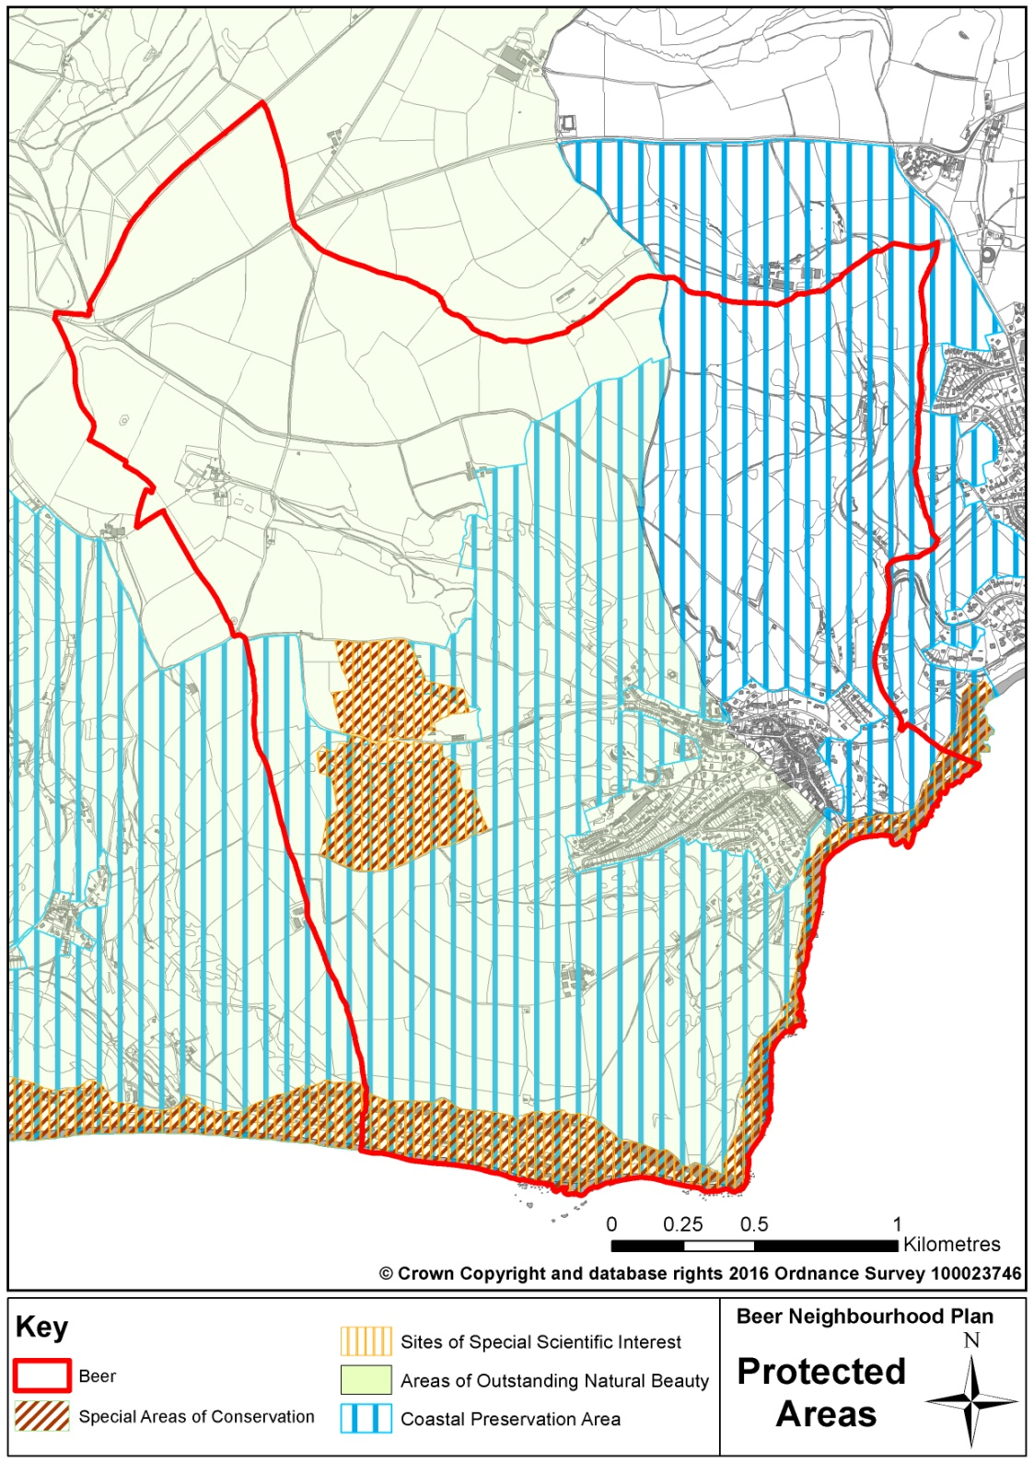
The Natural Environment is made up of chalk grassland, agricultural fields and copses with a unique local ecology. There are five County Wildlife Sites in the Parish. These are sites of “county importance” for wildlife, designated on the basis of the habitat or the known presence of particular species. According to the landscape character assessment, the parish comprises two main landscape character types: ‘Open Coastal Plateaux’ and ‘Coastal Slopes and Combes’. The established management guidelines, primarily to protect and enhance these areas, are set out in The Landscape Character Assessment and Management Guidelines for East Devon and the Blackdown Hills, which was produced by East Devon DC in partnership with the AONB bodies, in accordance with national guidance. The Guidance recognises the important role that management has to play in keeping the character through maintenance of historic field boundaries, planting of locally indigenous species, the improvements to ecological corridors and creating and maintaining rights of way. The importance of preventing development intruding on the natural landscape is also stressed.
Figure 1

The designations of so much of our countryside (statutory and otherwise), and the recognition by the community that we have much to protect and take care of, underpins the approach we have taken in the Neighbourhood Plan to development. The area’s topography, the steepness of terrain in particular, helps to put constraints on development, but the community has an aspiration for Beer to remain a small village and prevent ribbon development and urbanisation of the countryside (Village Design Statement). Our Neighbourhood Plan policies (starting on page 24) are aimed at ensuring development does not harm what is precious or special, that we protect all the locally important wildlife sites and the distinct local character features, whilst facilitating improvements to public access where it can be.

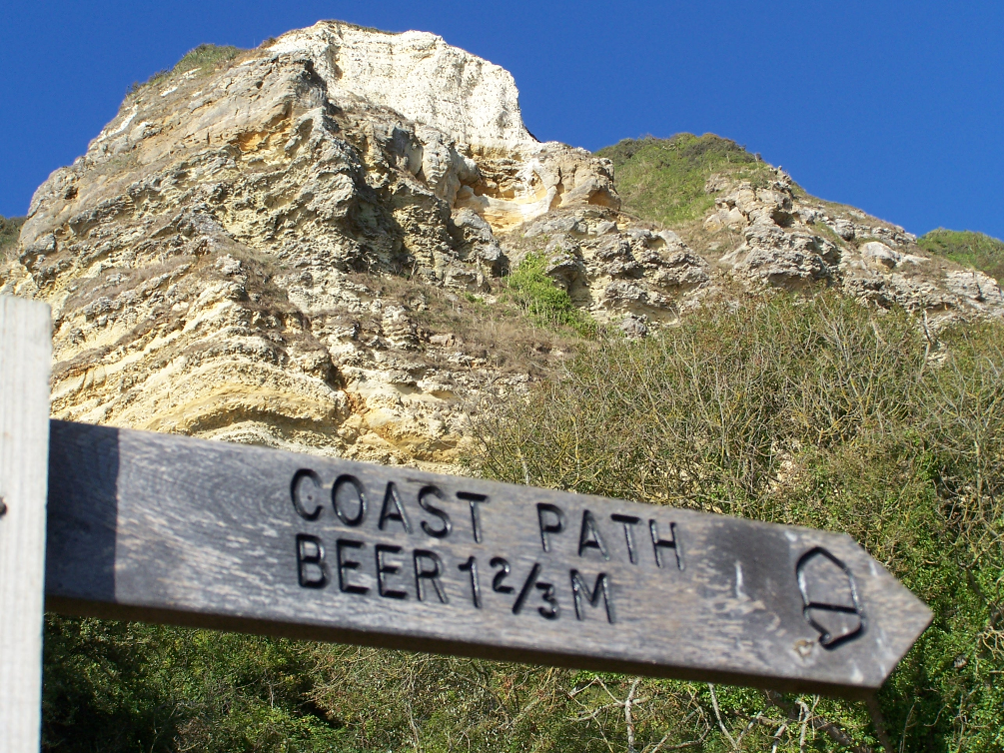
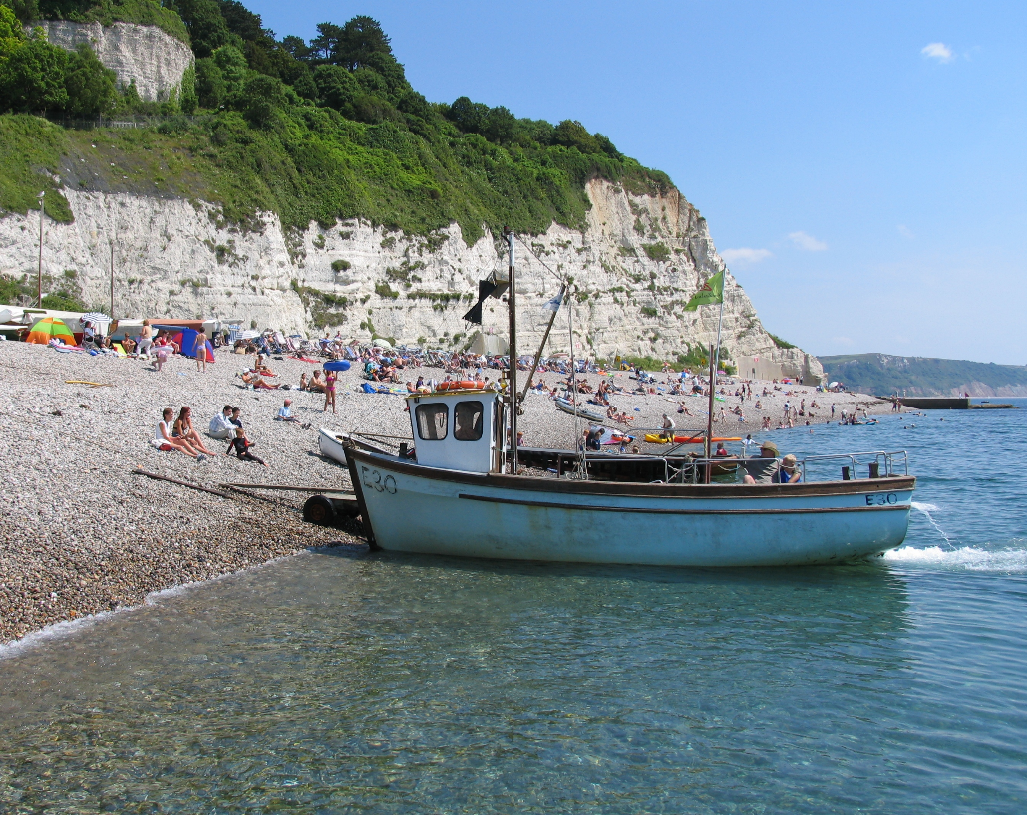
The Coastline of the parish is dominated by picturesque white chalk cliffs that encapsulate a shingle beach towards which the whole village faces, which helps define us visually, economically and socially. The Beach attracts many leisure and pleasure users, but it is also an important working environment. Beer village has no harbour but from the working beach a small fleet of fishing boats harvest mainly crabs, lobsters and mackerel from the bay. The cliffs provide a natural ‘harbour’ and suntrap, sheltering the cove from prevailing westerly winds. As well as being a valuable asset in terms of both tourism and fishing, they also serve an important defence role. The chalk cliffs have proven to be quite resistant to erosion and there has been negligible erosion of this section in the recent past. However, we cannot be negligent on this matter. If cliff recession does occur it could result in the loss of a few cliff top properties in the longer term. As the cliffs are not designated as a Coastal Change Management Area we do have some freedom to plan positively for some development but we do so with due caution and respect for the power of nature and the potential impact of climate change. We want the Beach to continue to function much as it does now (in 2015) whilst enabling, within reason, the requirements of those that wish to use it for work or pleasure in the future; without any detriment to or putting at risk the very special environment of this part of the World Heritage Site. Our Neighbourhood Plan policies (starting on page 24) recognise that there may be a need for small-scale development in the Beach area in the interests of better providing for the needs of visitors and those that use it for acceptable business purposes but we must also protect and enhance the unique environment we are the guardians of.
Add PSMA ref to maps…
Source: East Devon District Council

The Built Environment still retains the appearance of a traditional fishing village. Beer sits along a steep-sided valley with the main road, Fore Street running down the middle. The Brook adds character as it winds its way in an open channel down Fore Street to the sea. Village architecture ranges from 15th and 16th century to the contemporary, with local stone being used in many cases. There remains a cluster of fishermen’s operational buildings, many old and stone built, around Sea Hill, the access road to the Beach from Fore Street.
Beer has a rich history of quarrying, fishing, smuggling, agriculture and lace making. There has always been an abundance of natural materials such as pebbles, flint and Beer stone (a virtually pure chalk limestone). This is clearly evident in the many old buildings in the village, and particularly on Fore Street. The village’s smaller homes, in the central part of the village, originally housed the village’s working community; many are now used as second homes and holiday lets. The bigger, elegant properties, on the higher points around the valley, accommodated the wealthier property owners.
The importance of Beer Quarry Caves
Beer Quarry Caves are and have long been renowned for the mining of Beer stone. The Romans were the first to recognise the qualities of Beer stone. They found it relatively soft when first quarried but on exposure to air it hardens fivefold and turns a beautiful creamy white. Cut into fine ashlars, it yields a smooth finish and forms the closest joints and was once used a lot locally. It is ideal for carving fine detailed designs below ground, when it is soft, and becomes very durable when subsequently the sculpture is allowed to harden above ground. Over the centuries Beer Quarry Caves has hugely extended to meet stone demand, resulting in massive supporting columns and chambers, reminiscent of a growing, majestic structure in its own right. It has been used in half of Britain’s cathedrals and in many churches. Nowadays Beer stone tends to be used for repair purposes only. Beer Quarry retains planning permission for surface and underground working.

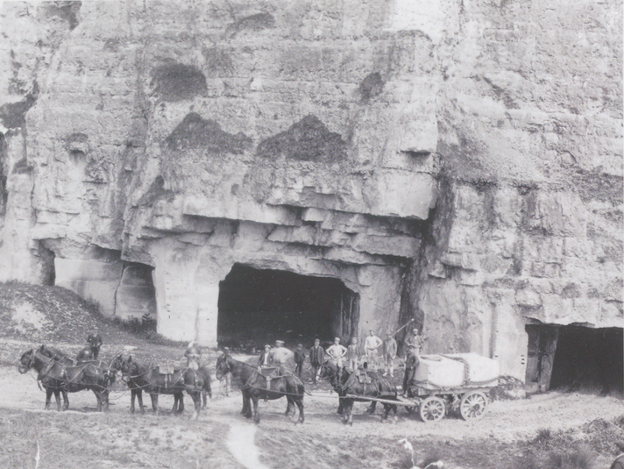

We have an agreed Design Statement for Beer to guide future development. It provides a set of guiding principles and criteria for the design of development in the village. Importantly, all development should respect the local character and vernacular, and the high-quality landscape setting of the village.

Our Neighbourhood Plan policies (starting on page 24) recognise that development will be necessary in response to changing needs and lifestyles and it can make a positive contribution to the character and vitality of the village, as long as we establish the limits and parameters to development.

The Housing stock continues to prove attractive to non-locals and is not serving all the needs of the local community. 2011 census data suggests that the majority of the 800 or so dwellings in the Parish are owned or mortgaged, with around 20% now being holiday homes or holiday lets. The size of population has been fairly steady over the centuries at around 1500, most of whom live in the village. The population profile of the Parish has aged significantly over the ten years from 2001-2011. The greatest increase was in the 60 to 64 age group, with +39% change. Beer has a relatively low proportion of young working families, i.e. those aged 24 to 44 year olds. This has an impact on all aspects of village life and is thought to be primarily down to the lack of affordable housing for young families. Average house prices in Beer are out of reach of many people. The average open market house price is estimated to be 11.5 times the average income in East Devon. The latest Beer Housing Needs Survey, in July 2013, identified a clear local need (27 households at the time) that could not afford to buy or rent on the open market locally.

Our Neighbourhood Plan policies (starting on page 24) seek to enable new housing development where it can be justified by meeting a local need and support the Beer Community Land Trust as a vehicle for providing homes for local people.
House prices and income
Our research indicates that the majority of sales in Beer in 2014 were terraced properties, selling for an average price of £268,578. Detached properties sold for an average of £828,829, with flats fetching £106,571. Beer, with an overall average price of £396,511 was more expensive than nearby Seaton (£219,230) and Colyton (£233,065), but was cheaper than Branscombe (£521,500). Overall sold prices in Beer over the last year were 38% up on the previous year and 15% down on the 2010 level of £463,859. Average house prices are in excess of £230,000 for a 3-bedroom house whilst average earnings are around £20,000 per annum. Housing is therefore out of reach to many local people.
Source: Local Evidence Report

The local Transport network is problematic at times. Beer is an old village with a network of routes designed originally for horses and carts. Moreover, the expansion that took place from the 1900s related to the small vehicles in use at that time. This has resulted in the compact attractive layout we have today but one that is too small in scale for today’s vehicles and the demands of their drivers or the customers they serve. Yet we are very dependent on the private motor vehicle and likely to remain so, as the economics of public transport provision fails to provide a sufficiently appealing and affordable service. We will not give up in our quest to see the public transport service improved. Response to our consultation on the Neighbourhood Plan’s draft aims and objectives showed that local people were keen to see public transport services protected and extended if possible. Our purpose however must be to continue to find ways of accommodating whatever vehicular traffic we have in as non-intrusive way as possible.

We recognise that there is a limited amount that the Neighbourhood Planning policy can do. Our policies focus on car parking, which is important to safety and visual amenity; although it’s not a matter that local people necessarily agree upon. As regards attracting and accommodating visitors it is clear that the existing car parks are seen as very important. We are intent therefore on protecting the car parking areas, which also help keep many of our own cars off the road

Whilst we accept that the motor vehicle will continue to be an important element in the life and well-being of our community and its economy for years to come, we do want to minimise the impact it has. We also expect new developments to help extend the network of pedestrian and cycle links in and around the area and make walking and cycling a more appealing option.

Our Neighbourhood Plan policies (starting on page 24) reflect our priorities and where we agree that planning policy can have a positive effect.

Beer hosts a variety of local Businesses. The village has a high proportion of jobs in the service sector. These tend to be low pay and low skill level; the range is commensurate with a typical tourist-focused community. The majority of higher skilled jobs are found out of the village. There is a manufacturing company in the village; however, this imports a significant proportion of its labour from around the general area and adjacent parishes. As there are few high skill jobs within the village, the training and better work opportunities are mostly out of the village. Around half of the respondents to the Community Survey 2014 that worked, did so either from home or elsewhere within the parish. A further 15% worked close-by in the Branscombe or Seaton areas.

Beer’s employment ‘picture’ is made more difficult to comprehend because of the high number of second home-owners we have. The 2011 Census does confirm that we remain a ‘working community’, although around a third of permanent residents of Beer aged 16-74 are retired or otherwise economically inactive. Neither unemployment nor under-employment appears to be a significant local problem. However, the community believes it important that we continue to create local working and training opportunities, particularly for our young people. It is the view if the Parish Council, expressed at the time of consultation on the draft Village DPD in 2014, that “we would like to see provision of around 10 small business units”. In the Community Survey 2014, 90% of respondents agree we should be creating more local jobs.

Retailing is an important facet of the local economy. The presence of so many shops and services helps make the village appear thriving and sustainable and thereby more attractive to tourists. The majority of residents use at least one of the shops on a regular basis and the loss of this convenience would be significant.

Our Neighbourhood Plan policies (starting on page 24) seek to protect our business/employment sites in the interests of maintaining a buoyant local economy and providing an efficient and effective working environment.

Beer remains a relatively sustainable community. We are served by a good range of everyday shops and have a good range of Community Facilities and Services that include a post office, meeting hall, churches, doctor’s surgery and school. Many of our local services and facilities are dependent on the tourism trade for their viability.

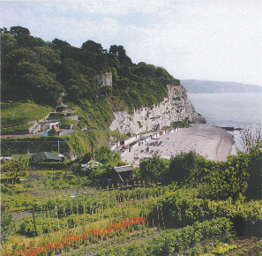
Only half of the respondents to the Community Survey 2014 rated the current level of community services and facilities as good or better. Just over 40% of people regard daily shopping as only adequate. Over 40% of people feel that local care service provision is only adequate. The level of local services such as banking and financial services and other business and professional services were ranked as poor by a significant proportion of respondents (almost 60% of respondents thought local banking provision was poor).

We would like to see the provision of a broader range of local services, convenient and accessible, to meet the needs of our community in the 21st century. Our Neighbourhood Plan policies (starting on page 24) support and protect the retail, service and other community facilities we have and aim to make them more appealing and accessible to local residents.

We recognise that a strong economic and social heart to our village is vital and we will be encouraging local people to support all our local facilities as part of a Community Action Plan.

Sports and Recreation facilities in Beer include the Jubilee Memorial Ground, Ash Hill and Underleys Road play areas, Beer Albion FC football ground, the Causeway amenity green-space, sailing club and the seafront allotments. Beer village has a range of structured opportunities for sports and recreation including sports clubs, scouts and Sunday schools but the 12 to 17 group is not well catered for.

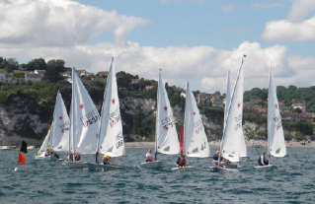
East Devon District Council has recognised that Beer is in need of additional recreation facilities. The District Council’s 2012 study into open space needs identified that teenagers’ or youths’ needs for recreation were not being met and there was a need for more facilities for this age group. It identified Beer as a large enough settlement area to need a multi-use games area (MUGA). A similar study in 2014 by East Devon District Council identified an overall deficit of playing pitch provision of around 1 hectare. The 2014 Community Survey showed that 76% of respondents agreed with the need for more or better leisure facilities for young people in particular. Our Neighbourhood Plan policies (starting on page 24) seek to protect, from development, what we have and facilitate the provision of further local sports and recreation facilities particularly to meet the demands of the younger members of the community.

Beer is a Tourism destination with the specific draws of the beach and access to the South West Coast Path. Its heritage, size and geographic location have also dictated its appeal and development. It is never going to attract the mass ‘bucket and spade' market. Therefore, any development should centre on enhancing the visitor enjoyment of the facilities it can provide, focussing on the beach, fishing, history, caves, walks and maximising the Jurassic Coast association.

Visitor and local facilities in the village are good and have been improving year by year. The village creates a strong bond of loyalty with its visitors. Whilst familiarity and old charm are important, new offerings and innovation will also attract, satisfy and encourage visitors. 99.6% of respondents to the Community Survey 2014 stated that tourism is very important to Beer. The AONB Management Plan identifies the local “desire to spread the tourism season to the ‘shoulder periods’ of spring and autumn through targeted events and special interest activities”.

Our Neighbourhood Plan policies (starting on page 24) focus upon facilitating responsible and new forms of tourism to enhance the ‘offer’ we make. That responsibility, towards our natural environment and the character of the built environment, is one that we must all share as we seek to take advantage of the Parish’s tourism potential.

The Neighbourhood Plan Area covers the whole parish and was approved as such for plan purposes by East Devon District Council following consultation. Figure 2 shows the extent of the area. With regard to the coastal area, the local planning authority and its Local Plan’s policies are effective, generally speaking, to the mean low water mark. This is also therefore, the extent to which the Neighbourhood Plan’s policies have effect.

Figure 2
Figure 2

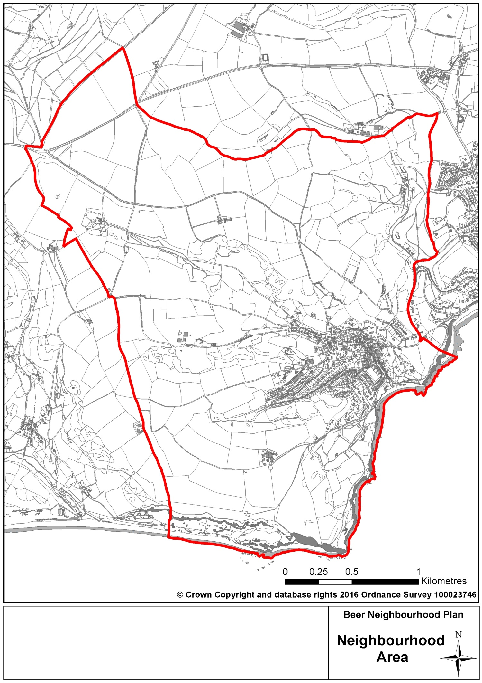

How have we got here?

The production of the plan has been driven by a steering group, comprised of residents and Parish Councillors. It was recognised at an early stage that for the plan to be truly representative of the planning issues of relevance in the parish and to be the community’s plan, we would need to conduct thorough engagement with those who live and work in the parish. We also recognised that the plan could not be properly developed without the input of organisations and agencies with a district, county, sub-regional or national remit.

The process and types of consultation and discussion that we have gone through are documented in detail in our Consultation Statement which accompanies this plan. However, the key methods we have used have included:

- Public exhibitions, meetings and events;
- A community questionnaire sent to all households;
- Focus groups;
- Discussion with local businesses (through the Coastal Communities project);
- Directly contacting wider-than-local organisations and agencies (strategic stakeholders) which have an interest in planning issues in the parish; and,
- Consultation ‘windows’ during which comments have been invited on draft documents.

Our development of the plan is based on a desire to be open and encourage comments and contributions from all quarters with the aim being to achieve consensus, but also to have debates about issues where the community is divided in its views.

Having developed the plan through this iterative approach, the first draft of the plan was shared with the community and other stakeholders and has been revised to reflect comments before progressing through the regulatory framework which will include consultation on the pre-submission version of the plan, formal submission to the local authority and public examination of the plan before an independent Inspector. After that point, assuming that the plan passes through the Examination successfully, the plan will be subject to a public referendum where residents on the electoral register will be asked if they support the final plan. If the referendum answer is a “yes” from a majority of voters turning out on the day, the plan will be “made” (or adopted) by the local authority.

Our Evidence Base

To inform the content of the Plan, we have developed our evidence base so that our policies are underpinned by clear reasoning and justification. We have done this in two ways. Firstly, we have undertaken local consultation (documented in our Consultation Statement which will be submitted alongside this Plan for Examination) and secondly, we have gathered together our understanding of the written evidence that already exists into a summary report. We have used these two approaches to help identify our Plan’s Aims, Objectives, Vision and its policies.

Strategic Environmental Assessment

The plan is subject to testing as it is developed to help determine the plan’s positive or negative impact on the social, environmental and economic character of the parish. This is done through a Strategic Environmental Assessment (SEA), with a report of the SEA accompanying this plan. The aim of the SEA is to identify potential impacts of our policies and then propose possible amendments to policies to lessen negative impacts which could arise as a result of the plan’s policies and / or proposals.

In conclusion, the SEA found, in relation to the first draft plan as a whole, that it:
“…performs well against all of the SA [sustainability appraisal] themes …with no significant negative effects. Through policies that seek to conserve and enhance landscape character and biodiversity, including locally important landscape and nature conservation features and sites, the NP provides additional detail over and above the Local
Plan. However, given that Policy H3 allocates a site within the AONB [Area of Outstanding Natural Beauty], this
results in an overall assessment of minor negative effects against the Landscape, Townscape and Natural Environment SA theme, although the policy requires mitigation of adverse effects. The NP scores significantly positive against the Communities, Population, Housing and Health and Economy, Skills and Employment SA themes through providing for additional housing to meet local needs, and protecting employment and retail space within the village and benefiting the vitality and viability of the village and its services. It also scores significant positive against Historic and Cultural Heritage SA theme, through providing strong protection for historic assets and the character of Beer village.”

The Plan’s Status

This Neighbourhood Plan, once made, will be a statutory development plan. That means that its policies will have significant weight (or real teeth) when it comes to being used by the local authority to help determine proposals for development submitted through planning applications. It will form the local tier of planning policy in our parish. It sits with the district-wide Local Plan, produced by East Devon District Council (also a statutory development plan) and underneath the umbrella of national planning policy in the Government’s National Planning Policy Framework (NPPF) and National Planning Practice Guidance (NPPG), as the main planning policy documents relevant to our area. Other important planning documents which govern specific issues are the Minerals and Waste Plans produced at the county-wide level.

The relationship between our Neighbourhood Plan and other key planning policy documents is shown below.

However, this plan should not be treated as a blueprint. When this plan is made (adopted) policies will need to be used by the local planning authority when it considers decisions that need to be made about development proposals submitted through the planning application process. The plan’s policies, however, cannot guarantee that a proposal will be refused nor be granted permission, but the policies will carry significant weight, alongside policies of the NPPF, NPPG and Local Plan when weighing up the appropriateness of the proposal in question.
Figure 3

National Planning Policy
(National Planning Policy Framework and
National Planning Practice Guidance)

County-wide Planning Policy
(Minerals and Waste Plans)
District-wide Planning Policy
(East Devon Local Plan)

Locally Specific Planning Policy
(Beer Neighbourhood Plan)

Sustainable Development

The National Planning Policy Framework (NPPF) and National Planning Practice Guidance (NPPG) set out the Government’s planning policy to which all plans and proposals for development should comply. The NPPF includes, at its heart, a “presumption in favour of sustainable development”. It is important to understand what that means for our plan as it sets the parameters within which we can make proposals and set policies.

When taking decisions on proposals for development this means that proposals should be approved where they accord with the development plan without delay. Where the development plan is absent, silent or relevant policies are out-of-date, planning permission should be granted unless any adverse impacts of doing so would significantly and demonstrably outweigh the benefits when assessed against the policies in the NPPF, or specific policies in the NPPF indicate that development should be restricted.

Translating this to what it means for our Neighbourhood Plan, it states that plans should “…support the strategic development needs set out in Local Plans, including policies for housing and economic development…” and “…plan positively to support local development, shaping and directing development in their area that is outside the strategic elements of the Local Plan”. The NPPF goes on to say that “The ambition of the neighbourhood should be aligned with the strategic needs and priorities of the wider local area. Neighbourhood Plans must be in general conformity with the strategic policies of the Local Plan.” We are also advised that Neighbourhood Plans should reflect these Local Plan policies and plan positively to support them, while not promoting less development than set out in the Local Plan or undermining its strategic policies. Outside of strategic policies, we are encouraged to shape and direct sustainable development in our area through our Neighbourhood Plan.

Our Vision

A Vision for Beer

In consultation with the parish the community looks to provide:

- A strong sense of identity; Beer is regarded as an historic fishing village around which the traditional buildings, the working beach and local heritage unites all residents
- Community spirit; set around village events in which local residents and businesses participate to encourage participation by young and old, locals and tourists
- Attractive and vibrant village centre that is accessible for all residents and visitors; regularly nominated for its beauty Beer provides a welcome haven that promotes a sense of pride
- Pedestrian friendly paths to enable easy access to the countryside and its walking routes
- Safe, convenient and sustainable transport links
- Support for the growing population with essential services such as the school, local businesses and affordable homes
- Community led development; to respect the unique village character and protect our high quality natural environment and wildlife
- Safe highways; resolving parking and highway issues to the benefit of residents and businesses
- Improved facilities for young people; providing areas of safety within the parish for our future generations

Our vision for the parish represents our view of what we would like the parish to be like in the future by the time that the plan reaches its end date. The vision is a representation of the aims of our plan, the things we would like to achieve, which have been derived from local community consultation and other evidence.

OUR AIMS, OBJECTIVES AND POLICIES

Natural Environment

Aims

Aim 1: Protect and enhance the natural environment, its ecology and bio-diversity.

Aim 2: Minimise the impact of new developments.

Objectives

Objective 1.1: Protect and enhance wildlife conservation sites.

Objective 1.2: Encourage measures to improve biodiversity.

Objective 1.3: Protect historic and natural features such as Devon Banks, hedges and trees.

Objective 1.4: Improve public access to the natural environment.

Objective 2.1: Prevent development on or near the skyline.

Objective 2.2: Ensure that new development has a minimal impact on the natural environment.

Objective 2.3: Ensure new development and technology does not cause undue visual intrusion and require whenever possible the undergrounding of cables and facilities.

Neighbourhood Plan Policies

Development and the Natural Environment

Justification for our policy

National planning policy encourages the planning system to “…contribute to and enhance the natural and local environment by…protecting and enhancing valued landscapes, geological conservation interests and soils….” and puts emphasis on the use of criteria based policies against which proposals on or affecting protected wildlife, geological and landscape areas can be judged. It also states (in paragraph 115) that “great weight” should be given to conserving landscape and scenic beauty in AONBs. At the local authority level, the Local Plan gives protection to the environment and landscape in its strategic policies: Strategy 5 “Environment” and Strategy 46 “Landscape Conservation and Enhancement and AONBs”. While not giving statutory planning policy protection, the policies and objectives of the East Devon AONB seek to ensure that the distinctive landscape features of the AONB are “maintained, enhanced, understood and appreciated”.
Formal Designations
Sidmouth to Beer Coast SSSI
Beer Quarry & Caves SSSI
Beer Quarry & Caves SAC
Beer Quarry and Caves County Wildlife Site
Sidmouth to West Bay SAC
Beer Head County Wildlife Site
Beer Fields County Wildlife Site
Bovey Lane Fields County Wildlife Site
Bovey Lane Quarries County Wildlife Site
East Devon Area of Outstanding Natural Beauty
Jurassic Coast World Heritage Site
Lyme Bay SAC
Torbay SAC

While there are other policies in the district-wide Local Plan which afford some protection of our natural environment, there are a number of locally specific issues which we consider are of sufficient importance to us to require policy protection and guidance in our Neighbourhood Plan. We are also aware that while the East Devon AONB Management Plan provides principles which should be applied to the natural environment in the part of the parish within the AONB, they do not have statutory weight in the decision-making process even though they should be considered as a “material consideration” when planning proposals are considered by the local planning authority. Given the quality of our environment and landscape outside of the AONB boundary and its value to us locally, we also feel that the quality of the environment outside the AONB merits an equilibrium of policy right across the rest of the parish. Our Plan seeks to reinforce some of the overarching principles of protection for the environment to give us the certainty that such policy coverage will remain during the lifetime of our plan. In doing so, it can fulfil its Aims and Objectives without relying solely on other policies set out elsewhere.

We are clear that it is not the role of the Neighbourhood Plan to prevent development from taking place and it is our intention to support local, small scale, development where it meets other planning policies outside of this plan and where done in a way sensitive to the natural environment and landscape. However, we are also clear, that there is a need for a balance to be struck so that any development which is proposed within the parish requires special consideration to ensure that it does not have adverse impact on the natural environment. This is something that has been previously recognised by the Beer Village Design Statement, produced in 2006, and which we are reviewing in a parish-wide context as part of the Neighbourhood Planning process.

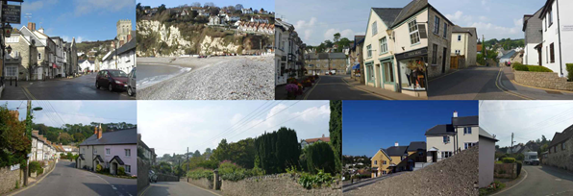
In addition to the environmental land designations in the parish, we value the wider natural environment and landscape as an intrinsic part of Beer and the setting of the village. The high-quality environment is something which is an important asset to residents and the tourism industry and as a result both the land and coastal environment in the parish need to have particular protection from development which could be inappropriate and spoil their quality. The landscape features of Beer are an important aspect of this with the hills surrounding the village a key and distinctive characteristic of our area, clearly visible from a stroll around the village.

We consider that views of the hills from the village are locally valued and that, therefore, the hills and their skylines should be protected. Whilst developments rising up the valley sides can be made to look attractive in the context of the surrounding landscape, the affect can be reversed where the skyline is intruded upon. We have identified the areas of prominent skyline around the village (identified on Figure 4), which largely follow natural contours.

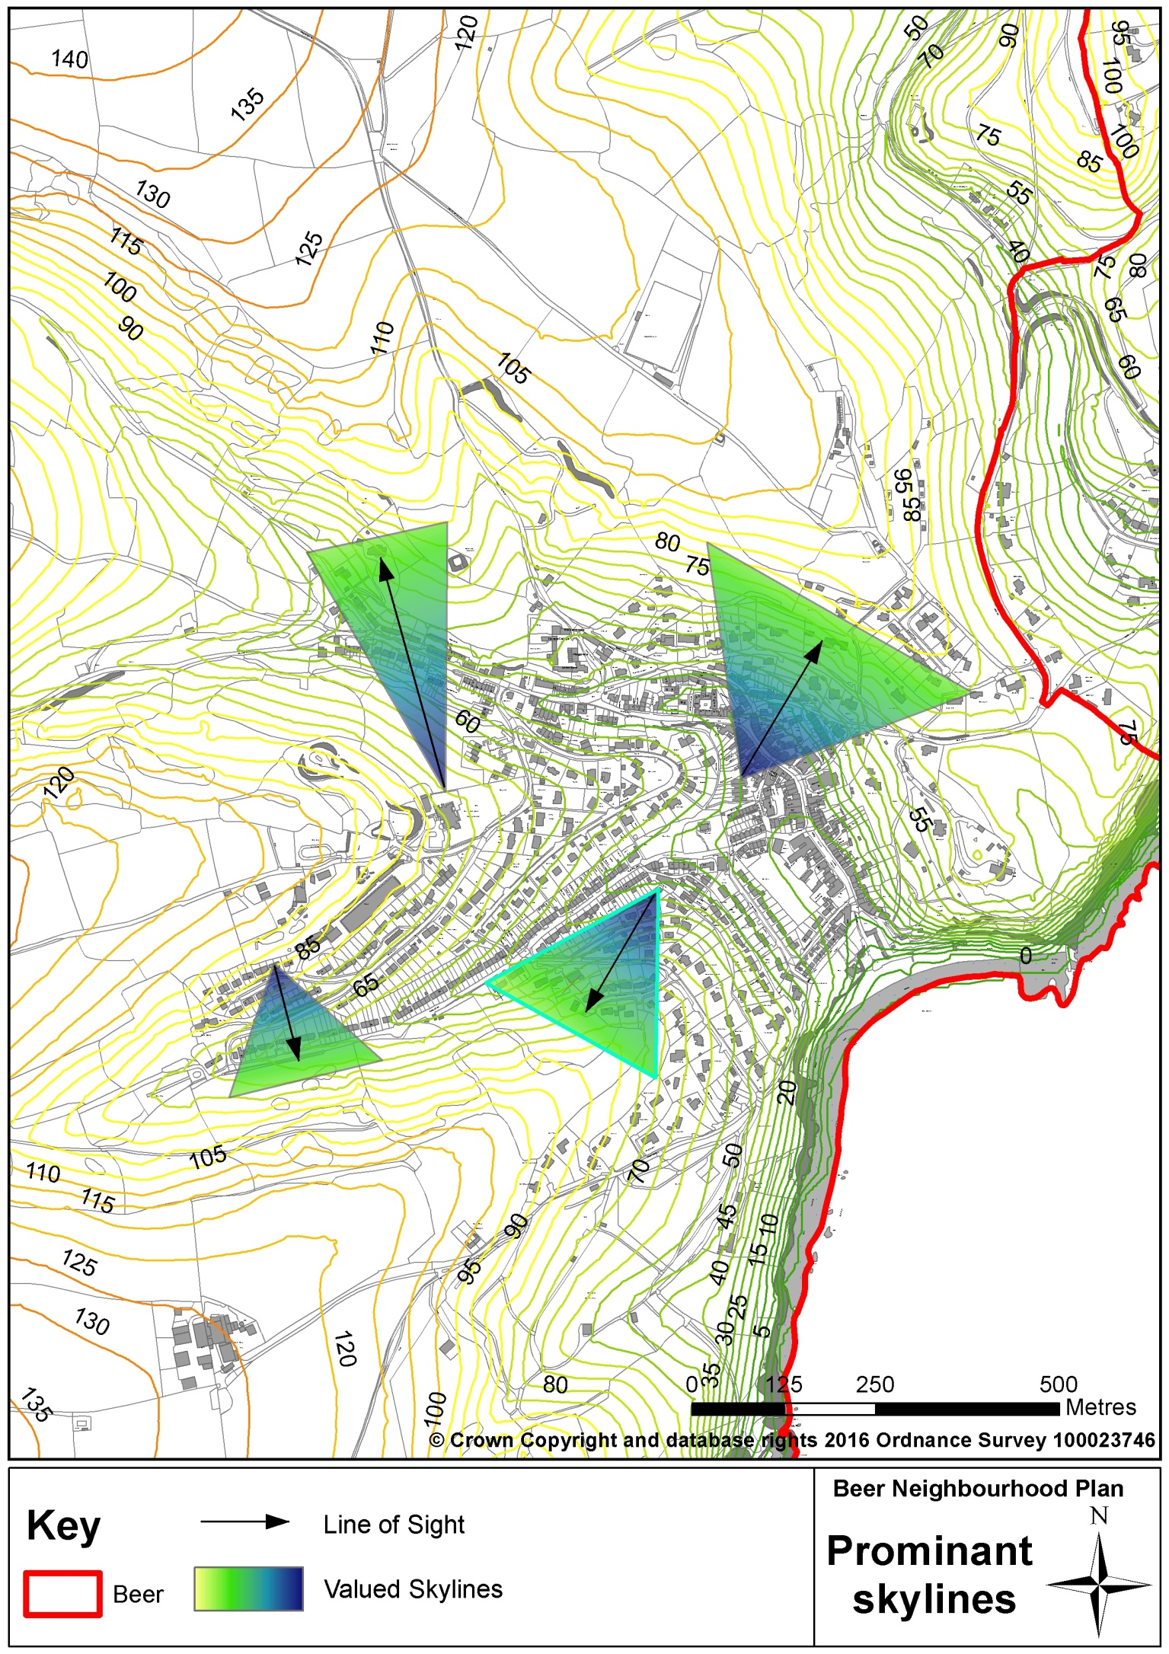
Figure 4 – Valued Prominent Skylines around Beer Village

Where development is proposed, our preference is for it to be appropriately designed (further details are given in the section of the plan which deals with heritage and the built environment) so that it ‘fits’ within the landscape without having adverse impacts on the surrounding landscape and the natural and built character of its setting. However, in some cases, it may be acceptable for landscaping to play a mitigating role as part of a solution to ensure that there is no adverse impact on the setting of the proposal. Where the use of planting is considered to be an appropriate part of that solution, species of plants considered locally appropriate and indigenous to the local landscape and habitats of the parish should be used. The county Landscape Character Assessment can be used as a broad guide, but local observation and assessment of the local setting and context will be the best guide to determine appropriate species to use.

Based on these important characteristics of our local environment and landscape, policy NE1 therefore sets out parameters which any development will need to meet for it to be acceptable and focuses on locally important factors, adding to and emphasising planning policies set elsewhere at national and local authority levels.

Policy NE1 – Development and the Natural Environment

The quality of Beer’s landscape and setting should not be compromised and valued features will be protected.

Development proposals will be supported where they:
i) have demonstrated that there are no adverse impacts on the natural environment (landscape, biodiversity and habitats) or any impacts are satisfactorily mitigated;
ii) have demonstrated that there are no adverse impacts on prominent skylines viewed from Beer village centre (identified on Figure 4);
iii) are of a scale, mass and density appropriate to their landscape setting; and,
iv) enhance the natural environment where there is the opportunity to do so by encouraging the retention of natural vegetation features e.g. hedges, trees and Devon Banks.

Where mitigating measures are unavoidably required for development to be acceptable within its landscape setting, appropriate landscaping should be employed to mitigate the impact of the development. Such measures should include the use of appropriate planting which can enrich the biodiversity of the area such as locally ‘indigenous’ trees and hedges, and should be set out in planning conditions as part of planning consent.

Key supporting evidence

Beer Neighbourhood Plan Aims and Objectives Consultation 2015
East Devon AONB Management Plan 2014-19
Devon Landscape Character Area Assessment, 2008
Land-use designations, courtesy of Multi-agency GIS Tool (MAGIC) and East Devon District Council websites
East Devon and Blackdown Hills Area of Outstanding Natural Beauty and East Devon District Landscape Character Assessment and Management Guidelines 2008
http:/eastdevon.gov.uk/planning/planning-policy/environment-and-green-infrastructure/ landscape
Beer Village Design Statement, 2006
Beer Parish Biodiversity Audit (consultation draft), Devon County Council, 2010

(The content of this and other relevant written evidence is summarised in the Beer Local and Strategic Written Evidence Reports)
Related national, district and AONB policies

National Planning Policy Framework
Paragraph 109 - The planning system should contribute to and enhance the natural and local environment…

East Devon Local Plan
Strategy 5 – Environment
Strategy 7 – Development in the Countryside
Strategy 46 – Landscape, Conservation and Enhancement and AONBs
Strategy 47 – Nature Conservation and Geology
D2 –Landscape Requirements
EN5 – Wildlife Habitats and Features

East Devon AONB Management Plan
Policies L1, BG1, C1

Locally Important Wildlife Sites

Justification for our policy

There are a number of locally important parts of the parish which we particularly value for wildlife and its habitat. While some of these areas are afforded some protection due to their location within areas already designated as being of county-wide and / or national European importance, such as County Wildlife Sites, SSSIs and SACs, we have identified a number of others which we consider to be worthy of local protection. These areas are named in our policy which seeks to protect them and enable improvement of their value to wildlife in terms of enriching habitats and biodiversity. Figure 5 identifies the geographic location and extent of these areas and our valued SSSI at Quarry Caves.

Figure 5 - Locally Important Wildlife Sites (LIWS)
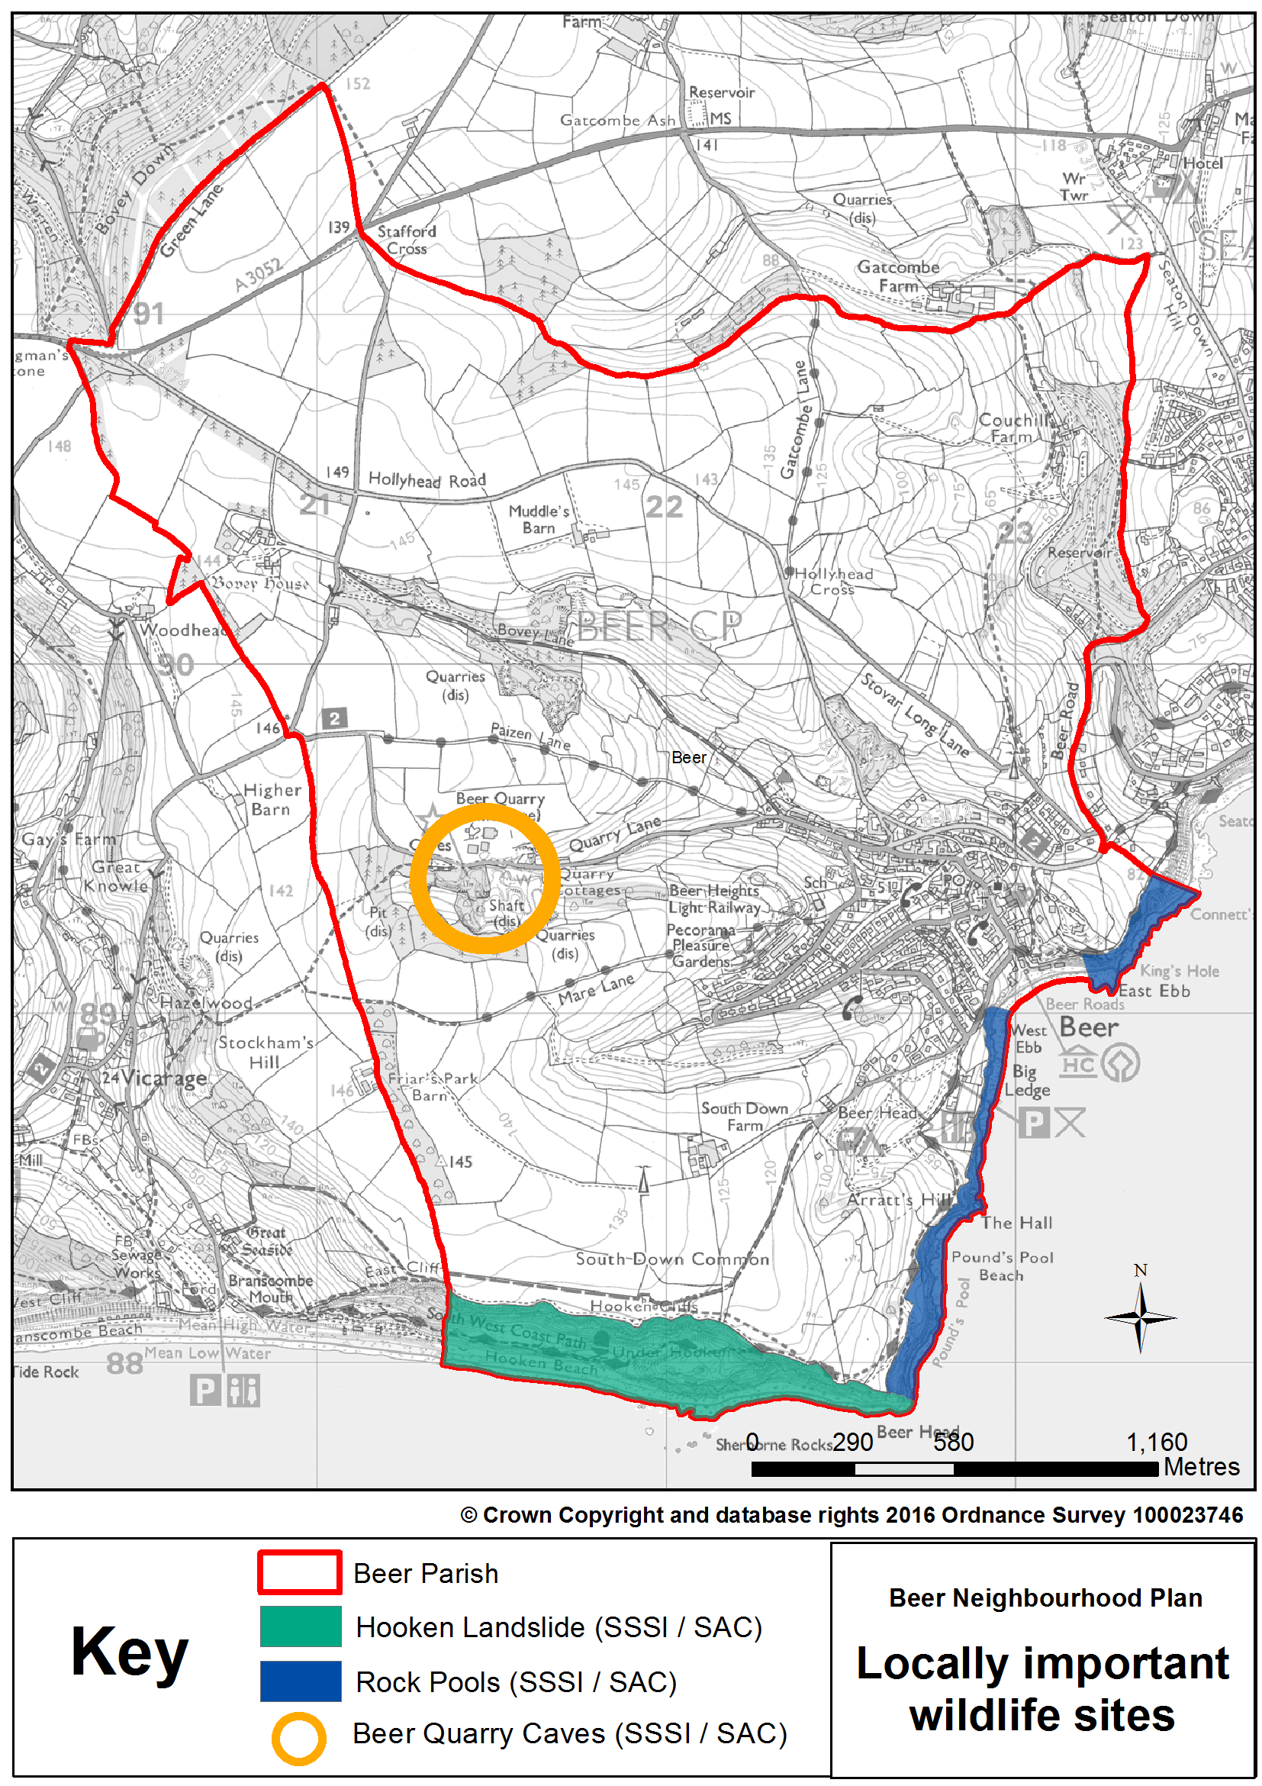

Policy NE2 – Locally Important Wildlife Sites

Locally Important Wildlife Sites (LIWS) will be protected from development to maintain and enhance their biodiversity and habitats they support. The following two sites, which are also designated sites of European importance for biodiversity/geodiversity, have been identified and appear on Figure 5 alongside Quarry Caves, a Site of Special Scientific Interest, (SSSI) and a Special Area of Conservation (SAC):
- Hooken Landslide (SSSI/SAC); and,
- Rock Pools (SSSI/SAC).

Development proposals affecting these areas should seek to protect or enhance the value of them to wildlife and enrich biodiversity. Where the negative impact of change is unavoidable, proposals should demonstrate how negative impacts will be mitigated.

Key supporting evidence

Local Identification of Locally Important Wildlife Sites, Neighbourhood Plan Steering Group, 2015
Land-use designations, courtesy of Multi-agency GIS Tool (MAGIC) and East Devon District Council websites
Beer Parish Biodiversity Audit (consultation draft), Devon County Council, 2010

(The content of this and other relevant written evidence is summarised in the Beer Local and Strategic Written Evidence Reports)
Related national, district and AONB policies

National Planning Policy Framework
Paragraph 109 - The planning system should contribute to and enhance the natural and local environment…

East Devon Local Plan
Strategy 5 – Environment
Strategy 46 – Landscape, Conservation and Enhancement and AONBs
Strategy 47 – Nature Conservation and Geology
EN4 – Protection of Local Nature Reserves, County Wildlife Sites and County Geological Sites
EN5 – Wildlife Habitats and Features

East Devon AONB Management Plan
Policies L1, BG1, C1

Protecting Historic Natural Features

Justification for our policy

Our concern about potential adverse impact on our local landscape extends to a need to protect the traditional and historic hedge banks, which frame the landscape character of the parish, from inappropriate change and loss. Devon hedges (commonly also referred to as “Devon banks”) are a common feature of the landscape in the parish. They are usually formed of an earth bank which is faced with either stone or turf and is often topped with bushes or shrubs. They are often very old, biodiverse and attractive, and they play an important role as stock-proof barriers and shelter for livestock and crops. Recently, fences and other boundary treatments have been replacing Devon Banks, natural stonewalls and hedgerows to the detriment of the visual ‘village-scape’ and wildlife.

Our farming community and other local landowners have a key role in maintaining the integrity of these important features. The successful conservation of these hedges is critical to maintaining the special character of Beer’s natural, farmed and historic landscape.

In relation to our policy below, for the avoidance of doubt, in this context, the definition of “development” includes changes to access to the highway where planning permission is required and in such cases the Devon County Council Highways Protocol for Protected Landscapes should be applied.

Policy NE3 – Protecting Historic Natural Features

Development proposals should ensure that they have no negative impacts on important Devon banks, hedges and trees.

Where change to existing traditional Devon banks, hedges and trees is unavoidable (for example, where there are no other options to access a site or for reasons of safety), proposals for development which affect important traditional Devon banks, hedges and trees will be supported where they have demonstrated that:
i) mitigating solutions have been assessed and, as a result, the proposal incorporates the least damaging option (to the hedgerow / bank, setting in the landscape, biodiversity and habitats); and,
ii) compensatory planting and landscaping will satisfactorily mitigate the impact and loss.

Key supporting evidence

Beer Neighbourhood Plan Aims and Objectives Consultation 2015
Hedgerow Regulations 1997
Conservation and Management Online Information Pack, Devon County Council, 1998 (http://www.devon.gov.uk/the_devon_hedge)
Protocol for Protected Landscapes, Devon County Council (Highways), 2011 http://www.devon.gov.uk/landscape-policy-guidance

(The content of this and other relevant written evidence is summarised in the Beer Local and Strategic Written Evidence Reports)
Related national and district policies

National Planning Policy Framework
Paragraph 109 - The planning system should contribute to and enhance the natural and local environment…

East Devon Local Plan
Strategy 5 – Environment
Strategy 46 – Landscape, Conservation and Enhancement and AONBs
Strategy 47 – Nature Conservation and Geology
D2 –Landscape Requirements
EN5 – Wildlife Habitats and Features

East Devon AONB Management Plan
Policies L1, BG1

Improving Access to the Natural Environment, and Rights of Way and Other Access (footpaths, pavements, bridleways and cycleways)

Justification for our policies

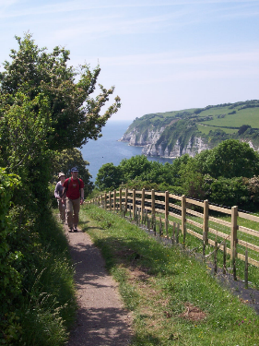
There is good public access to much of the countryside and natural environment, including the coast in Beer. Our research suggests that there is relatively good access by foot to the SSSIs, SACs and County Wildlife Sites and also to green lanes, the beach, and to amenities such as children’s play areas, public gardens, Beer Albion Football Ground, the churchyard, South Down Common, Couchill Woods and allotments. However, we support further improvements to our footpath network to enable, in particular, improved access from the village into countryside and coastal areas, to enable the community and tourists alike more opportunities to enjoy our high quality natural environment and to improve connections to the wider network. Improvements to pedestrian links between Beer village and Seaton have been identified by the Parish Council as desirable.

Together, our policies NE4 and NE5 provide support to proposals which will improve access, but without compromising the quality of the environment. Policy NE4 seeks to provide support, in particular, for improved access to the immediate countryside and coast surrounding Beer village. Policy NE5 seeks to improve and extend access on foot, bicycle and horse and encourage responsible use of the rural rights of way and other bridleways and pathways.

Policy NE4 – Improving Access to the Natural Environment

Development proposals outside of and on the edge of the Beer built-up area boundary that seek to improve public access to and enjoyment of the countryside (including publicly accessible cliff-top areas) will be supported, where they are in accordance with the other policies in this plan.

Policy NE5 - Rights of Way and Other Access (footpaths, pavements, bridleways and cycleways)

Proposals for development of, or affecting, rights of way and other access ways will be supported where:
i) they have no negative impact on the natural environment (landscape, biodiversity and habitats);
ii) they promote, protect, maintain and enhance the existing public rights of way network and other access ways;
iii) they improve and enhance the existing network of access through the provision of upgraded, new or extended routes; and,
iv) they prevent motorised vehicles (except those specifically designed for the disabled) from inappropriate use of public rights of way and other access ways through design measures and access gates.

Key supporting evidence

East Devon AONB Management Plan 2014-2019, page 42, policies ART1 and ART2
Main related national, district and AONB policies

National Planning Policy Framework
Paragraph 75 - Planning policies should protect and enhance public rights of way and access

National Planning Practice Guidance
Paragraph: 004 - Public rights of way form an important component of sustainable transport links and should be protected or enhanced
Reference ID: 37-004-20140306

East Devon Local Plan
Strategy 5B – Sustainable Transport
RC4 - Recreation Facilities in the Countryside and on the Coast
TC4 - Footpaths, Bridleways and Cycleways

East Devon AONB Management Plan
Policy ART1

Maritime and Shoreline

Aims

Aim 3: Ensure the beach and its facilities remain suitable for those who wish to use it for work or pleasure.

Aim 4: Provide high quality facilities and amenities (to enhance the visitor experience) that are in-keeping with their surroundings.

Objectives

Objective 3.1: Support development and change of use only where it is in-keeping with the vision of Beer as an Historic Fishing Village on the Jurassic Coast.

Objective 3.2: Protect the businesses on the beach and the cliffs from erosion.

Objective 3.3: Ensure that the concrete groyne is properly maintained.

Objective 3.4: Support and facilitate marine conservation measures.

Objective 4.1: Ensure any new development is of a very high standard and in-keeping with the vision for Beer, the Beach and it’s setting.

Objective 4.2: Ensure that good public access is maintained to the Beach and the surrounding public spaces and play areas.

Objective 4.3: Encourage marine activities such as commercial fishing, conservation, swimming, sailing, rowing and similar sports.

Neighbourhood Plan Policies

Beer Beach

Justification for our policy

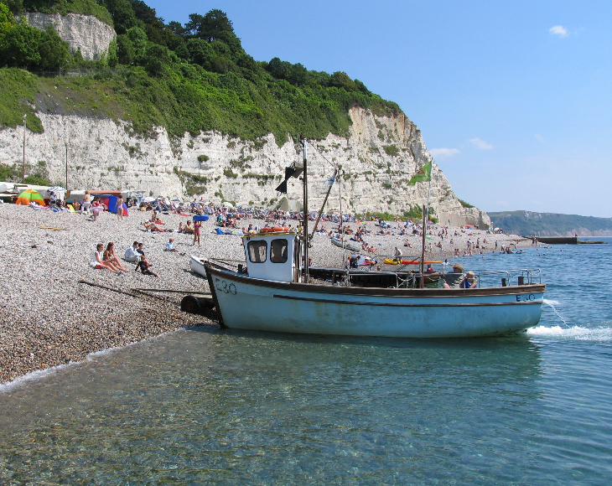
Whilst the community is very proud of its Beach there is recognition that its facilities may not be adequate to meet the needs and demands of Beach visitors in future. Just over half (51%) of respondents to the Community Survey 2014 thought the Beach needed additional facilities. Our policy MS1 enables new facilities to be developed on the Beach or on the access and slipway area, as long as there is evidence of a need and, more importantly, whatever is provided fits in, by being of the right scale and uses appropriate materials and finishes. Any development proposal should demonstrate how it will make a positive contribution to the overall enjoyment of the Beach. Furthermore, any development on the beach, shoreline or protective structures that takes place must take into account the Sidmouth to Beer SSSI, the Sidmouth to West Bay SAC, the Lyme Bay and Torbay SAC, the East Devon AONB, the Jurassic Coast WHS and the wider biodiversity and geodiversity issues where relevant.

Policy MS1 – Beer Beach
Development proposals on or adjacent to the Beach at Beer will be supported only if:
- they meet a proven need for community or visitor facilities; or
- support marine-related activities in accordance with policy MS7; and
- are of an appropriate scale and contribute positively to the special character of the local environment.

Coastal Erosion

Justification for our Policy

Our policy is made in recognition of prevailing circumstances and in support of the Shoreline Management Plan (SMP). The SMP records that our stretch of coastline is characterised by “dramatic and geologically important cliffs which are subject to large-scale and complex land-sliding. These events are difficult to predict with any certainty, making management of this shoreline difficult.” The long-term plan for this section of coastline is to allow it to continue to evolve naturally, whilst ensuring that the risk of flooding and erosion to the town of Beer continues to be managed.
At Beer, the plan is to “hold the line”. In the short-term to medium-term this means continuing to maintain the short lengths of defences to ensure adequate levels of protection are provided with the main aim of retaining beach material to reduce wave exposure at the toe of the cliff. In the long-term it may involve the “likely construction of larger defences at Beer in order to ensure adequate levels of flood protection and access to the shoreline are provided.”

Policy MS2 – Coastal Erosion
Development proposals which are deemed necessary to prevent flooding from coastal storms and coastal erosion at Beer in the interest of protecting local property and businesses will be supported, provided they do not negatively impact upon the Jurassic Coast World Heritage Site and the landscape. character and setting of the area.

The Groyne

Justification for our Policy

The Shoreline Management Plan also warns that in the long-term the beach may “continue to experience narrowing and steepening due to accelerated sea level rise, although the groyne here may help to retain some beach material. If insufficient beach feed occurs or retention becomes impossible, longer term implementation of this policy could mean the coast at Beer being armoured with no beach present. Under those circumstances further study would be warranted to determine if a more sustainable option would be to realign cliff top roads.”
The concrete pier is essential for beach stability. The maintenance of the concrete pier is backed up by the Shoreline Management Plan (Policy Unit 6a32), which states “continue to maintain defences under Hold Line Policy to provide continued protection to Beer”. The beach usually needs levelling at the beginning of the season (carried out by the owners, East Devon DC) in order that tourism and fishing businesses can continue. If the beach continues to grow, for instance, the pier may need modifying.

Policy MS3 – Groyne
Development proposals that are necessary to maintain the concrete groyne will be supported provided they do not negatively impact upon the Jurassic Coast World Heritage Site and the landscape character and setting of the area.

Marine Conservation

Justification for our Policy
The coastline of Beer is ecologically significant. The cliff faces are important nesting sites for seabirds (gulls and shags etc) and mining bees, and the rock pools host a variety of marine life; seaweeds, shellfish and fish.
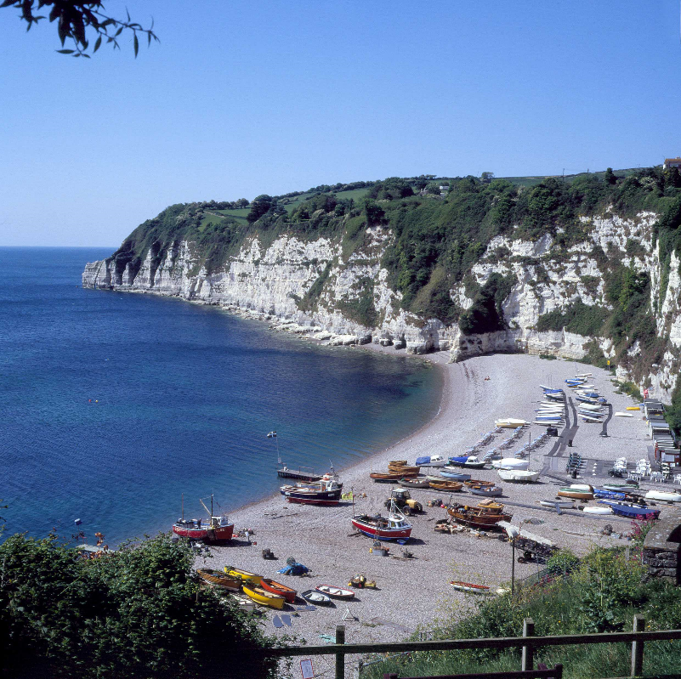
The area of Lyme Bay just off the coast of Beer falls within the Poole Bay to Lyme Bay Reefs, draft Special Area of Conservation (dSAC). The Poole Bay to Lyme Bay Reefs dSAC contains “mosaic of four areas containing extremely diverse reef habitats, comprising many geological and topographical forms, and nationally important sea caves”. One of these habitats, Lyme Bay Reefs, has a boundary along the low water mark in the south of the Parish.
Lyme Bay Reefs is proposed as an SAC as a result of its reef features, which range from cobbles and boulders to different types of bedrock. They support a wide range of seabed animals, including corals, such as the pink sea fan and sunset coral, sponges and bryozoans (‘moss animals’). Some of these species are long-lived and slow growing, which makes them particularly vulnerable to damage from human activities. The rich seabed communities also support a range of commercially important species such as scallop, crab and lobster.
We anticipate the area being a focus of marine conservation.
We are happy to accommodate this as long as any development associated with long-term marine conservation does not detract from the natural beauty and amenity we wish to protect.

Policy MS4 – Marine Conservation
Development proposals that facilitate and enhance marine conservation will be supported where they do not have a significant harmful impact on the Beach and the surrounding environmental features and assets.

Visitor Facilities and Amenities

Justification for our Policy
We welcome visitors and tourists and want to ensure that we continue to provide facilities and amenities to enhance the visitor experience. Consistent with our policy MS1 and general approach to protecting the coastline’s special character, any development proposal to provide visitor facilities and amenities must be of the right scale and of a quality to make a positive contribution to its setting. The Beer Village Design Statement provides guidance on how that may be achieved. We expect any development proposal to conform to the criteria set down in the Design Statement which is to be reviewed and updated alongside the Neighbourhood Plan consultation process. The need to protect the parish’s designated bathing waters must be taken into consideration in any development. Proposals related to the protection of the bathing water quality will be supported.

Policy MS5 – High Quality Visitor Facilities and Amenities
Development proposals to provide visitor-related facilities or amenities should demonstrate how they:
- have taken the Beer Design Statement into account; and,
- comply with the requirements set in Policy HBE1.

Beach Access

Justification for our Policy
We are supportive of measures that improve accessibility and enable everybody to enjoy the amenity of the Beach and the public areas of the coastline. The space and gradient requirements of mobility vehicles need to be taken into account when new facilities and amenities are provided (see policy TP4). Any development should be consistent with other policies in the Neighbourhood Plan, unless a special exception can be justified.

Policy MS6 – Access to the Beach and Connected Public Areas
Development proposals aimed at making access easier and safer to the Beach and its facilities, or the public areas shown in Figures 6 (which includes Jubilee and Sea Hill) will be supported, provided they do not negatively impact upon the Jurassic Coast World Heritage Site and the landscape character and setting of the area.

Marine-related Activity

Justification for our Policy
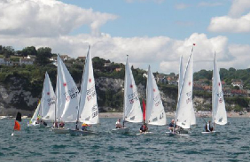
Ensuring the beach remains a safe working environment is important. Response to our consultation on the Plan’s draft aims and objectives showed that local people were keen to see the beach area remain a working environment. The development of facilities that enable marine-related activities in the interests of providing local jobs and contributing to the local economy have our support in principle. Any development at the Beach area in furtherance of such marine-related activity should not result in a harmful impact on other beach-related activities. They should also comply with other policies in the Neighbourhood Plan and conform to the Beer Village Design Statement 2015.

Policy MS7 – Marine-related Activities

The development of facilities which support marine-related activities, which demonstrate benefits to the local economy, on or adjacent to the Beach will be supported provided that the development would not have significant harmful impacts on:

- the Beach and surrounding environmental features and assets;
- the visitor experience;
- the amenities of residents and other neighbouring uses; and,
- existing commercial fishing operations.

Key supporting evidence

Shoreline Management Plan Review, Halcrow, 2011
Parish Biodiversity Audit for Beer, Devon County Council, 2010
Beer Community Survey Report, Beer Parish Council, 2014
Beer NP Aims and Objectives Consultation, 2015
Beer Tourism Survey 2016
Related national, district and AONB policies

National Planning Policy Framework
Para 28 – supporting the provision and expansion of tourist and visitor facilities in appropriate locations
Para 94 – adopt proactive strategies to mitigate and adapt to climate change taking full account of flood risk, coastal change
Para. 105 - apply Integrated Coastal Zone Management across local authority and land/sea boundaries
Para 106 – avoiding inappropriate development
Para 114 - maintain the character of the undeveloped coast…. and improve public access to and enjoyment of the coast
Para. 168 - Shoreline Management Plans should inform the evidence base for planning in coastal areas

National Planning Practice Guidance
Para: 078 Ref: 7-078-20140306 - neighbourhood plans should avoid allowing inappropriate development in areas vulnerable to coastal change or adding to the impacts of physical changes to the coast
Para: 006 Ref: 26-006-20140306 – good design can help achieve access and inclusion
Para: 012 Ref: 26-012-20140306 - Planning should promote access and inclusion

East Devon Local Plan
Strategy 6 - Development within Built-Up Area Boundaries
Strategy 44 - Undeveloped Coast and Coastal Preservation Area
Strategy 45 - Coastal Erosion
EN25 – Development Affected by Coastal Change
RC4 - Recreation Facilities in the Countryside and on the Coast
TC2 - Accessibility of New Development

East Devon AONB Management Plan
Key Objective – conservation and enhancement of the high quality and internationally significant coastline
Policy C2 – maintain highest standard of bathing water and litter management

Marine and Coastal Access Act and the UK Marine Policy Statement

Heritage and Built Environment

Aims

Aim 5: Establish the limits of development.

Aim 6: Encourage and support good design recognising local characteristics while not ignoring contemporary ideas.

Aim 7: Support more outdoor activities.
:
Aim 8: Encourage small scale renewable energy installations wherever they are appropriate.

Objectives

Objective 5.1: Maintain a tight development boundary in the direction of Seaton to prevent the merging of the two communities either actual or perceived.

Objective 5.2: Ensure there is no building to the east of existing built-up area boundary (and ensure a green wedge between Beer and Seaton).

Objective 5.3: Ensure that all new development sites are of an appropriate scale in-keeping with surroundings (i.e. number of dwellings) but adequate in space standards.
Objective 5.4: Support development where it provides affordable homes conditioned for local occupancy.

Objective 6.1: Insist on traditional design in the Conservation Area.

Objective 6.2: Ensure the design of new development is of a high standard.

Objective 6.3: Allow dormer windows with pitched roofs.

Objective 6.4: Allow extensions where they comply with the agreed design standards.

Objective 6.5: Promote the use of local materials such as Beer stone, flint and chert and resist block walls or render.

Objective 7.1: Allow pavements to be used for business purposes e.g. tables for cafes.

Objective 8.1: Encourage solar panels where not visually intrusive. In the Conservation Area, only support them where they do not detract from the visual appearance of Beer.

Objective 8.2: Small-scale wind turbines will be supported in principle, but only outside the built-up area and where they will not compromise the beauty and value of the Jurassic Coast & AONB.

Neighbourhood Plan Policies

Beer – Seaton Local Gap

Justification for our policy

Our 2014 community questionnaire confirmed that maintaining a “green wedge” between Beer and Seaton is considered to be very important. The Local Plan sets out a policy to prevent coalescence on the coast at various points, with the gap between Beer and Seaton being one of these. The gap enables the two settlements to retain their distinct character and identity and also protects a part of the countryside which falls outside of the AONB boundary but which we consider is of high quality. The Local Plan policy (Strategy 44 – “Undeveloped Coast and Coastal Preservation Area”) reads as follows:

“Land around the coast and estuaries of East Devon, as identified on the Proposals Map, is designated as a Coastal Preservation Area. Development or any change of use will not be allowed if it would damage the undeveloped/open status of the designated area or where visually connected to any adjoining areas. The Coastal Preservation Area is defined on the basis of visual openness and views to and from the sea.”

The defined area in relation to the gap between Beer and Seaton is set out in the Local Plan – see Figure 1 on page 9 of this plan. Local Plan Strategy 44’s designation area is marked by the light blue vertical lines. However, the green gap between Beer and neighbouring Seaton within the Beer Parish boundary is narrow and is of such importance locally that we consider that a policy in this plan is justified¹². The policy provides specificity in relation to the factors which are important to us and what types of development would be acceptable within the defined gap.

Policy HBE1 – Beer Local Gap

To ensure that Beer maintains its separate identity, setting in the landscape and local built character and extent, the designated Built-up Area Boundary will be reinforced to the east and north-east (as identified on Figure 6) to prevent coalescence between Beer and Seaton and maintain a local green gap. Proposals for development (including change of use) which require planning permission will only be acceptable where they:

i) are for measures to prevent coastal erosion in line with policy MS2; or,
ii) propose improvements to access to the countryside in line with policy NE5; or,
iii) are for essential agricultural uses;

And,

iv) do not compromise the visual openness and landscape character of the gap;
v) maintain the character of the undeveloped coast; and,
vi) meet the requirements of policy NE1; and,
vii) meet the requirements set out in Local Plan policy Strategy 44.

__________________________
¹² Beer Parish Council Community Questionnaire 2014
Figure 6 –Beer Local Green Gap
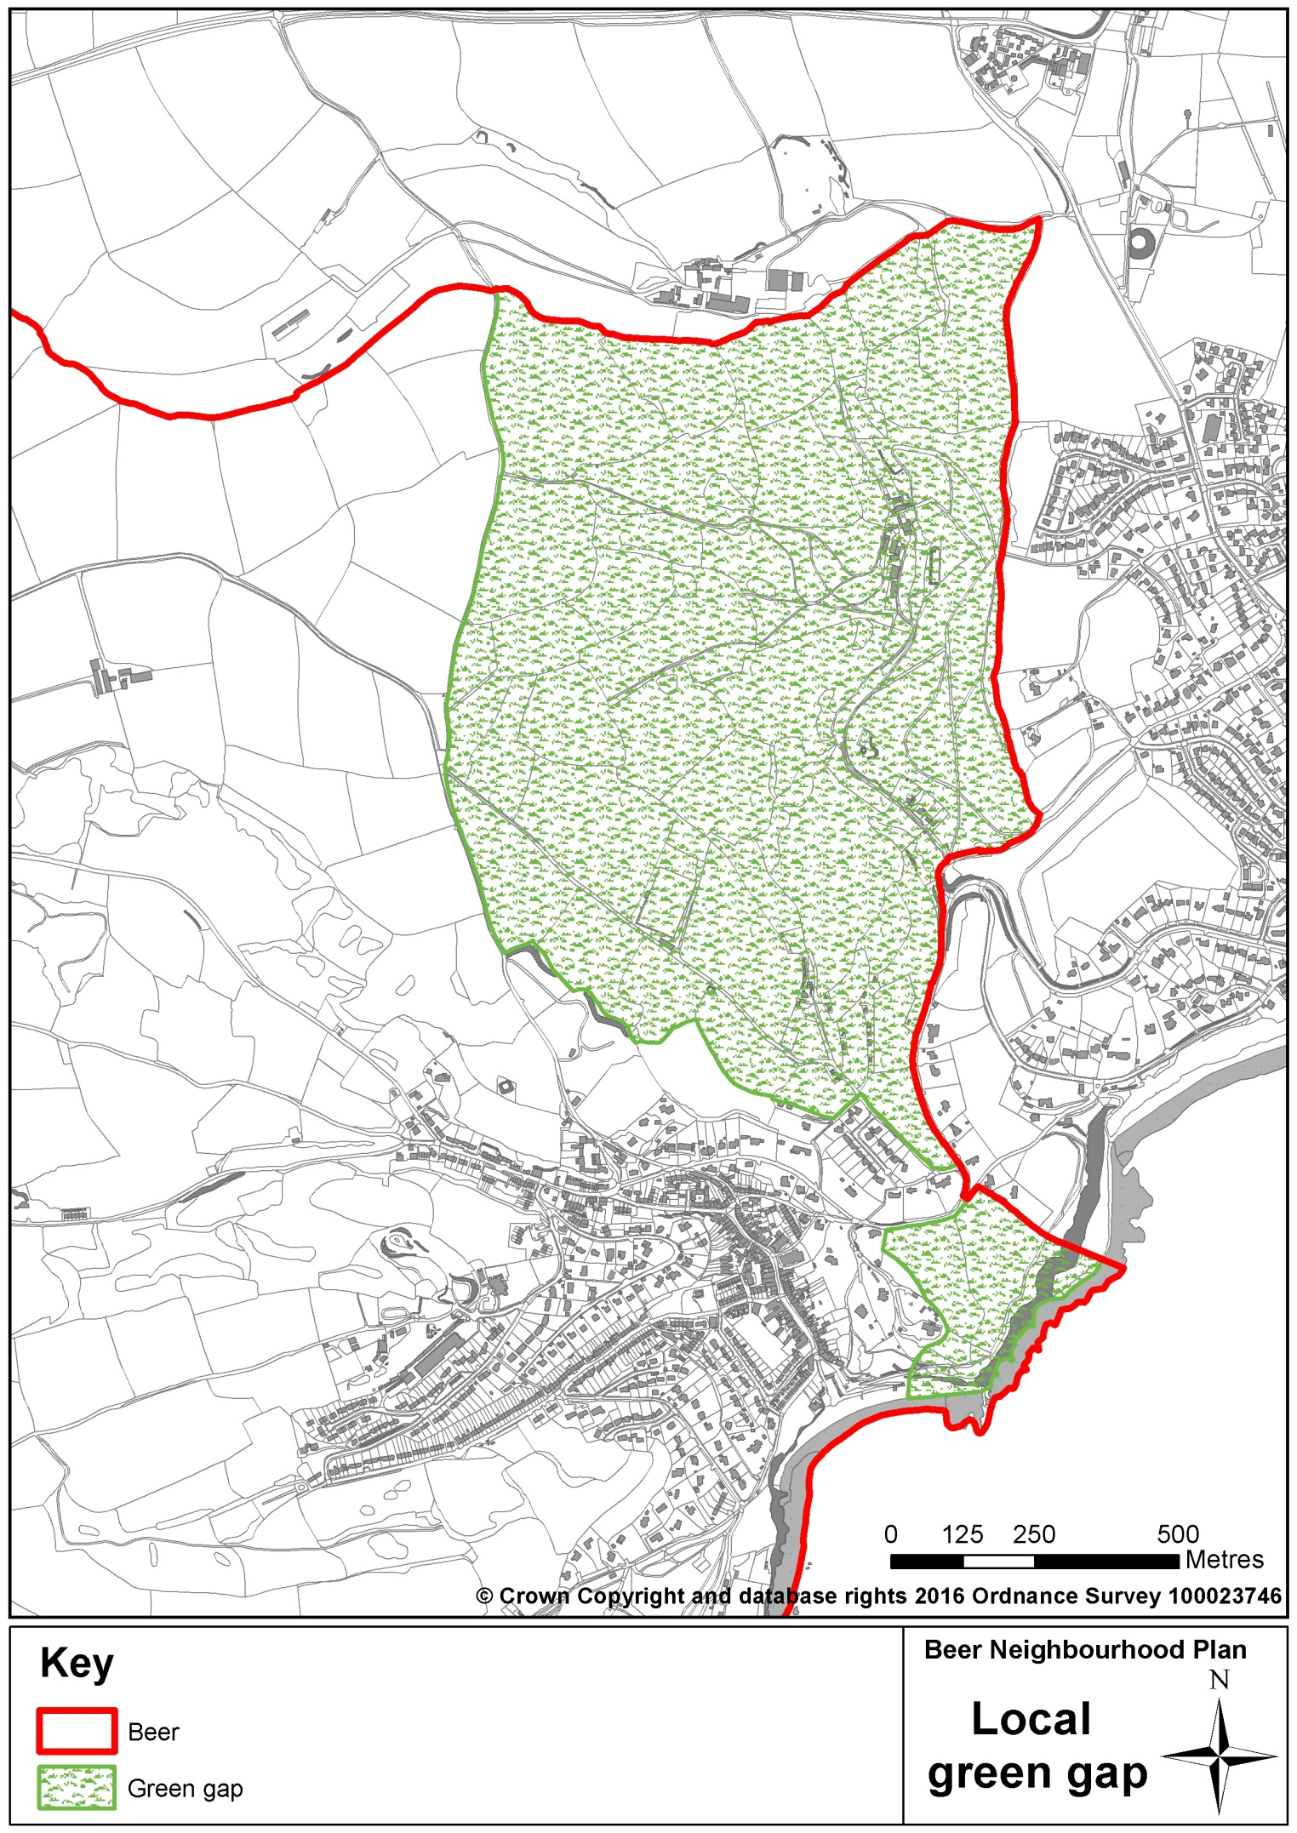
© Crown copyright & database rights [2015] Ordnance Survey [0100057321 EUL]. Use of this data is subject to terms & conditions.

Key supporting evidence

Beer NP Aims and Objectives Consultation, 2015
http://www.beerparishcouncil.org.uk/BeerParish/beer_neighbourhood_plan-20304.aspx

Related national, district and AONB policies

National Planning Policy Framework
Para 106 – reduce risk from coastal change…
Para 109 - planning system should contribute to and enhance the natural and local environment by…
Para 114 – maintain the character of the undeveloped cost…

National Planning Practice Guidance
Para: 078 Ref: 7-078-20140306 - neighbourhood plans should avoid allowing inappropriate development in areas vulnerable to coastal change or adding to the impacts of physical changes to the coast

East Devon Local Plan
Strategy 44 - Undeveloped Coast and Coastal Preservation Area

High Quality Design

Justification for our policy

Historically in Beer, the abundance and variety of local Beer stone ensured a readily accessible supply for buildings. Many of our very old buildings were of sturdy construction and so are still in use. Much of the charm of the village arises from a visible potpourri of architectures and ages bound by the common thread of local materials. Beer Stone, together with other building stones derived from the Upper Greensand that outcrops in the area, are defined as “key building stones” in Devon Minerals Plan, which encourages the small-scale extraction of these stones to support local character.
Significant Architectural Features
Old cottages comprising flint, stone and thatch
Beer stone walling, houses - both structural and decorative
Listed buildings
Arts and crafts houses
The Brook, a canalised old stream flowing alongside Fore Street
Old water conduits and iron tap - remnants of older times
The Draft East Devon Villages Development Plan Document (2014) recognises the special character of Beer that led to much of the village being designated a Conservation Area in 1973 and extended in 1990. It mainly comprises the historic village core centred on Fore Street, the coastal fringe and large houses on the soles to the east and north of the village. Within the existing Conservation Area are some 40 individually listed buildings. The most noteworthy of the listed buildings according to EDDC’s Conservation Area Appraisal are the ecclesiastical buildings of:
- The Parish Church of St Michael built 1876/77;
- The Congregational Church opened 1866;
- The Almshouses and Charity School 1820; and,
- The Cemetery Chapel 1866.

The Conservation Area Appraisal identifies the following “features of special importance” in the village:
- A particularly attractive setting in a narrow valley sloping towards the sea;
- The main street;
- The fast-flowing stream in a narrow channel and the two 18th century conduits;
- Extensive use of Beer stone;
- The considerable Arts and Crafts influence;
- Some good examples of early 20th century housing; and,
- A wealth of mature trees.

The Appraisal concludes that: “….Beer has a number of exceptional qualities. It is therefore essential to maintain adequate conservation disciplines for the future to check any further advances in the erosion of the character of its dramatic natural setting or of what remains of the high quality of built environment.”¹³

_________________________
¹³ Beer Conservation Area Appraisal, East Devon DC, 1999
Figure 7 - Beer Conservation Area Appraisal Map of Historic Building Character

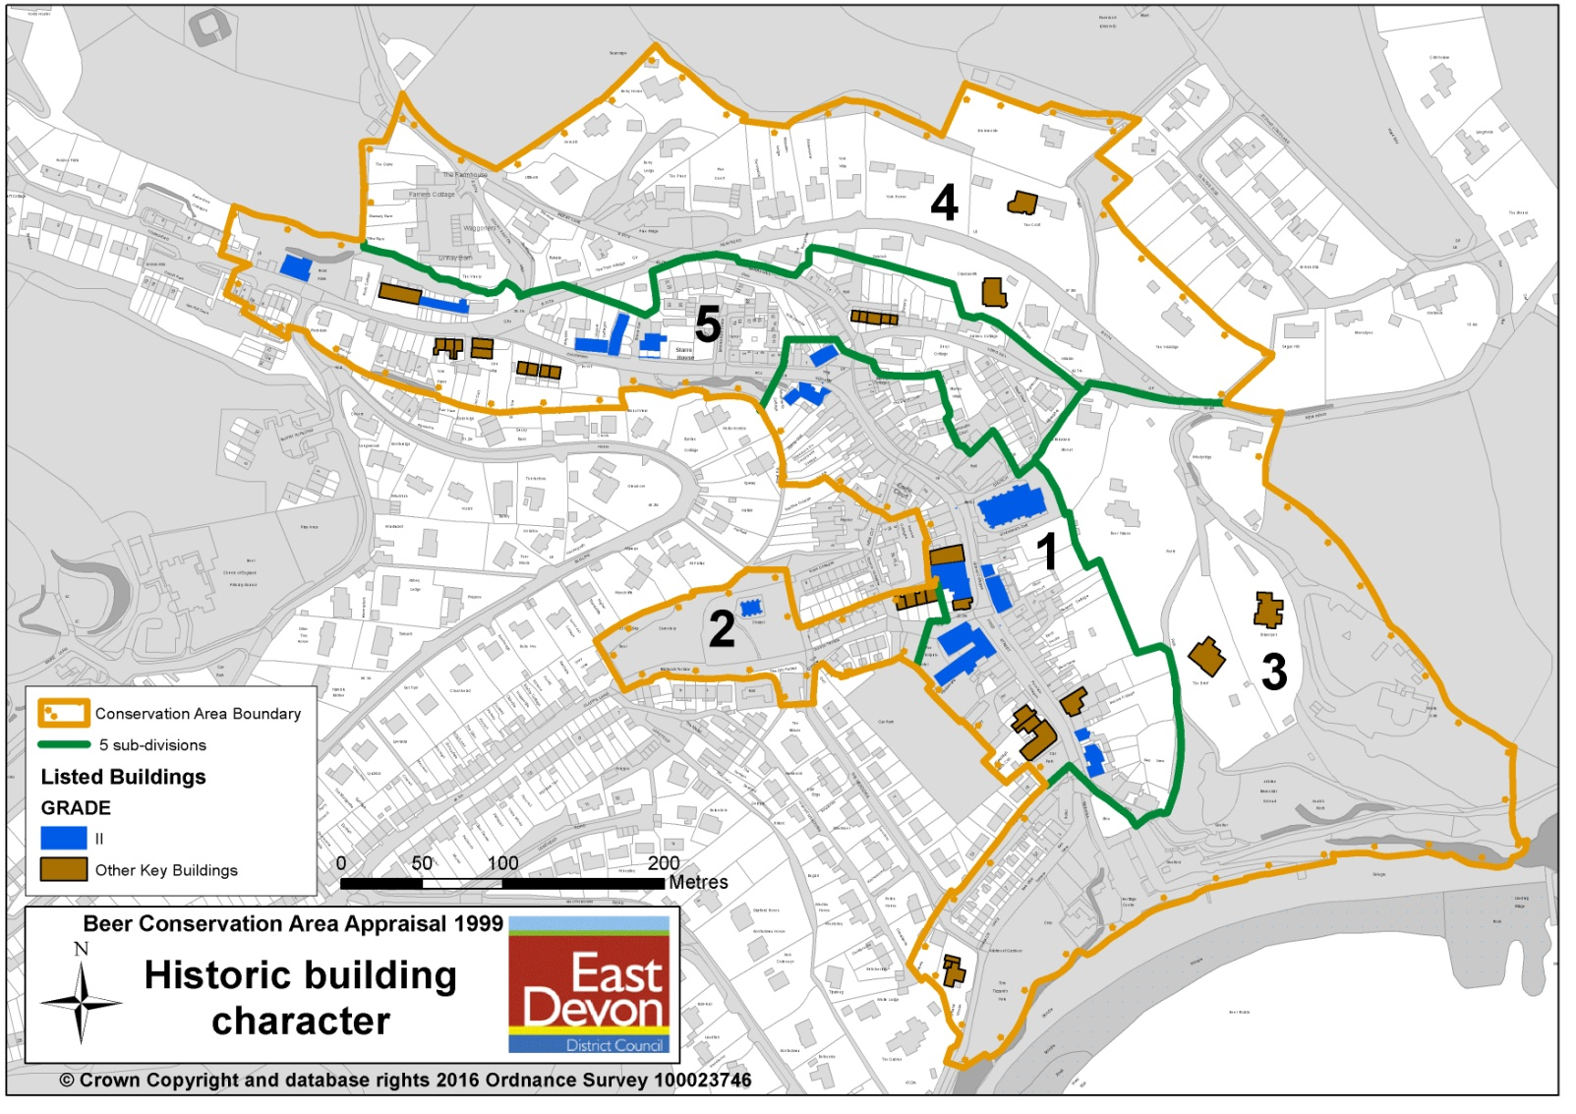
© Crown copyright & database rights [2015] Ordnance Survey [0100057321 EUL]. Use of this data is subject to terms & conditions.

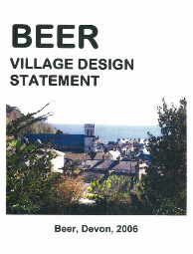
In 2006, the support for the historic and heritage value and overall built character of the village led to the development of the Beer Village Design Statement (VDS). The VDS has provided a set of guiding principles and criteria for the design of development in the village. For example, all development should respect the local character and vernacular, and the high-quality landscape setting of the village, with the use of dressed Beer stone, chert, random flint rubble, slate and painted timber being preferred. New infrastructure, such as wires, should be located underground to avoid their proliferation spoiling the skyline.

As part of this Neighbourhood Plan, the Statement has been reviewed and shared again with the community to determine whether it needs updating and to consider whether the guidance can be applied across the wider parish. The Statement sets out guiding principles and ‘policies’ relating to what we consider to be high quality design in the Beer context should any new development be proposed. We intend to adopt the revised guidance as a supplementary document to this plan and it is referenced in policy BHE1 to ensure that the Statement carries weight in the planning process alongside this plan.

The National Planning Policy Framework provides significant support for the protection of heritage assets and the importance of good design. One of the twelve core principles of planning is stated as being that it should “conserve heritage assets in a manner appropriate to their significance, so that they can be enjoyed for their contribution to the quality of life of this and future generations”. Another states that planning should “always seek to secure high quality design and a good standard of amenity for all existing and future occupants of land and buildings.” Our policy HBE1 responds positively to these objectives in the context of Beer and sets a series of criteria that any proposals for development must take into account.

Policy HBE2 – High Quality Design

To ensure that new development is sympathetic to the traditional and historic built character and landscape of the parish, development proposals will be supported where they are of high quality design, enhance visual amenity of the setting and minimise any adverse visual impact on locally valued character, and on neighbouring properties to the proposed development site.
To be considered as high-quality design, development proposals should meet the requirements set out in the Beer Village Design Statement. Particular attention should be paid to:
- ensuring that the size, height, density, scale and location of the development is appropriate to the form, scale and setting of the surrounding built environment, respecting key characteristics such as (but not limited to) steeply pitched roofs with deep soffits and small paned windows;
- ensuring that materials and design of the development are in-keeping with the character of the surrounding built environment, with a focus on the use of local materials such as Beer stone (where available), flint and chert and resisting block walls or render;
- ensuring that it is designed in such a way as to minimise its impact on the skyline, on the visual amenity of the surrounding landscape, on views of the proposed development and on the natural environment;
- ensuring the use of traditional design in the Beer Conservation Area and preserving or enhancing the essential character of the Conservation Area; and,
- ensuring the support of development which shows a high degree of sustainability.

Key supporting evidence

Beer Village Design Statement, Beer Parish Council, 2006
Beer Neighbourhood Plan Aims and Objectives Consultation 2015
Draft East Devon Villages Development Plan Document, East Devon District Council, 2014

(The content of this and other relevant written evidence is summarised in the Beer Local and Strategic Written Evidence Reports)
Related national, district and AONB policies
National Planning Policy Framework
Paragraph 17 - always seek to secure high quality design
Paragraph 56 - good design is a key aspect of sustainable development
Paragraph 57 - achieve high quality and inclusive design for all development
Paragraph 66 - designs should take account of the views of the community

National Planning Practice Guidance
Paragraph: 001 Good quality design is an integral part of sustainable development
Reference ID: 26-001-20140306
Paragraph: 007 Planning should promote local character (including landscape setting)
Reference ID: 26-007-20140306
Paragraph: 030 Good design interprets and builds on historic character, natural resources and the aspirations of local communities
Reference ID: 26-030-20140306

East Devon Local Plan
Strategy 48 - Local Distinctiveness in the Built Environment
D1 - Design and Local Distinctiveness

East Devon Management Plan
Policy P1

Devon Minerals Plan Policy M15 Supply of Building Stone.

Sharing use of Pavements for Business and the Social Economy

Justification for our policy
We are intent on maintaining and enhancing our vibrant village centre, building on the high quality of our built environment, for the benefit of residents and visitors. Our community questionnaire results found that there is a majority of support for parts of Fore Street in Beer village to be used for a range of outdoor leisure activities (including dining). There is also recognition of tourism being important to Beer. We therefore support the principle of shared use of pavements to foster an open-air culture for residents and visitors. However, we also recognise that there is limited space on pavements to allow shops, cafes and restaurants to advertise freely and seat people outside their premises. Accessibility in the village centre is important if the village is to remain a welcoming and accessible place for residents to use and a popular place to visitors.

Not all outdoor advertisements and signs require planning permission and the Planning Portal has advice about when planning permission is needed¹⁴. Temporary and small signs often do not need permission, but whether or not signs and advertisements do need permission, they must comply with five ‘standard conditions’.
___________________________
¹⁴ See http://www.planningportal.gov.uk/permission/commonprojects/advertssigns/ If there is any doubt about whether permission is needed, applicants are advised to discuss proposals with the local authority, East Devon District Council

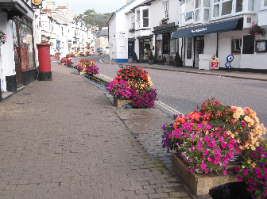
They must be: kept clean and tidy; be kept in a safe condition; have the permission of the owner of the site on which they are displayed (this includes the Highway Authority if the sign is to be placed on highway land); not obscure, or hinder the interpretation of, ofﬁcial road, rail, waterway or aircraft signs, or otherwise make hazardous the use of these types of transport; and, be removed carefully where so required by the planning authority. Policy D4 of the Local Plan sets out a policy for the display of advertisements and includes a number of criteria which must be met for permission to be granted which include factors related to amenity and safety.

The placement of tables and chairs on the pavement or highway in relation to cafes and restaurants (or any food and drink establishments) may involve several different types of consent, permission or licences. This may include consents outside the planning system such as a Tables and Chairs Licence required under the Highways Act 1980, a premises licence (where alcohol or late-night food or drink is served) or licences for some forms of entertainment. Where tables and chairs are placed on the pavement or highway, planning permission will normally be required because it introduces a change of use of the land and this should be sought prior to application for other consents.

With these issues in mind, our policy HBE2 is designed to work with policy D4 of the Local Plan and focuses on issues of particular importance to us locally and within the context of Beer village centre. While pedestrian safety is dealt with in the Local Plan policy, the issue of accessibility is not and so our plan also emphasises this factor in the consideration of advertisements and outdoor seating, where these require planning permissions. The Beer Design Statement deals with development in relation to the character of the built environment and should also be considered where proposals for advertisements and outdoor seating are made.

Policy HBE3 – Sharing use of Pavements for Business and the Social Economy

Development proposals for the shared use of pavements for business purposes, such as tables and chairs for food and drink establishments or advertisements / signs, will be supported where satisfactory arrangements can be made to allow the safe movement past the area by pedestrians, people with impaired mobility and people with mobility vehicles.

Key supporting evidence

Beer Neighbourhood Plan Community Questionnaire, December 2014
Beer Neighbourhood Plan Aims and Objectives Consultation 2015

(The content of this and other relevant written evidence is summarised in the Beer Local and Strategic Written Evidence Reports)
Related national and district policies

East Devon Local Plan
D4 – Applications for Display of Advertisements

Renewable and Low Carbon Energy

Justification for our policy

We recognise the importance and value that renewable and low carbon energy schemes (and improvements to energy efficiency of buildings where done sensitively) can have to help provide alternatives to fossil based fuels and therefore help reduce carbon dioxide emissions, improve the security of energy supply, reduce household bills for energy, generate an income for community organisations and businesses and reduce the cost of supply of energy.

From a list of renewable and low carbon technologies, our community questionnaire results highlighted most support for smaller scale technologies and installations, rather than larger scale ‘farms’ for solar and wind.¹⁵ Only 12% of respondents supported no renewable or low carbon technologies. Community consultation has therefore shown support for small scale local community energy schemes, domestic and commercial energy generation.
Examples of Scale of Renewable and Low Carbon Technologies

Biomass
Large scale = 10 - 40 MW electricity generating plant
Small scale = domestic, community and commercial premises boilers, stoves and combined heat and power

Solar photovoltaic (electricity generation) and solar heat (tubes)
Large scale = whole field solar arrays for commercial generation
Small scale = domestic, community and commercial building roof mounted, vertical or fixed vertical array on agricultural land used for generation for farm buildings

Wind
Large scale = 25m – 135m in height
Small scale= 12m – 25m
Micro scale = less than 11m

In practical terms, different types of renewable and low carbon energy installations will be suitable in different built and natural landscapes. We have set out how we value our natural landscape and environment in Beer and the policy we have developed on energy proposals reflects this position and our desire to be supportive of smaller scale renewable and low carbon energy schemes in appropriate places. Such proposals can help to contribute positively to the rural sustainability of our community. However, this cannot take place at the cost of damaging our valued local landscape and character of our village, and so our policy sets a series of parameters within which proposals for such technologies will be tested.

On 18th June 2015, the Government introduced a requirement for local planning authorities to only grant planning permission for wind energy development if: the development site is in an area identified as suitable for wind energy development in a Local or Neighbourhood Plan; and, following consultation, it can be demonstrated that the planning impacts identified by affected local communities have been fully addressed and therefore the proposal has their backing.¹⁶ Notwithstanding this policy position, our policies on energy still cover proposals for wind turbines and provide additional and locally specific tests to ensure that, should any such proposals come forward during the Neighbourhood Plan period, and national policy or Local Plan policies change, there are criteria in place against which applications can be appropriately tested. We consider large scale wind turbines to be inappropriate in landscape terms in the parish and we have not allocated any land for the development of such schemes.

_________________________
¹⁵ For example, our 2014 community questionnaire results showed 63% of respondents supported solar panels on homes, 62% supported solar panels on commercial land farm buildings, 47% solar hot water tubes (heating), 37% small wind turbines under 25m (82 feet), 35% bio-mass community heating and 28% agricultural land solar arrays on a small scale. Large solar farms received only 12% support and large-scale wind farms only 10%. 12% support none of the technologies listed.
¹⁶ See the following link to the Government’s announcement, reference HCWS42 http://www.parliament.uk/business/publications/written-questions-answers-statements/written-statement/Commons/2015-06-18/HCWS42/

Policy HBE4 – Renewable and Low Carbon Energy

Development proposals for small-scale domestic, commercial and community renewable and low carbon energy generation will be supported where:

- the proposal complies with the other policies in this Plan;
- the proposal is located within the curtilage of a building;
- the proposal is sensitively sited and there are no adverse impacts on landscape character, wildlife, habitats and biodiversity, the Jurassic Coast and Area of Outstanding Natural Beauty, or it can be demonstrated that impacts can be satisfactorily mitigated;
- the number, siting, scale and design of installations and associated infrastructure and buildings have no adverse impact on (or any adverse impacts can be mitigated):
- local amenity (including visual amenity, noise, vibration, electromagnetic interference, shadow flicker, reflection);
- nearby dwellings;
- the enjoyment of or access to public rights of way and other access routes; and,
- public safety.

Key supporting evidence

Devon Landscape Character Assessment, Devon County Council
Accommodating Wind and Solar PV Developments in the Devon Landscape: Advice Note
Beer Neighbourhood Plan Community Questionnaire, December 2014
Beer Neighbourhood Plan Aims and Objectives Consultation 2015

(The content of this and other relevant written evidence is summarised in the Beer Local and Strategic Written Evidence Reports)
Main related national, district and AONB policies

National Planning Policy Framework
Paragraph 97 - to help increase the use and supply of renewable and low carbon energy, local planning authorities should recognise the responsibility on all communities to contribute to energy generation from renewable or low carbon sources…

East Devon Local Plan
Strategy 39 - Renewable and Low Carbon Energy Projects

East Devon AONB Management Plan
Policy EQC1

Housing

Aims

Aim 9: Increase accessibility and affordability to housing for local people.

Aim 10: Support a supply of smaller dwellings to meet local needs.

Objectives

Objective 9.1: Support development where it demonstrates it is fulfilling an identifiable local housing need.

Objective 9.2: Ensure provision of an appropriate mix of dwelling sizes, tenures and external space.

Objective 9.3: Ensure new dwellings are designed to be compatible with their immediate surroundings.

Objective 9.4: Support the development of affordable rental and shared equity/ownership housing.

Objective 9.5: Ensure that all housing developments provide at least the maximum proportion of affordable housing required by local plan policies and that rents or sales mechanisms are in line with national guidance.

Objective 9.6: Control the allocation of affordable housing to give people with local connections highest priority.

Objective 9.7: Support community initiatives including CLT’s and other community housing schemes.

Objective 10.1: Support sympathetic conversions and extensions.

Objective 10.2: Ensure special needs (including the requirements of the elderly) are given appropriate consideration in the design of buildings and developments.

Objective 10.3: Allow conversions/change of use from commercial to residential, but only where the commercial use is proven to be no longer viable.

Introduction: Planning Policy Context for Housing in Beer

The East Devon Local Plan sets the context for housing development in Beer. It provides a ‘strategic framework’ for development, with this Neighbourhood Plan providing more detailed local policies where consultation has suggested a need and where it is considered necessary in light of policies already contained in the Local Plan.

In 2012, a version of the Local Plan had suggested that 40 dwellings could be accommodated in Beer, which received support, in principle, from the local community following an East Devon District Council consultation. Since that time, East Devon District Council was required, by the Local Plan Examiner, to revisit the strategy and level of development proposed for settlements. This review has resulted in a revised policy in the most recent version of the Local Plan which draws back from setting a figure for new housing development in Beer.

The adopted Local Plan policy Strategy 27 “Development at the Small Towns and Larger Villages” now identifies Beer as one of a list of settlements that offers a range of facilities and services to meet many of the everyday needs of residents. The policy states that the village will have a built-up area boundary to be designated in the forthcoming East Devon Villages Plan, which has been submitted by the District Council to the Secretary of State for Communities and Local Government (via the Planning Inspectorate). The Parish Council is supportive of the proposed revised boundary which is based on historic and current consultation and shown in Figure 8.

Figure 8 – Beer Village Built-up Area Boundary
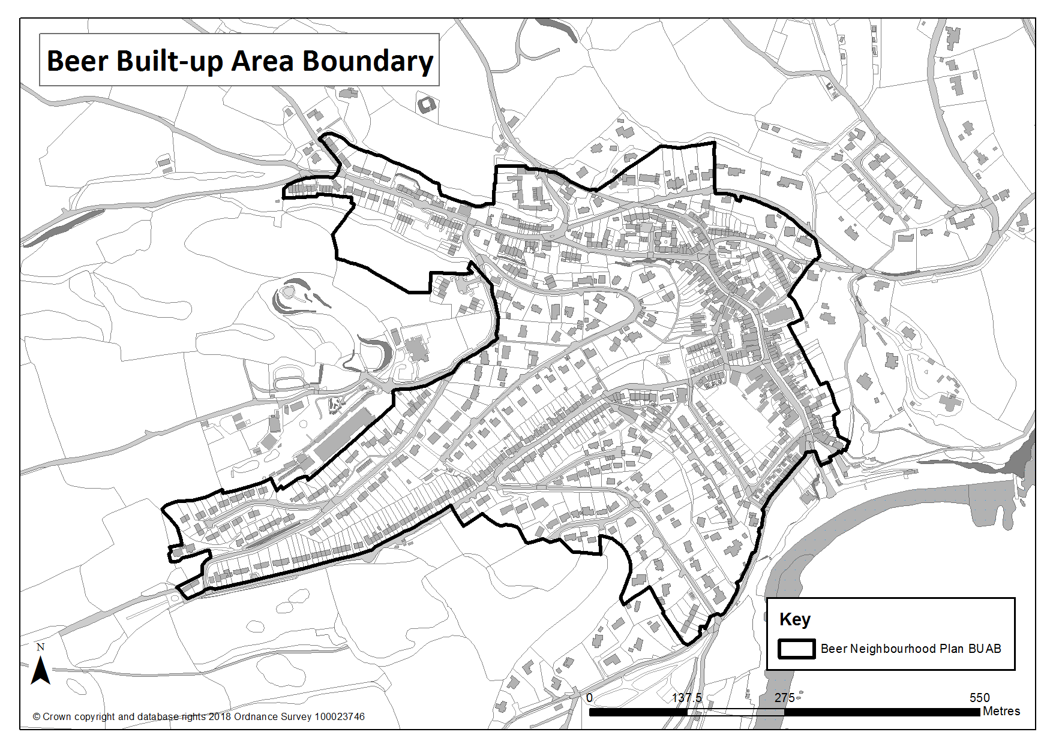
© Crown copyright & database rights [2015] Ordnance Survey [0100057321 EUL]. Use of this data is subject to terms & conditions.
Strategy 27 also goes on to say that Beer will not have land specifically allocated for housing development in the East Devon Villages Plan and that “If communities wish to promote development other than that which is supported through this strategy (the Local Plan) and other strategies in the Plan (at the settlements listed above or any other settlement) they will need to produce a Neighbourhood Plan or promote community led development (for example Community Land Trusts) justifying how and why, in a local context, the development will promote the objectives of sustainable development.” So, having reached a level of agreement, in principle for around 40 dwellings to be built in Beer in the next 10-15 years, the Local Plan does not now set a number.

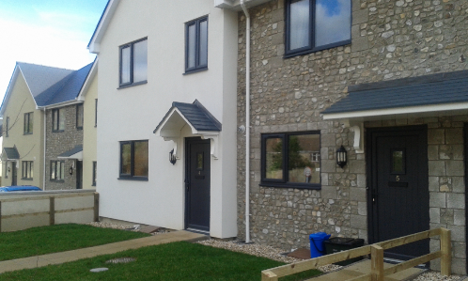
Therefore, the policy position outlined in the adopted Local Plan is for no specific housing site allocation for Beer. In our community questionnaire of 2014 only 12% of respondents support additional open market housing. Despite this, the community were agreeable to further development to achieve the delivery of affordable housing to meet the needs of local people during the lifetime of this neighbourhood plan. However, we need to recognise that a small amount of market housing may be needed to make delivery of affordable housing viable.

Community consultation in recent years (see Key supporting evidence) has suggested that where market housing is developed, there is a community desire to see new homes being used for permanent occupation or short-term continual holiday lets for most of the year to eliminate predominantly empty second homes within housing estates.

Neighbourhood Plan Policies
Meeting the Demand for Local Needs/Affordable Housing through the allocation of Affordable Housing Sites
Justification for our policy

Strategy 34 of the Local Plan “District-wide Affordable Housing Provision Targets” states that 50% of new dwellings within the built-up area boundary (of Beer) should be affordable. The strategy then suggests that the affordable housing to be provided should accord with the district-wide target of 70% social or affordable rent and 30% intermediate or other affordable housing. Affordable housing provision will be subject to viability considerations.

The housing needs survey undertaken in 2013 provides justification for local variance of this broad target. Strategy 35 of the Local Plan provides for mixed affordable and open market housing schemes, in villages and outside of Built-up Area Boundaries. Up to or around 15 dwellings will be allowed where there is a proven local need demonstrated through an up to date robust housing needs survey. Affordable housing must account for at least 66% of the houses built. Where a proposal does not meet the above targets, it will be necessary to submit evidence to demonstrate why provision is not viable or otherwise appropriate.

Our housing needs survey, undertaken in 2013, established that there was then a need for 27 affordable dwellings in the parish of Beer. Of that number, 14 were in immediate need in 2013 and 13 were identified as being needed in the period between 2013 and 2018. In terms of tenure, the need was for 24 to be subsidised (social) rent and 3 shared equity (part-owned). With regard to the size of dwellings identified, 17 x rented homes were needed for single people and couples, 5 x two bedroom and 2 x three bedroom rented homes were needed for families with children, 2 x shared ownership homes were needed for single people and 1 x three-bedroom shared ownership home was needed for a family.

Since 2013, some affordable dwellings have been delivered. Beer Community Land Trust (CLT) was established in 2013 as an Industrial Provident Society with the aim of developing community assets for the benefit of the community, the highest priority being the development of affordable housing. In February 2015, 7 affordable dwellings, 3 of which were available for shared equity and 4 for rent from the CLT, were completed on the edge of the village (Little Hemphay). The use of a CLT for the delivery of such developments means that dwellings can be safeguarded in perpetuity for people with local connections¹⁷ and who live and work in the area. However, there is still a demand for affordable homes in Beer, with (of the 27 identified in the housing needs survey) 20 dwellings still being required for subsidised/social rent in the short-term at least.
Market
Private Sale | Private Rent
“Starter” Homes

Intermediate
Shared Ownership | Shared Equity
Low Cost Sale | Low Cost Rent

Social
Affordable and Social Rent
AFFORDABLE / LOCAL NEEDS HOUSING
Figure 9: Defining Housing Tenures
__________________________
¹⁷ Strategy 35 of the Local Plan states that “… local connection means one or more of the following connections in priority order in respect of parishes or the parish grouping: i) persons who have been permanently resident therein for a continuous period of three years out of the five years immediately prior to the Affordable Dwelling being offered to them; or ii) being formerly permanently resident therein for a continuous period of five years at some time in the past iii) having his or her place of permanent work (normally regarded as 16 hours or more a week and not including seasonal employment) therein for a continuous period of at least twelve (12) months immediately prior to being offered the Affordable Dwelling; or iv) persons who can demonstrate a close family connection to the district in that the person’s mother, father, son, daughter or sibling has been permanently resident therein for a continuous period of five years immediately prior to the Affordable Dwelling being offered to them and where there is independent evidence of a caring dependency relationship.” We support this definition in the context of Beer.

We therefore support development which can comply with policy H1 below to meet the identified needs of local people to 2018 and beyond that date on the basis of up-to-date housing needs assessments being carried out. This policy applies to Beer village as defined within the East Devon Villages Plan built-up area boundary.

Definitions of sustainability such as access to public transport, essential retail, schools and churches are all dependant on having a vibrant, active population. In Beer, maintaining a critical mass of year-round active residents to use and enjoy the facilities of the village, is a key factor in maintaining its sustainability. Without the development of more affordable homes with occupancy conditions, the percentage of holiday homes (currently nearing 25%) will increase, further reducing the number of active residents. Affordable housing with occupancy restrictions, favouring people with family, employment or historic connections to Beer, is an important factor in maintaining social cohesion, family ties and community responsibility, all of which impact significantly on the wellbeing of the residents. Therefore, the provision of affordable housing made available to local people is one of the most important factors in maintaining the viability of a community.

During the development of this plan, the community has demonstrated a desire for the development of more housing but strictly and only on the basis that a significant proportion would be affordable housing. Public consultation in the parish has also consistently identified the need to provide affordable housing with local occupancy conditions as a high priority (see Key supporting evidence). It is also recognised that, except for community led schemes benefiting from a fully discounted site, affordable housing can only be delivered as part of a mixed market housing development. The percentage of affordable houses required within any mixed market scheme has changed over the years. When the prospect was first considered 40% affordable was acceptable (Policy H4 (Affordable Housing) East Devon Local Plan 1995 – 2011) compared to the current 50% or 66% required by the current Local Plan, depending on the location of the site. Local Plan policy allows for issues of viability to be considered if a lesser percentage is proposed.

The need to allocate a site for affordable housing was recognised part way through the production of the Neighbourhood Plan. Following refusal of an application for development at Short Furlong, it became apparent that the new East Devon Local Plan policies could not support development greater than 15 houses outside of the BUAB¹⁸.

Despite Local Authority concerns about potential impact on the landscape, the Parish Council’s preferred site for development is Short Furlong. Further consultation has been necessary to gather the community’s views on this, to consolidate the evidence for more housing and to identify a specific site or sites for potential development. Previous consultation on sites has been undertaken by the District Council in connection with the SHLAA (Strategic Housing Land Availability Assessment)¹⁹ process and the BUAB review²⁰. Therefore, in the summer of 2016, public consultation was held specifically to identify a preferred site for additional housing. The consultation included the four sites originally put forward by land owners in the District Council’s SHLAA process.

_________________________
¹⁸ East Devon Local Plan 2006-26 Strategy 35
¹⁹ The SHLAA is a technical exercise that the District Council is required to undertake periodically to gather information about sites which may become available for housing development. The process identifies potential sites and assesses their suitability in planning terms for development. It does not give planning permission for sites.
²⁰ The SHLAA assessment of the potential sites can be viewed on our website - SHLAA Consultation Report 2012
Figure 10 - Plan showing sites considered in the 2016 public consultation
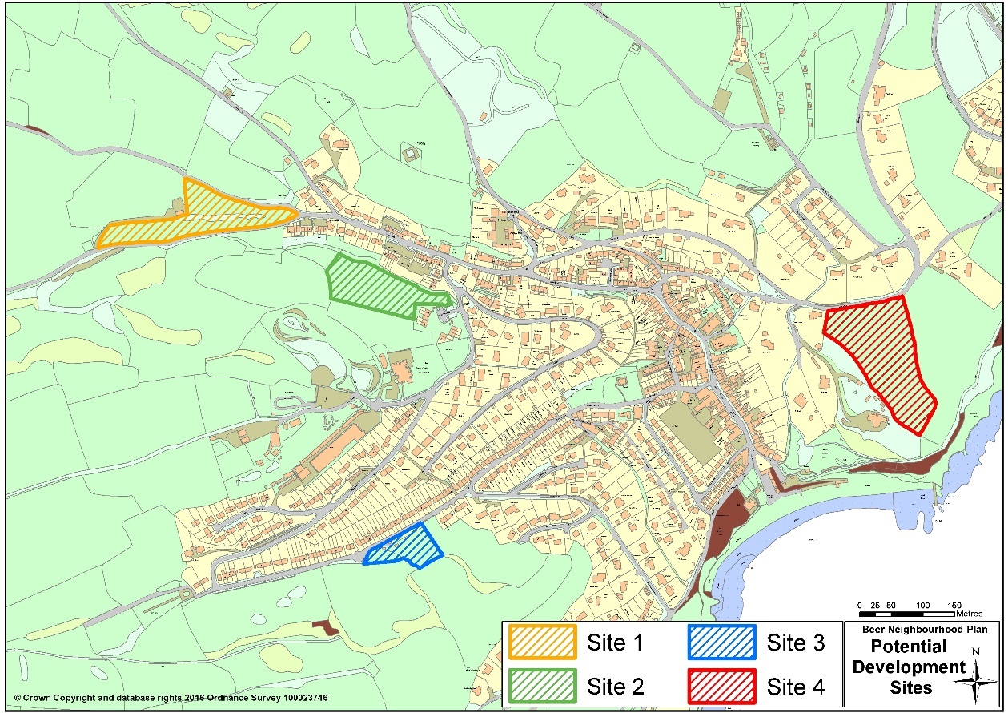

Figure 10 Key:
Site 1: Land between Quarry Lane and Paezens Lane
Site 2: Extension of Short Furlong development to the west
Site 3: Field to the south of Park Road, to the west of Southdown
Site 4: Land off New Road

The consultation asked:
- Do you support additional housing if it includes affordable housing?
- Which of the proposed sites do you prefer?
- Are there any other sites you would prefer?
- What size mix of houses would you prefer?
- What tenure, rental/shared ownership would you prefer?

In summary, the consultation concluded:

- A simple analysis of the preferred house size mix resulted in: 1 bed 10%, 2 bed 35%, 3 bed 45%, 4 bed 10%
- A simple analysis of the preferred tenure mix resulted in: 50% affordable rented and 50% shared equity or equivalent
- 93% of respondents supported additional housing as long as it included affordable housing
- 51% of respondents voted the extension of Short Furlong as their first preference
- Respondents suggested a number of alternative sites but none of these have been put forward by land owners
The consultation report is available on Beer Parish Council website ²¹.

_______________________
²¹ Beer Parish Council NP Consultation Report Summer 2016

Both the SHLAA consultation in 2012 and the Neighbourhood Plan consultation in 2016 addressed the topic of where the community would prefer additional housing to be located in the village, along with questions relating to the mix of housing and other village concerns. Regarding the preferred location, the 2012 consultation included 3 named sites as only these sites had been put forward by land owners. The 2016 consultation included the same 3 sites plus one additional site put forward by a land owner. The Short Furlong extension was the preferred site in both surveys gaining 48% and 45% of the vote. The closest rival site in the 2012 survey, gaining 45%, has significant practical difficulties and was a third choice in the 2016 consultation. The conclusion is that both consultations identified the Short Furlong extension as the preferred site for development and this development must include affordable housing with a mix of tenure and size of dwelling.

The initial advice suggested that for affordable housing development to be delivered at Beer outside the BUAB, site allocation determined through the neighbourhood plan consultation process would be the most appropriate way forward, providing this is what the community desires. Following the additional community consultation confirming the preferred site this advice was amended, suggesting moving the BUAB to include the preferred site thereby allowing any development to be compliant with Local Plan Strategy 35.

There are few opportunities in Beer for development within the current BUAB other than one or two-unit, infill plots. These offer fewer than the 6-dwelling threshold at which affordable housing contributions are required (for developments between 6 & 10 dwellings a contribution towards off site affordable housing will be expected but this can be used District-wide). Development outside of the BUAB, as stated in Strategy 35 is restricted to around 15 houses and subject to a minimum affordable percentage of 66% which should not be reduced on viability grounds.

Development in Beer is also challenging with construction costs above average because of the topography and proximity to the AONB, imposing stringent environmental and design conditions. Issues of economies of scale must also be considered to minimise unit construction costs. The possibility of the viability argument reducing the percentage of affordable houses below the policy target is acknowledged. A figure less than the Local Plan target percentage may be acceptable as we consider that any open market housing development which enables delivery of some affordable housing is better than no development and no affordable houses.

The potential for a developer to deliver a viable housing scheme(s) outside of the BUAB, compliant with Strategy 35, that would provide the number of affordable homes required in Beer is virtually zero given build costs. Our Neighbourhood Plan therefore takes the pragmatic stance of proposing an amendment to the current BUAB to allow Short Furlong (the preferred site following community consultation) to be extended. The plan then goes on to allocate the site for up to 31 houses to be developed complying with Strategy 34 of the local plan. This requires 50% affordable but recognises that the percentage may be reduced subject to viability. The community supports additional development on the basis that a significant proportion of new housing will be made available to meet the local need for affordable housing and that this alone justifies developing in the visually prominent, environmentally sensitive landscape around the village.

Therefore, where viability evidence justifies a lower level of affordable housing than 50%, then this shall be limited to an absolute minimum of 40%. Regarding the mix of tenure of the affordable housing, the district wide target, as stated in Strategy 34 of the local plan may be adjusted depending on local demand and financial viability of the affordable elements of the scheme.

Significant concern was expressed during the consultation process regarding development outside of the current BUAB and the potential adverse environmental effects and the visual impact it could have on the landscape. Whilst the negative issues are acknowledged, the benefit to the village of additional affordable housing must be balanced against any perceived negative impact. Any development proposal must include measures to mitigate any negative impact. The primary consideration for any proposed scheme outside of the BUAB must therefore balance numbers of affordable houses delivered against overall visual impact and mitigation measures proposed.

Environmental Assessments

Our Strategic Environmental Assessment (SEA) tested the suitability of our preferred site against the other sites
identified in the SHLAA. It recognised that while a site allocation potentially has some minor negative effects on
landscape, natural environment and townscape themes, conversely there will be significant positive effects on
housing and community and the vitality and viability of Beer, confirming our thinking set out earlier in this section. In
relation to the Short Furlong site, it concluded²² that it:

“performs well against the majority of SA [sustainability appraisal] objectives, particularly when compared against the reasonable alternatives (the other 3 sites that were consulted on). In providing for much-needed housing, particularly affordable housing for those with local connections, it has a significant positive effect on those for
Housing and Communities, and a synergistic positive effect on the Vitality and Viability of the village.

There is clear tension between provision of housing and with the objectives to conserve land and protect and
enhance the Landscape Character, given that in order to deliver sufficient housing to meet the villages and parish’s
needs, development would need to be on sites outside of the Built-Up Area Boundary of Beer village, and so be in
countryside covered by protective designation including, in the case of Sites 1, 2 and 3, within the AONB. Despite
being within the AONB and having minor negative effect on landscape, the Site Allocation (Policy H3) is assessed as
having less significant impact on Landscape Character than development at any of the alternative sites given their
location and characteristics.”

We were also advised by the District Council to carry-out a Habitats Regulation Assessment (HRA) of our preferred
site for allocation to comply with the EU Habitats Directive, due to the potential impact that its development could
have on the designated Special Area of Conservation (SAC) at Beer Quarry Caves. As a result of its recommendations,
policy H3 has been amended to introduce the last paragraph below to mitigate any potential adverse impact on bats
habitat. Our policies H1 to H3 seek to provide a framework to enable the delivery of affordable housing which matches our objectives set out above.

_______________________
²² See SEA non-technical summary, paragraphs 8.1 and 8.2

Policy H1 – Meeting the Demand for Local Needs Housing in Beer Village
Proposals for new dwellings will be supported where the proposed dwelling or mix of dwellings:
i) help to meet a demonstrable local need for affordable housing based on an up-to-date assessment of need and comprise an appropriate mix of dwellings to respond to this need for specific tenures including:
a) affordable rented; and / or,
b) shared equity;
c) social rent
ii) are of the appropriate house type (detached, semi-detached, terraced, flatted, bungalows, etc.) to respond to local needs;
iii) are of the appropriate size (in terms of number of bedrooms) to accommodate local needs;
iv) are for people with a local connection (as defined in the adopted Local Plan);
v) are of a size, scale and design appropriate to the built character and setting; and,
vi) satisfy the requirements in the adopted East Devon Local Plan.

Proposals within the built-up area boundary will deliver at least 50% affordable housing, in line with Strategy 34 of the Local Plan. If viability evidence justifies a lower level of affordable housing, then this shall be limited to an absolute minimum of 40%. The tenure mix of the affordable housing may be adjusted depending on local demand and the financial viability of the affordable elements of the scheme.

Proposals outside the built-up area boundary should provide at least 66% affordable housing, in line with Strategy 35 of the Local Plan.

Proposers of development should engage with the local community and Parish Council to help ensure that proposals take into account both this plan’s aims and objectives and the views of the local community.

Policy H2 – Community Housing

Proposals for new housing development brought forward to meet a demonstrable local market or affordability need which seek to retain the dwellings as community assets in perpetuity (for example through Community Land Trusts) are supported.

Policy H3 – Site Allocation: Land at Short Furlong
Land at Short Furlong identified in Figure 11 is allocated for up to 31 dwellings with a minimum amount of affordable housing of at least 40% to be provided on-site in accordance with policy H1. Proposals should be informed by detailed Landscape and Visual Impact assessment (noting the sensitivity of the site and Beer in general) in line with current best practice guidance and demonstrate that they will minimise any adverse impacts on the landscape character and visual amenity of the area and skyline. Where this is not feasible satisfactory measures to mitigate adverse impact must be taken.

Proposals will be supported where they:
- provide adequate drainage promoting the use of Sustainable Drainage Systems (SuDS) and ensure no net increase in flood risk;
- provide safe and satisfactory access arrangements;
- deliver high quality design reflecting local building styles and materials;
- retain existing vegetation surrounding the site with new tree and hedgerow planting incorporated into the scheme, to retain and encourage biodiversity and minimise potential impact to the Area of Outstanding Natural Beauty; and
- provide an appropriate level of information on the impact of the proposal on the archaeological interest and heritage asset of the site.

Proposals should be informed by detailed landscape assessment (noting the sensitivity of the site and Beer in general) and demonstrate that they will minimise any adverse impacts on the landscape character of the area and skyline or, where this is not feasible satisfactorily mitigate adverse impact.

Proposals must be supported by a project-level Habitats Regulations Assessment, together with details of any necessary mitigation measures including a Bat Mitigation Strategy which must:
vi) be approved by the Local Planning Authority prior to permission being granted and be subject to implementation through enforced conditions;
vii) demonstrate how the site will be developed in a way that ensures that impacts to bats associated with the
Beer Quarry Caves Special Area of Conservation (SAC) are avoided, including maintaining suitable commuting routes to prevent fragmentation of habitats;
viii) be informed by appropriate ecological survey information and an appropriate lighting assessment;
and,
ix) demonstrate that there will be no adverse effect on the Beer Quarry Caves Special Area of Conservation
(SAC) alone or in combination with other plans or projects.

Figure 11 – Site Allocation: Land at Short Furlong
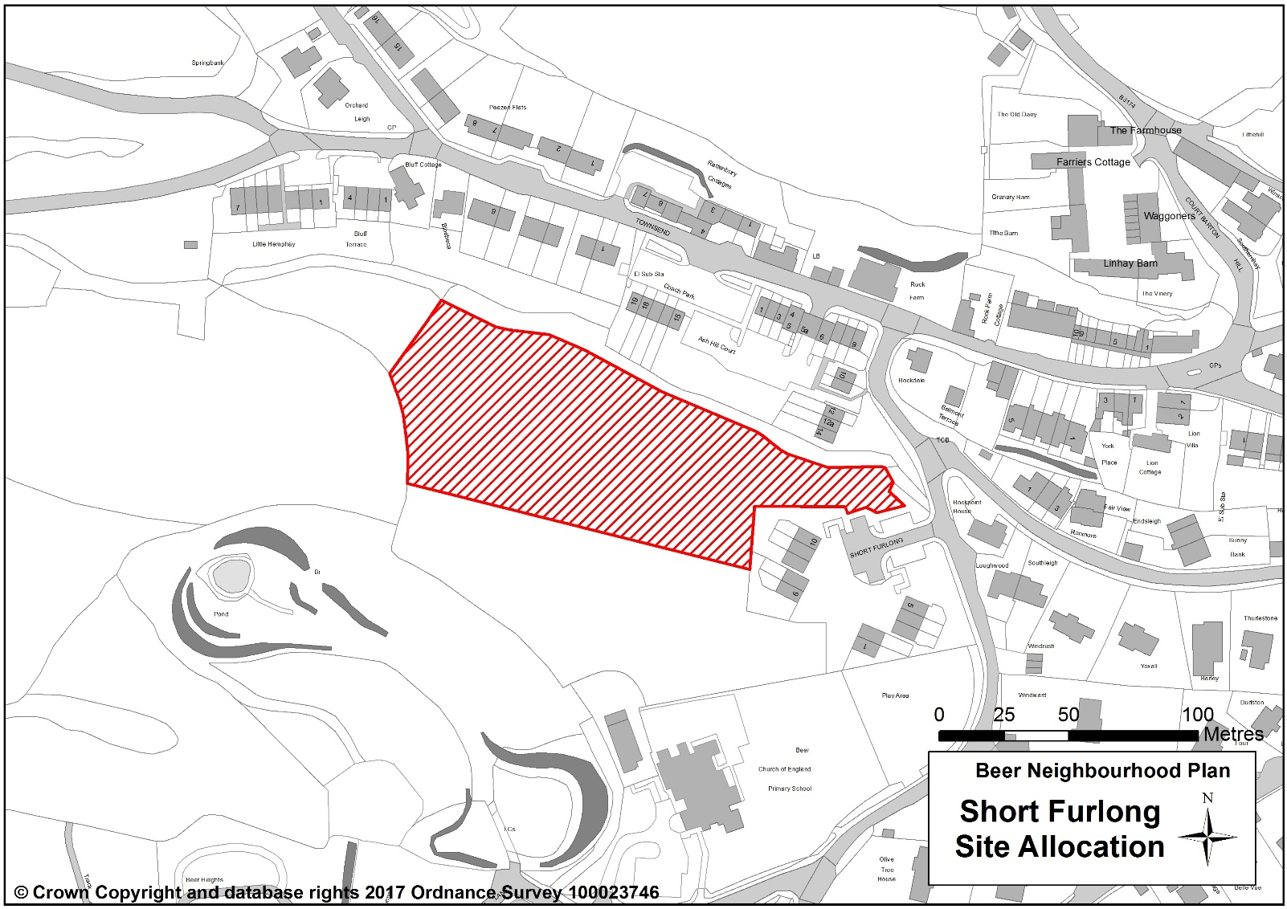

Key supporting evidence (available on Beer Parish Council website)
http://www.beerparishcouncil.org.uk/BeerParish/beer_neighbourhood_plan-20304.aspx
SHLAA Consultation Report 2012
Beer Housing Needs Survey, July 2013
Beer Neighbourhood Plan Community Questionnaire, December 2014
Beer Neighbourhood Plan Aims and Objectives Consultation 2015
Beer Neighbourhood Plan/Housing Sites
Consultation, Summer 2016
Sustainable Drainage Systems:Guidance for Devon
https://new.devon.gov.uk/floodriskmanagement/sustainable-drainage/
CIRIA SuDS manual
https://www.ciria.org//memberships/The Suds Manual C753

Strategic Environmental Assessment 2017
Habitats Regulations Assessment 2017

(Written evidence is summarised in the Beer Local and Strategic Written Evidence Reports)
Related national, district and AONB policies

National Planning Policy Framework
Paragraph 55 - To promote sustainable development in rural areas, housing should be located where it will enhance or maintain the vitality of rural communities….

East Devon Local Plan
Strategy 3 – Sustainable Development
Strategy 4 – Balanced Communities
Strategy 7 – Development in the Countryside
Strategy 35 – Exception Mixed Market and Affordable Housing at Villages, Small Towns and Outside Built-up Area Boundaries
Strategy 27 – Development at the Small Towns and Larger Villages
Strategy 34 – District-wide Affordable Housing Provision
Strategy 38 - Sustainable Design and Construction
EN22 - Surface Run-Off Implications of New Development

East Devon Villages Plan

Meeting the Special Needs of People in Housing Design

We are aware that new housing should be designed ensuring that the needs of the current population with mobility and accessibility challenges are met and also to help accommodate the needs of our growing ageing population. To that end, we support Strategy 36 of the Local Plan “Lifetime (accessibility and adaptable) Homes and Care / Extra Care Homes” which sets out the requirements for housing developments’ accessibility standards in alignment with Part M/2 of Building Regulations. It requires that on sites of 10 dwellings or more, all affordable housing and around 20% of any market housing must meet such standards unless viability evidence demonstrates otherwise.

Change of Use from Commercial to Residential Use in the Village Centre

Justification for our policy

We value the shops, other retail and commercial premises we have in the village of Beer. Their mix and presence make Beer a sustainable local community and an attractive offer to visitors, recognised by policies in the Local Plan and the East Devon Villages Plan. Our 2014 community questionnaire responses suggest support for the retention and improvement of our facilities and services in the village. For example, 91% of respondents said that daily shopping needs were adequate, good or very good, 73% said that business services are adequate, good or very good and 59% said that banking and financial services were poor and thus perhaps require some protection from loss, as far as the planning system can achieve this in land-use terms.

While we have not had any recent proposals in the village to convert premises to dwellings, we would like to see business and commercial premises retained, not only for their contribution to the local community and visitors, but for the role they play in local employment and the overall built character of the village. Policy E14 in the Local Plan “Change of Use of Village Shops or Services” and draft Policy 5 in the East Devon Villages Plan provide a level of protection of such uses which we consider is appropriate in Beer. In addition, paragraph 28 of the National Planning Policy Framework supports local rural communities to promote a strong economy through Neighbourhood Plans by encouraging them to “promote the retention and development of local services and community facilities in villages, such as local shops, meeting places, sports venues, cultural buildings, public houses and places of worship.”

As this Neighbourhood Plan is being written, the Local Plan has just been adopted and the East Devon Villages Plan has been submitted by the District Council to the Secretary of State for Communities and Local Government (via the Planning Inspectorate). Therefore, in the absence of an adopted policy which specifically relates to Beer village centre, and to meet the objectives developed from our local consultation, we have set out a policy which reproduces the emerging East Devon Villages Plan policy in part.

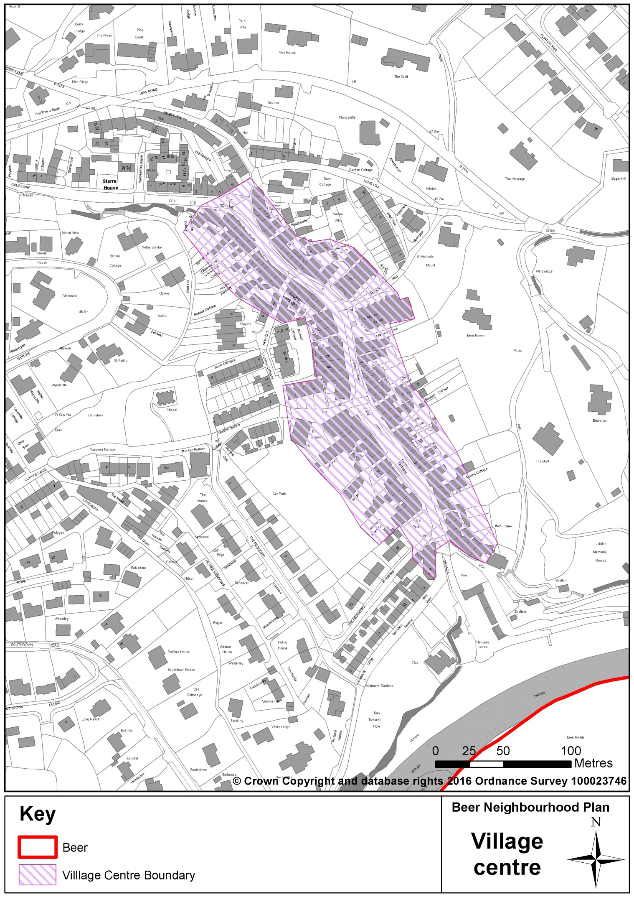
Figure 12 – Beer Village Centre

© Crown copyright & database rights [2015] Ordnance Survey [0100057321 EUL]. Use of this data is subject to terms & conditions.

Policy H4 – Change of Use from Commercial to Residential Use in the Village Centre

The village centre in Beer is defined on Figure 12.
Within the village centre, to ensure that the mix of retail and commercial premises and uses is retained, development proposals for the conversion of retail, commercial and business premises to residential dwellings (which require planning permission) which will not contribute to the vitality of the village centre will only be supported where:
i) it is demonstrated that the premises are surplus to local economic need and demand and commercial use is no longer viable. Evidence will be required to show that the building and / or site has been actively marketed for at least 12 months (ideally over two summer seasons) at a sound, realistic and viable price for the existing or similar uses. A vigorous economic assessment will be undertaken to establish the potential and viability of any specific concern and marketing of any property or business will need to include an offer to the local community for their acquisition or operation; and,
ii) the proposal does not adversely change the character of the building and its setting in the built environment and meets the requirements of the Beer Design Statement.

Proposers of development should engage with the local community and Parish Council to help ensure that proposals take into account both this plan’s aims and objectives and the views of the local community.

Key supporting evidence

Beer Neighbourhood Plan Community Questionnaire, December 2014
Beer Neighbourhood Plan Aims and Objectives Consultation 2015

(The content of this and other relevant written evidence is summarised in the Beer Local and Strategic Written Evidence Reports)
Related national, district and AONB policies

National Planning Policy Framework
Para 28 - Planning policies should support economic growth in rural areas in order to create jobs and prosperity by taking a positive approach to sustainable new development….

East Devon Local Plan
E14 – Change of Use of Village Shops or Services

East Devon Villages Plan
Policy 5 – Village Centre Vitality

Transport and Parking

Aims

Aim 11: Reduce on-street parking and the impact of the motor vehicle where possible, and improve accessibility through support to public and community transport initiatives.

Objectives

Objective 11.1: Protect existing car park facilities and parking numbers and improve parking services.

Objective 11.2: Support efforts to create more off-street private parking.

Objective 11.3: Ensure all new development incorporates easy access for pedestrians and cyclists, and mobility vehicles to village, countryside and public spaces.

Neighbourhood Plan Policies

Car Park Capacity

Justification for our Policy

The Parish has four public car parks. These are very important to Beer in many ways. They accommodate most of our visitor traffic, they enable long-term and short-term visits to the village, they help keep parked cars off the narrow roads, and they serve to minimise the visual intrusion that can occur when a large number of cars are parked together.
Parking is at a premium in the summer months and even in the winter months street parking in residential areas is near capacity. The Central car park is at capacity in the summer as is the Beach Court car park, both of which give essential short-term parking for shopping. The Cliff Top car park is outside of the BUAB and in the AONB and is a great attraction to visitors and walkers as it is adjacent the South West Coast Path. Townsend coach and car park provides parking for visiting coach parties and allocated parking for local residents, which is in demand as the nearby road is congested and full of parked cars throughout the year. The small parking area in Underleys near the school also provides useful additional parking for parents as the road is full during school time. The loss of any of these public parking spaces would severely impact on tourism and local resident quality of life.
Given our relative isolation and the lack of public transport options we shall need our car parks for many years to come. We shall protect them from development or any loss of capacity. Designated residential parking areas are also afforded similar protection.
Only a small majority of the community feel we need more car parks, although 80% of the respondents to the Community Survey 2014 feel that we should introduce further parking restrictions. 60% of respondents however would like to see parking restrictions eased in some areas. Parking is a matter that the Parish Council will need to keep under review and keep the subject of regular local consultation (see our appended community actions). Most of the comments we received in our consultations related to the convenience or otherwise of parking arrangements for those that live in Beer. As regards attracting and accommodating visitors it is clear that the existing car parks are seen as very important.

We are intent therefore on protecting the car parking areas we have, which are acknowledged by the community as being important and which also help keep many of our own cars off the road.

Policy TP1 – Protecting Car Parking Capacity
The following car parks (see Figure 13) are important assets to the local community and essential to the functionality of Beer as a tourist destination:
- Central Car Park
- Beach Court Car Park
- Cliff Top Car Park
- Townsend Coach & Car Park
- Designated residential parking:
Underleys
The Meadows parking bays
Their use as car parking areas will be safeguarded and their capacity maintained.

Figure 13 - Protected Car Parks
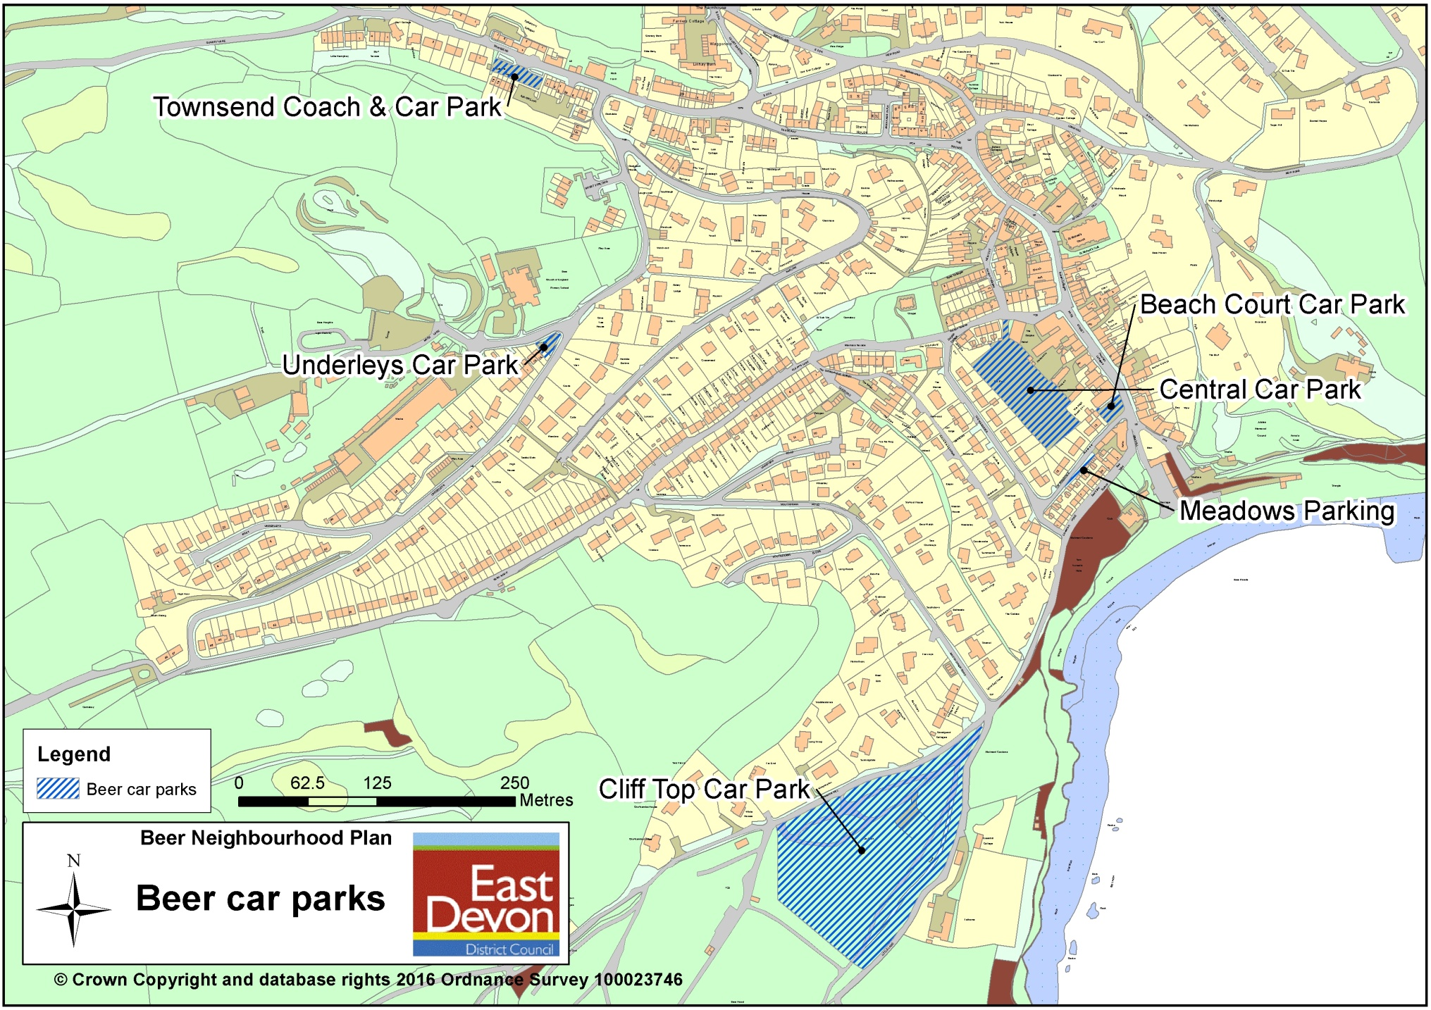

Car Parking

Justification for our Policy
For reasons of road safety and of visual amenity, the loss of vehicle parking capacity is not something that we will support. We expect new development to ensure that there is no net loss of parking capacity and to include within the development proposals sufficient parking spaces, of appropriate types, to accommodate any additional parking demand they are expected to generate. Response to our consultation on the Plan’s draft aims and objectives confirmed that local people want to protect our car parking areas.
Policy TP2 – Car Parking
Development proposals which result in a loss of vehicle parking spaces of any type will only be supported:
- at on-street and public car parks, if the equivalent or increased capacity is provided elsewhere in Beer; and,
- at private car parks, if the equivalent or increased capacity is provided elsewhere or the need for the private parking capacity can be shown to be reduced as a result of the development proposals.
All development proposals must demonstrate how any additional parking requirements generated will be accommodated.

Off-street Parking

Justification for our Policy

Most households in Beer have established a regular place to park their cars, much of this is off-road. The number of cars per household however is expected to continue to grow, similar to the national trend. In the interests of accommodating more local cars, more motor vehicle-borne visitors, and in the interests of safety and visual amenity, we will support the development of any additional off-road parking areas either via a designated car park or a private parking area, as long as these can be provided without damage to the local environment, including increasing flood risk through run-off.
New developments should provide off-road parking spaces to ensure that pressure on limited existing parking is not increased, in accordance with the standards laid down in the Local Plan.
Policy TP3 – Off-street Parking
Where planning permission is required, development proposals to provide additional off-road parking spaces/areas will be supported as long as they do not have an adverse impact on:
- the character of our local built environment;
- the quality of the surrounding natural environment;
- the visual amenity of the area; and,
- flood risk (including local surface water flooding).

Accessibility

Justification for our Policy
The contours of the Parish do not particularly encourage walking or cycling. We would like to see some of the other barriers removed so that the use of the motor car for short trips is less necessary. We expect new development to include measures to link the development with the wider network of paths and cycleways and ensure that these measures are normally of an acceptable standard, in terms of width, gradient and surface, to be usable by mobility vehicles.

Policy TP4 – Accessibility
Development proposals must, where practicable, facilitate safe and appropriate pedestrian and cycle access and links to the village, countryside and community facilities and spaces. This includes providing sufficiently wide pavements for use by mobility vehicles.

Key supporting evidence

Beer Community Survey Report, Beer Parish Council, 2014
Beer Neighbourhood Plan, Local Evidence Report, 2014
Beer NP Aims and Objectives Consultation, 2014

Beer Tourism Survey 2016
Related national, district and AONB policies

National Planning Policy Framework
Para 39 – take into account local car ownership levels
Para 41 - identify and protect…. sites and routes which could be critical in developing infrastructure to widen transport choice

National Planning Practice Guidance
Para: 012 Ref: 26-012-20140306 - Planning should promote access and inclusion

National Planning Practice Guidance
TC2 - Accessibility of New Development

East Devon AONB Management Plan
Key Objective – the impact on the special qualities of the AONB is considered in the planning and provision of transport networks and services
T1 – promote the development of high quality, integrated and sustainable transport services and initiatives in and around the AONB
T2 – work to ensure road and transport schemes within the AONB have regard to the purpose of the AONB

Business and Jobs

Aims

Aim 12: Support local employment.

Aim 13: Support the provision of reliable and high-speed connectivity.

Aim 14: Protect the local retail sector.

Objectives

Objective 12.1: Support and protect existing employment areas.

Objective 12.2: Encourage further business development in appropriate locations.

Objective 12.3: Support applications to convert existing facilities to increase or create employment opportunities.

Objective 12.4: Support changes of use from one employment class to another providing this is not damaging to the wider domestic, commercial or natural environment.

Objective 13.1: Support applications for installation of necessary infrastructure to allow roll out of super-fast broadband where it is not to the detriment of the historic or natural environment.

Objective 14.1: Resist change of use from business and commercial classifications to residential or other use classifications unsuited to the location.

Objective 14.2: Control the design and redevelopment of shop fronts to retain a style and scale in-keeping with a village environment.

Objective 14.3: Support the development or redevelopment of new commercial premises within the established commercial area of Fore Street.

Objective 14.4: Allow conversion from residential to commercial in Fore Street.

Objective 14.5: Support new business where it provides diversification from the current commercial opportunities and is in-keeping with the local area.

Neighbourhood Plan Policies

Existing Employment Land and Buildings

Justification for our Policy

The existing business land and premises are a vital element in our sustainability as a community. We do not want to lose any of our existing sites. East Devon Local Plan Strategy 32 places stringent criteria on the loss of employment space. However, we do not want buildings or sites left vacant for 12 months or more. We do expect the premises to have been actively marketed to seek alternative buyers, for instance, before any change of use proposals come forward.

We are also concerned that any change of use is appropriate and complementary to its location and setting. We expect any proposed change of use to be fully justified. Without positive reasons being shown, applications for a change of use from business/commercial use to other uses will not be supported.
Policy B1 – Existing Employment Land and Buildings
Development proposals that result in the loss of existing employment land and buildings (which require planning permission) will only be supported where they demonstrate that:
- the existing use is no longer viable;
- they will have no adverse effect on residential amenity (such as noise, trading hours, light pollution, anti-social behaviour and so on) in nearby areas; and,
- there will be no adverse impact on the natural environment (landscape, biodiversity and habitats) or that negative impacts will be satisfactorily mitigated.
Proposers of any development that results in the loss of existing employment land and buildings should engage with the local community and Parish Council to help ensure that the proposals take into account the current views of the local community.

New and Converted Employment and Retail Premises

Justification for our Policy
Beer village centre, as defined in Figure 12, is the heart of the Parish and should remain the main focus for commercial activity and services that will enable us to continue to function properly and sustainably as a community. The range of activity and the vibrancy engendered also contributes to the ‘attraction’ of Beer for visitors.
We will support new commercial and business development that helps to strengthen its function if it fits in and complements what we have in the village centre physically, economically and socially; as long as there is no adverse impact on the amenity and overall quality and character of the centre.
We believe that the views of the community on development proposals that affect the village centre, including whether they consider the proposed development would lead to an over-supply of the same kind of use, are very important.

Policy B2 – Development of New and Converted Employment and Retail Premises in Beer Village Centre
Development proposals within the village centre (as defined in Figure 12) for new employment and retail premises, including the conversion of existing premises (which require planning permission) will be supported where they:
- do not lead to a net loss of retail units (shops) or retail floor-space;
- do not lead to the loss of community facilities;
- have no adverse effect on residential and village centre amenity in nearby areas (through noise, trading hours, light pollution, anti-social behaviour and so on);
- have no adverse impact on the built character of the village centre;
- do not adversely impact upon road safety;
- maintain or enhance the character and diversity of village centre uses; and,
- conform to the requirements of the Beer Design Statement.
Proposers of development for new employment and retail premises should engage with the local community and Parish Council to help ensure that the proposals take into account the current views of the local community.

Internet Connectivity

Justification for our Policy

Like many other communities in Devon we are, in 2015, getting frustrated at the lack of progress in providing us with the superfast internet service that we want. Regular and reliable use of the internet and social media is important if we are to maintain our quality of life. Fast and reliable connection is essential for running successful businesses, accessing services and assistance, furthering education and creating a breadth of opportunities for personal growth and development. We are intent on establishing and maintaining the highest level of connectivity.
While the main driver for our policy is to help sustain and improve the local economy, the need for improved provision extends beyond the traditional business premises and offices. Many local people are now working from home or running a business from home which also requires high speed broadband connectivity.
However, achieving our goal cannot be done ‘at all costs’. Given the special quality of our natural and built environment, it is important to minimise the visual impact of new connectivity infrastructure such as cabling or telecoms boxes or hubs for super-fast fibre broadband. Such infrastructure should be appropriately sited, sympathetically designed, even camouflaged so that it is in-keeping with its setting and surroundings.

Policy B3 – Improving Internet Connectivity
- The development of a super-fast broadband infrastructure to serve the Parish will be supported where it is sensitively sited and sympathetically designed.
- All new residential, educational and business premises development will be required to make provision for high speed broadband and other electronic communication networks.

Shopfronts

Justification for our Policy

The visual appearance of Fore Street is a major contributor to the overall character of Beer that we are keen to protect and enhance if possible. Any development to replace an existing shopfront or create a new one should adhere to the Conservation Area polices and the guidelines set out in the Beer Design Statement. Our policy on shopfronts should apply equally to shopfronts that are not located on Fore Street.
Policy B4 – Shopfronts
Development proposals for new or renovated shop fronts will be supported where they:
- are of high quality design and preserve the traditional appearance as set out in the Beer Design Statement; and,
- comply with Policy HBE2.
Any associated signage should be of a suitable scale, meet the requirements of the Beer Design Statement and comply with the safety requirement of Policy HBE3.

Key supporting evidence

Beer Community Survey Report, Beer Parish Council, 2014
Beer Neighbourhood Plan, Local Evidence Report, 2014
Beer NP Aims and Objectives Consultation, 2015
Related national and district policies

National Planning Policy Framework
Para 20 – meet the development needs of business
Para 21 - support existing business sectors
Para 28 - support the sustainable growth and expansion of all types of business and enterprise in rural areas
Para 28 - promote the retention and development of local services and community facilities in villages
Para 42 - Advanced, high quality communications infrastructure is essential for sustainable economic growth
Para 43 - equipment should be sympathetically designed and camouflaged where appropriate
Para 56 - Good design is a key aspect of sustainable development
Para 57 - plan positively for the achievement of high quality and inclusive design for all development

East Devon Local Plan
Strategy 32 - Resisting Loss of Employment, Retail and Community Sites and Buildings
Strategy 48 - Local Distinctiveness in the Built Environment
E2 - Employment Generating Development in Built-Up Areas
E5 - Small Scale Economic Development in Rural Areas
E14 - Change of Use of Village Shops or Services
D1 - Design and Local Distinctiveness
D4 - Applications for Display of Advertisements

East Devon AONB Management Plan
Key Objective – A sustainable rural economy that serves to conserve and enhance the special qualities of the landscape
RES1 – encourage the principle of local markets and sustainable local produce…
RES2 – encourage the development of sustainable employment opportunities that are compatible with the AONB purpose….

Community Facilities and Services

Aim

Aim 15: Support the development and provision of local services.

Objectives

Objective 15.1: Protect existing community assets for the continued use and enjoyment of the community.

Objective 15.2: Improve physical access to existing facilities and encourage use of local services.

Objective 15.3: Support private and community provision of services and facilities to be provided for the benefit of the community.

Objective 15.4: Promote and encourage the use of private, public and community land and facilities for use by and benefit of the community.

Neighbourhood Plan Policies

Community Assets and Facilities

Justification for our Policy

We are intent on remaining sustainable as a community and retaining a full range of local community facilities and services. In the Community Survey 2014, two-thirds of respondents reported positively about the Community Rooms we have; nearly 50% felt that daily shopping and health services were good or better.
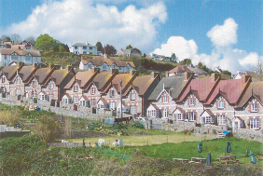
We do not want people to have to travel out of the Parish to satisfy their daily needs. Our policy CFS1 seeks to protect what we have. The Parish Council will consider using the East Devon Register of Community Assets²³ as a mechanism to ensure those facilities and buildings regarded by the community as most important are given the protection²⁴ afforded by the legislation.
Any proposal that results in a loss of a community facility or asset should be accompanied by clear evidence in the form of a bona fide local community consultation that the community regards the current use as redundant.

___________________________
²³ East Devon DC is required to keep lists of these ‘assets of community value’. A building or other land is an asset of community value if its main use has recently been or is presently used to further the social wellbeing or social interests of the local community and could do so in the future. The Localism Act states that ‘social interests’ include cultural, recreational and sporting interests.
²⁴ The Community Right to Bid gives community groups a chance to save assets that are important to them. If an owner of a listed community asset wants to sell it they have to notify East Devon DC. If community groups are interested in buying an asset they can use the Community Right to Bid to 'pause' the sale, giving them six months to prepare a bid to buy it before the asset can be sold.
CFS1 – Loss of Community Assets and Facilities
Development proposals that result in the loss of local retail, service provision, community facilities or a ‘community asset’ (listed by East Devon District Council) will only be supported where:
- it is to be replaced with community space of an equal or higher quality on the same site or another site with satisfactory access for the main users of the existing community asset or facility;
- the proposed alternative use would, overall, provide equal or greater benefits to the local community; and
- it is demonstrated, through local community consultation, that it is no longer required by the community for the current use it serves.

Access to Public Areas and Facilities

Justification for our Policy

We recognise the need to improve accessibility to our public buildings and areas. We will support development that ensures these can be accessed and enjoyed by the whole community.

Policy CFS2 – Access to Public Areas and Facilities
Development proposals that make access to public areas and facilities easier and safer will be supported.

Key supporting evidence

Beer Community Survey Report, Beer Parish Council, 2014
Beer Neighbourhood Plan, Local Evidence Report, 2014
Beer Village Design Statement, Village Design Statement Team, 2006
Beer NP Aims and Objectives Consultation, 2014

Additional local evidence will be sought during local consultation.
Related national and district policies

National Planning Policy Framework
Para 28 - promote the retention and development of local services and community facilities in villages
Para 70 - guard against the unnecessary loss of valued facilities and services

National Planning Practice Guidance
Para: 005 Ref. ID: 53-005-20140306 - A healthy community is a good place to grow up and grow old in …

East Devon Local Plan
Strategy 32 - Resisting Loss of Employment, Retail and Community Sites and Buildings
Strategy 37 - Community Safety
E14 - Change of Use of Village Shops or Services
RC5 - Community Buildings
RC6 - Local Community Facilities
RC7 - Shared Community Facilities
TC2 - Accessibility of New Development

East Devon AONB Management Plan
Key Objective – Improved access to services and facilities….
CC2 – ….strengthen community capacity, resources, information, services and facilities within the AONB….

Sports and Recreation

Aims

Aim 16: Improve the provision of sport and recreation opportunities in the Parish.

Aim 17: Provide facilities for children and young people.

Objectives

Objective 16.1: Protect and enhance existing facilities.

Objective 16.2: Support the development of indoor sports facilities and opportunities for all ages.

Objective 16.3: Provide sports facilities in locations preferred and indicated by the community whenever possible.

Objective 16.4: Ensure standard of facilities, at time of development, and ongoing maintenance are in line with national guidelines.

Objective 17.1: Support the provision of new facilities following consultation with the specific age groups.

Objective 17.2: Provide additional play areas and equipment related to the needs of the specific age groups.

Neighbourhood Plan Policies

Sports and Recreation Facilities and Pitches

Justification for our policies

Sport, recreation and play are important for a healthy community and our local play sports and recreation facilities are very important and contribute significantly to community life. As East Devon District Council evidence has suggested, we are under-provided for in terms of playing pitches in the parish and so wish to protect what we currently have in order to retain current supply and use by future generations. The National Planning Policy Framework sets out support for the prevention of loss of important facilities and pitches in paragraphs 70, 73 and 74 and our policies build on this policy framework.

Our community questionnaire found that indoor sports facilities and facilities for young people are considered to be ‘poor’ in Beer by over 50% of respondents and so proposals to improve these types of facilities would be particularly welcomed and supported. The results also suggest that there is some room for improvement in the provision of outdoor sports facilities for young children. Conversely, between 60% and 70% of people gave our parks / open spaces, clubs and societies and social activities a positive rating in the survey (‘good’ or ‘very good’).

For these reasons, policy SR1 lists our sports and recreation facilities and seeks to protect them from loss. These facilities and pitches are also shown in Figure 14. Any proposal to replace any of our recreation assets would need to be fully justified and we would require proposals to be developed taking into account community consultation. We would prefer not to see a net loss of existing community sport and recreation space if possible, although our policies leave proposals to be considered on their merits subject to satisfying tests where replacement community benefit or access can be gained though a proposal for change. We are also keen to encourage and support the provision of improved or new additional facilities and have developed policy SR2 which enables this to take place if such developments are proposed. In response to our consultation responses on children’s play and young people’s facilities, policy SR3 sets out support for new facilities and the criteria which should be considered as such proposals are developed. While it is important to bring such new facilities forward, it should be done in association with the users of those facilities and any nearby residents close to the proposal.

Any development that takes place must take into account the Sidmouth to Beer SSSI, the Sidmouth to West Bay SAC, the Lyme Bay and Torbay SAC, the East Devon AONB, the Jurassic Coast WHS and the wider biodiversity and geodiversity issues where relevant.

Figure 14 – Existing Sports and Recreation Facilities and Pitches
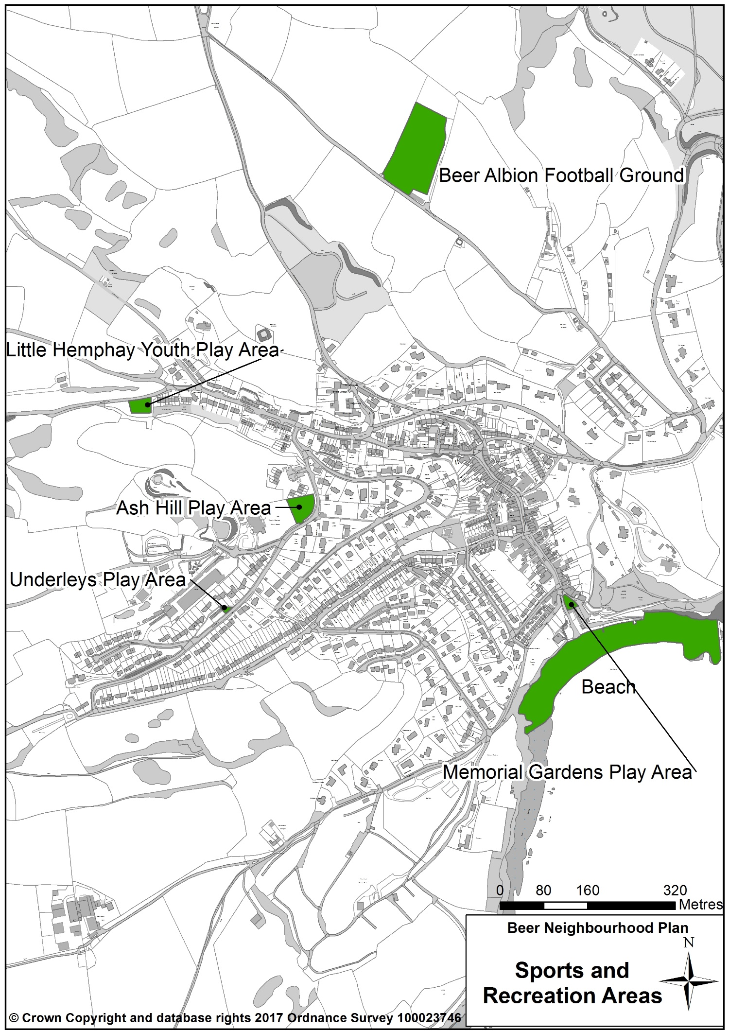

Policy SR1 – Protecting our Existing Sports and Recreation Facilities and Pitches and Preventing their Loss

Our existing valued sports and recreation facilities and pitches (shown in Figure 14) which are used by the community will be protected from change of use and are:
- Beer Albion Football Ground,
- Little Hemphay Youth Play Park,
- Ash Hill Play Area,
- Underleys Play Area,
- Memorial Gardens Play Area and
- Beach
Proposals which result in a loss of existing sports and recreation facilities and pitches and / or their capacity and / or community accessibility (availability for community use) will only be supported where:
- An assessment has been undertaken which clearly shows that facilities are surplus to local and strategic need and demand; or
- The loss resulting from the proposed development would be replaced by equivalent or better provision in terms of quantity, quality and community accessibility in a suitable location and demonstrate community benefit; or
- The development is for alternative sports and recreational provision, the needs for which clearly outweigh the loss.

Proposals which replace existing facilities and pitches should demonstrate that they benefit the community or that there is secured community access.

Proposers of development should engage with the local community and Parish Council to help ensure that proposals take into account both this plan’s aims and objectives and the views of the local community.

Policy SR2 - Improved, new and additional sports and recreation facilities and pitches

Proposals for improved, new and / or additional play, sports and recreation facilities and pitches will be supported where they:

i) respond to a demonstrable need and demand for the proposed facility;
ii) provide community access;
iii) demonstrate how they will be effectively managed and maintained in perpetuity; and,
iv) meet up-to-date standards of design set by the appropriate agency or governing body.

Proposers of development should engage with the local community and Parish Council to help ensure that proposals take into account both this plan’s aims and objectives and the views of the local community.

Policy SR3 – Facilities for Children and Young People

Proposals for improved, new and / or additional facilities to meet the needs of children and young people will be supported where:
- they demonstrate that they meet the needs of the age groups to which they relate;
- they demonstrate how they will be effectively managed and maintained in perpetuity;
- they demonstrate that local young people or children and their parents / guardians have been consulted and involved in developing the proposal; and,
- they demonstrate that local residents have been consulted and positive measures have been taken to ensure that there are no adverse impacts on local amenity.

Key supporting evidence

East Devon Open Space Study Review 2014
Beer Neighbourhood Plan Community Questionnaire, December 2014
Beer Neighbourhood Plan Aims and Objectives Consultation, 2015

(The content of this and other relevant written evidence is summarised in the Beer Local and Strategic Written Evidence Reports)
Related national and district policies

National Planning Policy Framework
Paragraph 70 - policies should be based on up‑to‑date assessments of the needs for open space, sports and recreation facilities and opportunities for new provision…
Paragraph 73 - Access to high quality open spaces and opportunities for sport and recreation can make an important contribution to the health and well-being of communities…
Paragraph 74 - Existing open space, sports and recreational buildings and land, including playing fields, should not be built on unless…

National Planning Practice Guidance
Paragraph: 005 - A healthy community encourages green open space and safe places for active play and food growing
Reference ID: 53-005-20140306

East Devon Local Plan
RC1 - Retention of Land for Sport and Recreation
RC4 - Recreation Facilities in the Countryside and on the Coast

Tourism

Aims

Aim 18: Extend the tourist season in ways that preserve and enhance the established character of Beer as a tourist destination.

Aim 19: Introduce new facilities commensurate with the established character of Beer.

Objectives

Objective 18.1: Increase and promote additional events for community enjoyment and to encourage tourism.

Objective 18.2: Encourage the temporary and alternative use of private and community assets to support tourism.

Objective 18.3: Create and promote schemes that reinforce the established character of Beer as a tourist destination as well as promoting new elements.

Objective 19.1: Support the development of new tourism facilities providing they do not harm the existing natural and historic environment.

Objective 19.2: Resist tourism-related development that would detract from the established character of Beer.

Objective 19.3: Support the development of new hotels or guest houses where a demand can be demonstrated.

Objective 19.4: Resist the loss or change of use of existing holiday facilities unless non- viability can be proven.

Objective 19.5: Support change where it introduces new uses that enhance the tourism offering of Beer.

Objective 19.6: Ensure all development contributes to the economic and social sustainability of Beer.

Neighbourhood Plan Policies

Temporary and Alternative Use to Support Tourism

Justification for our Policy

We support the growth of tourism and believe that there is scope for more festivals and one-off events. 71% of respondents to the Community Survey 2014 were supportive of the idea of more festivals and events.
Our policy T1 is aimed at facilitating the temporary use of spaces and buildings for a period of up to two months to enable such special events and activities to take place as long as they have no long-term nor permanent detrimental effect.

Policy T1 - Temporary and Alternative Use of Private and Community Assets to Support Tourism
Where the temporary change of use of buildings and open spaces for organised community events and tourist-related activity requires planning permission, proposals will be supported where:
- the temporary use would not have significant harmful impacts on the wider visitor experience;
- the temporary use will cause no permanent damage to the fabric and structure of any building it occupies; and,
- the temporary use would not have significant harmful impacts on the amenities of neighbouring residents.

New Developments for Tourism

Justification for our Policy

In accordance with our general approach of encouraging responsible tourism we will support new tourism development that is deemed to be sustainable by way of bringing benefits to the area either physically, social or economically whilst not harming the environment and the character of the area. The AONB Management Plan tells us that “the relationship between tourism and the enhancement and care of the landscape would benefit from further development e.g. visitor payback”²⁵.
Policy T2 – New Developments for Tourism
Sustainable tourism development proposals and/or extensions to or expansion of existing tourism uses will be supported in principle provided they do not harm the existing natural and historic environment or detract from the established character of Beer.
New Holiday Accommodation

Justification for our Policy

New holiday accommodation in the form of hotels or guest houses are welcomed provided that they meet an identifiable need and demand and do not result in an increase in ‘second homes’ in the area. We expect proposals to set out a clear demand and need for the accommodation proposed through an understanding of occupancy levels for that type and quality rating (if applicable) of holiday accommodation in the last two summer seasons. Figures should indicate a high level of occupancy (an average of over 75% room occupancy per month) throughout June to August inclusive. Alternatively, a gap in provision for the type and quality rating must be demonstrated. We expect occupancy requirements to be enforced through the use of conditions / occupancy restrictions on such proposals. __________________________
²⁵ East Devon Area of Outstanding Natural Beauty, Management Strategy 2014 – 2019, East Devon District Council 2014
Policy T3 – New Holiday Accommodation
Development proposals to provide visitor accommodation will be supported where they demonstrate that:
- they are primarily for holiday purposes;
- there is demand and need for additional accommodation of the type proposed within Beer; and,
- they will not be occupied for residential purposes, including as a second home, unless ancillary to the business
Loss of Tourism Facilities

Justification for our Policy

We will resist the loss of existing tourist facilities unless there is clear evidence that the demand for such facilities no longer exists. In this case we expect the site to be used for an alternative tourism purpose or other purpose that has clear benefits for the local community.
Policy T4 – Loss of Tourism Facilities
The loss of tourist facilities to other uses will only be supported where:
- it can be satisfactorily demonstrated that the tourist facility is no longer viable; or,
- the proposed alternative use would provide equal or greater benefits for the local economy and community than the current use.

Improving Tourism

Justification for our Policy

Tourism is prone to change as it is influenced by fashion and lifestyles. We are prepared to accommodate changes in tourism demands in the interests of maintaining a healthy local tourist economy.

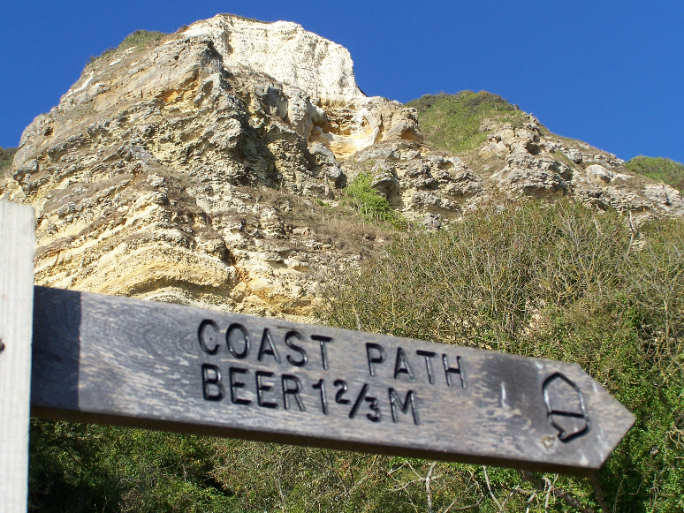
We concur too with the AONB Management Plan’s assertion that sustainable countryside recreation needs to be promoted for its benefits on healthy active lifestyles and improved mental well-being. We are prepared to support tourism development that furthers this health agenda as long as any proposal results in an improvement in the quality of what we offer and does not jeopardise the natural beauty and character of the area that must remain the main attraction and reason why people visit Beer.

Policy T5 – Improving the Quality and Diversity of the Tourism Offer
Development proposals that improve the quality and diversity of existing tourist facilities, attractions and accommodation will be supported providing that the development:
- does not have a detrimental effect on the distinct character of Beer;
- does not adversely affect the surrounding infrastructure, particularly local road networks and water supply and sewerage; and,
- benefits the local community through, for instance, provision of local employment opportunities and improvements to local service provision.

Key supporting evidence

Beer Community Survey Report, Beer Parish Council, 2014
Beer Neighbourhood Plan, Local Evidence Report, 2014

Beer NP Aims and Objectives Consultation, 2015

Beer Tourism Survey 2016
Related national and district policies

National Planning Policy Framework
Para 28 - support sustainable rural tourism and leisure developments …include supporting the provision and expansion of tourist and visitor facilities in appropriate locations

National Planning Practice Guidance

National Planning Practice Guidance
Strategy 33 - Promotion of Tourism in East Devon
E16 - Proposals for Holiday or Overnight Accommodation and Associated Facilities
E18 - Loss of Holiday Accommodation
E19 - Holiday Accommodation Parks
E20 - Provision of Visitor Attractions

East Devon AONB Management Plan
Key Objective – a sustainable access, recreation and tourism sector that is in keeping with the AONB purpose….
ART 2 - …..encourage and support sustainable tourism activities within the AONB area…..

Monitoring and Review

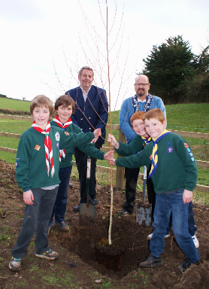
While there is no statutory requirement for the impact of this Plan and its policies to be monitored, the Parish Council will periodically monitor the impact of policies on change in the parish by considering the policies’ effectiveness in the planning application decision making process. The Parish Council will do this by referring to this Plan when reviewing planning applications. The Parish Council will also work with East Devon District Council to monitor, periodically, the plan’s impact against the range of indicators identified in Table 7 of the SEA.

The Clerk will keep a record of the application, any applicable policies, the comment from the Parish Council and the eventual outcome of the application. The delivery of community actions that have been identified will also be periodically monitored.

A full or partial review of this Plan is unlikely to be considered necessary during its lifetime unless triggered by changes to legislation, changes to national or district-wide planning policies or significant planning issues being raised by the local community which cannot be dealt with effectively by a combination of national, district and / or existing Neighbourhood Plan policies.

Appendix 1

Neighbourhood Plan Community Actions

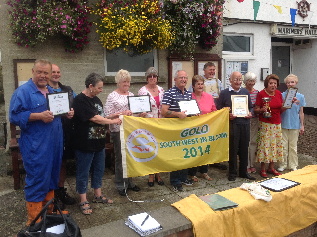
We are advised by Government planning policy guidance that community objectives and actions cannot feature as a main part of this Neighbourhood Plan, given its status as part of the statutory development plan. These community actions are not planning policies and do not, therefore, form part of the statutory development plan for the parish. However, it is important that we include reference to them to maintain links between those things that the Neighbourhood Plan can have an influence over through its land use planning policies and the issues that concern local residents and businesses which require action but cannot be dealt with through the planning system.

These community actions are, therefore, set out below as we feel that it is important to ensure that they are represented to present the whole picture of policy and linked actions required to deliver the aims and objectives identified during the Neighbourhood Plan process.

Natural Environment

In response to help meet Aim 1: Protect and enhance the natural environment, its ecology and bio-diversity

Community Objective 1.1 Encourage measures to improve biodiversity.
Community Action A The Parish Council will work with the community and other partners to encourage measures to improve biodiversity.

Community Objective 1.2 Encourage farming practices that minimize dangers of flooding.
Community Action B The Parish Council will work with the farming community and other partners to encourage agricultural practices which minimise the risk of surface water run-off exacerbating flooding in close proximity to dwellings and businesses.

In response to help meet Aim 2: Minimise the impact of new developments.

Community Objective 2.1 To help prevent flooding by regular maintenance of The Brook.
Community Action C The Parish Council will work with partners to help ensure that The Brook is effectively maintained to reduce the risk of local flooding.

Community Objective 2.2 Encourage sustainability for all developments.
Community Action D The Parish Council will encourage sustainability measures for development. Development proposals in Beer will be supported where they meet policy requirements at the national, district and neighbourhood level (contained in this Neighbourhood Plan). Proposals will need to meet the highest required standards in sustainability for the type of proposal made and proposals which exceed nationally set standards will be particularly welcomed.

Heritage and the Built Environment

In response to help meet Aim 5: Establish the limits of development.

Community Objective 5.1 Encourage high standards of insulation and energy efficiency and sustainability.
Community Action E The Parish Council will work with partners to encourage best use of energy efficiency measures in existing properties, where appropriate.

In response to help meet Aim 7: Support more outdoor activities.

Community Objective 7.1 Enable the safe use of the streets of Beer for public entertainment from time to time e.g. Barrel Rolling, Regatta etc.
Community Objective 7.2 Allow people to use public spaces for a variety of formal and informal community uses – e.g. Youth Park for community barbeque.
Community Action F The Parish Council will continue to work with partners to help ensure that the streets of Beer and other civic and public open spaces are used as a community asset for public entertainment and local cultural activities.

In response to help meet Aim 8: Encourage small scale renewable energy installations wherever they are appropriate.

Community Objective 8.1 Encourage solar panels where not visually intrusive. In the Conservation Area, only support them where they do not detract from the visual appearance of Beer.
Community Action G The Parish Council will encourage the installation of solar panels where they are not visually intrusive.

Community Objective 8.2 Resist off-shore generation.
Community Action H The Parish Council will work with partners to help ensure that the value and beauty of Beer’s Jurassic Coast is not compromised by the development of inappropriate off-shore energy generation.

Transport and Parking

In response to help meet Aim 10: Reduce on-street parking and the impact of the motor vehicle where possible, and improve accessibility through support to public and community transport initiatives.

Community Objective 10.1 Protect the provision of public bus services.
Community Objective 10.2 Promote improvements to bus destination coverage and timetables with recognition of the employment and education needs.
Community Objective 10.3: Support community initiatives for the provision of alternate public transport such as car share schemes.
Community Action I The Parish Council will work with the community and other partners to protect and improve the community’s accessibility to transport services.

Community Objective 10.4 Control on-street parking through the introduction of resident only zones in appropriate locations.
Community Action J The Parish Council will work with the community and other partners to explore opportunities for the introduction of residents’ parking schemes where beneficial to residents.

Community Objective 10.5 Support applications for traffic restrictions to allow public events on the highway.
Community Action K The Parish Council will support applications for traffic restrictions to allow public events on the highway.

Business and Jobs

In response to help meet Aim 12: Support local employment.

Community Objective 12.1 Encourage private and community employment initiatives with particular reference to training opportunities for young people.
Community Action L The Parish Council will explore ways of encouraging private and community employment initiatives with particular reference to training opportunities for young people.

In response to help meet Aim 13: Support the provision of reliable and high-speed connectivity.

Community Objective 13.1 Help to ensure that high speed connectivity is available throughout the Parish.
Community Objective 13.2 Encourage the introduction of new technologies where these can benefit the community.
Community Action M The Parish Council will seek to help ensure that the parish has high speed internet connectivity and will support the principle of new technologies during the plan period where they can benefit the community.

Sport and Recreation

In response to help meet Aim 16: Improve the provision of sport and recreation opportunities in the Parish.

Community Objective 16.1 Support community initiatives for the development of new facilities and maintenance of existing facilities and assets.
Community Action N The Parish Council will support community initiatives for the development of new sport and recreation facilities and the maintenance of existing facilities and assets, where their need is demonstrated and the community supports provision.

In response to help meet Aim 17: Provide facilities and opportunities for children and young people.

Community Objective 17.1 Support the provision of new facilities following consultation with the specific age groups.
Community Action O The Parish Council will support community initiatives for the development of new facilities, play areas and equipment for children and young people and the maintenance of existing facilities and assets, where their need is demonstrated and the community supports provision.

Paragraphs 109-113, National Planning Policy Framework, DCLG
p. 24, East Devon AONB Management Strategy, 2014-2019, (see key objective)
South Devon & Dorset Shoreline Management Plan Review, Halcrow, 2011
South Devon & Dorset Shoreline Management Plan Review, Halcrow, 2011
South Devon & Dorset Shoreline Management Plan Review, Halcrow, 2011
South Devon & Dorset Shoreline Management Plan Review, Halcrow, 2011
South Devon & Dorset Shoreline Management Plan Review, Halcrow, 2011
Parish Biodiversity Audit for Beer, Devon County Council, 2010
In 2009, Natural England proposed the area from Poole Bay to Lyme Bay as a Special Area of Conservation under the EC Habitats Directive. The area was duly submitted by Defra to the European Commission as a Candidate Special Area of Conservation in August 2010
Parish Biodiversity Audit for Beer, Devon County Council, 2010
The community questionnaire responses were 76.5% of respondents said that the green wedge is very important, 15.8% that it was quite important and 7.7% stated that it is not important.

