
2025 Air Quality Annual Status Report (ASR)
In fulfilment of Part IV of the Environment Act 1995 Local Air Quality Management, as amended by the Environment Act 2021
Date: April 2025

Information | East Devon District Council
Local Authority Officer | Alice Gill
Department | Environmental Health
Address | Blackdown House  Border Road  Heathpark Industrial Estate  Honiton  EX14 1EJ
Telephone | 01395 517457
E-mail | environmentalhealth@eastdevon.gov.uk
Report Reference Number | EDDC2024ASR
Date | April 2025

Local Responsibilities and Commitment
This ASR was prepared by the Environmental Health Department of East Devon District Council with the support and agreement of the following officers and departments:
- Private Sector Housing, East Devon District Council
- Climate Change Officers, East Devon District Council
This ASR has been approved by:
Matt Blythe, Assistant Director Environmental Health
Cllr Geoff Jung, Portfolio Holder for the Coast, Country, and Environment
This ASR has not been signed off by a Director of Public Health.
If you have any comments on this ASR please send them to Environmental Health at:
Blackdown House, Border Road,
Heathpark Industrial Estate,
Honiton. EX14 1EJ
01395 517457
environmentalhealth@eastdevon.gov.uk

Executive Summary: Air Quality in Our Area

Air Quality in East Devon
Breathing in polluted air affects our health and costs the NHS and our society billions of pounds each year. Air pollution is recognised as a contributing factor in the onset of heart disease and cancer and can cause a range of health impacts, including effects on lung function, exacerbation of asthma, increases in hospital admissions and mortality.
Air pollution particularly affects the most vulnerable in society, children, the elderly, and those with existing heart and lung conditions. Low-income communities are disproportionately impacted by poor air quality, exacerbating health and social inequalities.
Table ES 1 provides a brief explanation of the key pollutants relevant to Local Air Quality Management and the kind of activities they might arise from.
Table ES 1 - Description of Key Pollutants
Pollutant | Description
Nitrogen Dioxide (NO₂) | Nitrogen dioxide is a gas which is emitted from high-temperature combustion processes such as road transport or energy generation.
Sulphur Dioxide (SO₂) | Sulphur dioxide (SO₂) is a corrosive gas which is predominantly produced from the combustion of coal or crude oil.
Particulate Matter  (PM₁₀ and PM_{2.5}) | Particulate matter is everything in the air that is not a gas.  Particles can come from natural sources such as pollen, as well as human made sources such as smoke from fires, emissions from industry and dust from tyres and brakes.  PM₁₀ refers to particles under 10 micrometres. Fine particulate matter or PM_{2.5} are particles under 2.5 micrometres.

This ASR presents the monitoring results for 2024 within East Devon District Council.
East Devon District encompasses urban and urban fringe areas as well as market towns and villages, seaside towns and remoter rural and coastal areas. Much of the district is undeveloped countryside with land uses mainly being agricultural. In recent years there has been significant growth in the western side of the district due to the urban extension of Exeter and the growth of a new town, Cranbrook. The M5 motorway runs through the west of the district, and the area is bisected east to west by the A35 and A30 major trunk roads. Smaller main roads serving the main towns and commercial areas feed into the strategic network. It is envisaged that there will be further development on the western side of the district, including a new town, and it is likely that vehicle flows will increase as a result of this.
NO₂ is the main pollutant of concern within East Devon District Council (EDDC) which predominantly is sourced from road traffic, particularly in areas with higher levels of congestion. As such EDDC have continued to focus on monitoring NO₂ and managing the effects. EDDC have 56 passive monitoring sites including 1 triplicate tube location. Two of the passive monitoring sites were installed in 2024. There is one Automatic Urban and Rural Network (AURN) continuous monitoring station within EDDC.
Air quality across East Devon is good overall. In 2024, there were no sites across the district which have reported an annual NO₂ concentration level above the air quality objective of 40µg/m³. The highest annual mean concentration was reported to be 30.5 μg/m³ and was recorded at diffusion tube N46 which is located at Honiton (High Street) - Windmill Court on the A35.
There has been a predominantly downward trend in NO₂ concentration in East Devon, with 50 diffusion tubes across the district in 2024 reporting a decrease in NO₂ concentration in comparison to 2023. There has been a slight increase in concentration reported at 4 diffusion tube monitoring locations during 2024 in comparison to 2023. The highest increase for this reporting year was recorded at site N09 which is located at the High Street/ Dowell Street Junction in Honiton. There was an increase of 12.7 % from 22.0 μg/m³ to 24.8 μg/m³ at this location.
The Honiton AURN continuous monitoring data has a reported decrease of 29.9 % from 9.7 μg/m³ to 6.8 μg/m³. The continuous monitoring data did not exceed the annual mean air quality objective for 2024, or for the previous five-year period.
In 2024, East Devon District Council established an Air Quality Strategy which sets out a suite of actions to deliver long-term improvements in air quality across the district. Development of the Strategy involved cross-working with teams at Devon County Council, such as Transport Planning and Public Health Devon, and teams at East Devon District Council such as Private Sector Housing and Climate Change. Actions include the Council fleet decarbonisation plan (transition to electric vehicles), increased numbers of electric vehicle charging points in car parks, the Council Green Travel Plan for employees, support and access to grant funding for home efficiency improvements and air quality campaigns such as Clean Air Night.
East Devon District Council revoked their only Air Quality Management Area (AQMA) in April 2018 as a result of monitored improvements in air quality in the designated area, in addition to the 2017 detailed air quality report, which concluded that no exceedances were likely to be observed at locations of relevant exposure within the district.

Actions to Improve Air Quality
Whilst air quality has improved significantly in recent decades, there are some areas where local action is needed to protect people and the environment from the effects of air pollution.
- The Council continue to recommend that all major new developments across the district incorporate measures to discourage car use with the provision of cycle and walking routes, subsidise new bus services, and install electric vehicle charging points across the area.
- There has been collaboration with other local Councils, such as Devon Country Council, with the aim to deliver project plans for cycling and walking infrastructure in future. For example, the Clyst Valley and New Communities Infrastructure Plan.
- The Devon Low-Carbon Energy & Transport Technology Innovator (DELETTI) programme is ongoing, this programme aims to help reduce emissions with the installation of electric vehicle charging points for public use across Devon. Currently there are 42 electric charging bays within East Devon District Council owned car parks and plans to install a further 9 electric charging bays in 2025.
- The Council is in the process of transitioning its own fleet of vehicles to electric. In 2024, 45 % of the fleet were electric vehicles and there are plans to increase this to 50 % in 2025.

Conclusions and Priorities
Monitoring in EDDC during 2024 showed no exceedances of the annual mean air quality objective for NO₂ (40μg/m³). Most of the diffusion tube monitoring sites reported a decrease in NO₂ concentration in comparison to 2023. It is likely that continued home-working; increased fuel prices; and the current cost of living crisis may all be contributing to lower than normal traffic levels.
The Honiton AURN automatic urban background monitoring site continued to monitor no exceedances for both the annual mean objective values in 2024 and one recorded 1-hour period with a concentration greater than 200 µg/m³ during 2024.

How to get Involved
Residents of East Devon can help to improve air quality in the district by using alternative methods of sustainable transport such as walking, running, cycling, public transport or replacing petrol/diesel cars with an electric vehicle. Car sharing is also an easy way to reduce private car use. Further information regarding East Devon District Council’s Local Air Quality Management strategy, including access to the Council’s LAQM reports, are on the Council’s website.

Table of Contents
Local Responsibilities and Commitment i
Executive Summary: Air Quality in Our Area ii
Air Quality in East Devon ii
Actions to Improve Air Quality iv
Conclusions and Priorities v
How to get Involved v
1 Local Air Quality Management 1
2 Actions to Improve Air Quality 2
2.1 Air Quality Management Areas 2
2.2 Progress and Impact of Measures to address Air Quality in East Devon 3
2.3 PM_{2.5} – Local Authority Approach to Reducing Emissions and/or Concentrations 10
3 Air Quality Monitoring Data and Comparison with Air Quality Objectives and National Compliance 12
3.1 Summary of Monitoring Undertaken 12
3.1.1 Automatic Monitoring Sites 12
3.1.2 Non-Automatic Monitoring Sites 12
3.2 Individual Pollutants 13
3.2.1 Nitrogen Dioxide (NO₂) 13
3.2.2 Particulate Matter (PM₁₀) 14
3.2.3 Particulate Matter (PM_{2.5}) 14
Appendix A: Monitoring Results 16
Appendix B: Full Monthly Diffusion Tube Results for 2024 44
Appendix C: Supporting Technical Information / Air Quality Monitoring Data QA/QC 47
New or Changed Sources Identified Within East Devon During 2024 47
Additional Air Quality Works Undertaken by East Devon District Council During 2024 48
QA/QC of Diffusion Tube Monitoring 48
Diffusion Tube Annualisation 48
Diffusion Tube Bias Adjustment Factors 49
NO₂ Fall-off with Distance from the Road 51
QA/QC of Automatic Monitoring 51
PM₁₀ and PM_{2.5} Monitoring Adjustment 52
Automatic Monitoring Annualisation 52
NO₂ Fall-off with Distance from the Road 52
Appendix D: Map(s) of Monitoring Locations and AQMAs 53
Appendix E: Summary of Air Quality Objectives in England 67
Glossary of Terms 68
References 69

Figures
Figure A.1 – Trends in Annual Mean NO₂ Concentrations 32
Figure A.2 – Trends in Number of NO₂ 1-Hour Means > 200µg/m³ 36
Figure A.3 – Trends in Annual Mean PM₁₀ Concentrations 39
Figure A.4 – Trends in Number of 24-Hour Mean PM₁₀ Results > 50µg/m³ 42
Figure A.5 – Trends in Annual Mean PM_{2.5} Concentrations 45
Figure D.1 – Map of Non-Automatic Monitoring Site 62
Tables
Table 2.1 – Declared Air Quality Management Areas 5
Table 2.2 – Progress on Measures to Improve Air Quality 10

Table A.1 – Details of Automatic Monitoring Sites 16
Table A.2 – Details of Non-Automatic Monitoring Sites 17
Table A.3 – Annual Mean NO₂ Monitoring Results: Automatic Monitoring (µg/m³) 22
Table A.4 – Annual Mean NO₂ Monitoring Results: Non-Automatic Monitoring (µg/m³) 23
Table A.5 – 1-Hour Mean NO₂ Monitoring Results, Number of 1-Hour Means > 200µg/m³ 38
Table A.6 – Annual Mean PM₁₀ Monitoring Results (µg/m³) 39
Table A.7 – 24-Hour Mean PM₁₀ Monitoring Results, Number of PM₁₀ 24-Hour Means > 50µg/m³ 41
Table A.8 – Annual Mean PM_{2.5} Monitoring Results (µg/m³) 42
Table B.1 – NO₂ 2024 Diffusion Tube Results (µg/m³) 48
Table C.1 – Annualisation Summary (concentrations presented in µg/m³) 53
Table C.2 – Bias Adjustment Factor 54
Table C.3 – Local Bias Adjustment Calculation 55
Table C.4 – Non-Automatic NO₂ Fall off With Distance Calculations (concentrations presented in µg/m³) 57
Table C.5 – Automatic NO₂ Fall off With Distance Calculations (concentrations presented in µg/m³) 61
Table E.1 – Air Quality Objectives in England 64

Local Air Quality Management
This report provides an overview of air quality in East Devon during 2024. It fulfils the requirements of Local Air Quality Management (LAQM) as set out in Part IV of the Environment Act (1995), as amended by the Environment Act (2021), and the relevant Policy and Technical Guidance documents.
The LAQM process places an obligation on all local authorities to regularly review and assess air quality in their areas, and to determine whether the air quality objectives are likely to be achieved. Where an exceedance is considered likely the local authority must declare an Air Quality Management Area (AQMA) and prepare an Air Quality Action Plan (AQAP) setting out the measures it intends to put in place in order to achieve and maintain the objectives and the dates by which each measure will be carried out. This Annual Status Report (ASR) is an annual requirement showing the strategies employed by East Devon District Council to improve air quality and any progress made.
The statutory air quality objectives applicable to LAQM in England are in Table E.1.

Actions to Improve Air Quality
  - Air Quality Management Areas
Air Quality Management Areas (AQMAs) are declared when there is an exceedance or likely exceedance of an air quality objective. After declaration, the authority should prepare an Air Quality Action Plan (AQAP) within 18 months. The AQAP should specify how air quality targets will be achieved and maintained and provide dates by which measures will be carried out.
East Devon District Council currently does not have any declared AQMAs.
A local Air Quality Strategy is under development to prevent and reduce polluting activities.

  - Progress and Impact of Measures to address Air Quality in East Devon
Defra’s appraisal of last year’s ASR concluded:
The report is well structured, detailed, and provides the information specified in the Guidance. The following comments are designed to inform future reports:
- Table C.1 includes annualisation factors for N63_LODGE but no final annualised concentration. As this site had 9 months of valid data capture, annualisation was not required as per LAQM.TG(22), despite having a data capture of less than 75%. It may be useful to state that annualisation has not been completed for this reason, as including N63_LODGE within Table C.1 suggests that annualisation was completed for this site. Alternatively, N63_LODGE could be removed from Table C.1 to avoid confusion.
- The Council have included a discussion regarding measures to reduce PM_{2.5} concentrations. Within this discussion, the Council have stated that Defra modelled PM_{2.5} background concentrations are well-below the objective, which supports the monitored concentrations from the AURN site. The Public Health D01 indicator has also been included, which is below the regional and national statistics. The Council should continue to include these discussions in future reports.
This has been noted, and the DEFRA modelled PM2.5 background concentrations and Public Health Indicator data has been included within this current report.

- Figure D.10 does not have a complete figure caption and currently is titled “2023 NO₂”. Could the Council clarify which location this Figure shows.
- A screen capture of the appropriate national bias adjustment sheet has been included for completeness. This is welcomed and ensures that the most up-to-date national adjustment factor has been used.
This has been noted.

- Clear graphs have been included to show the trends in concentrations across the monitoring network over the last 5 years. These graphs are easy to read and clearly show the trends. It would be useful for the objective value to be highlighted on the graphs for an easy comparison.
The objective values are now shown on the graphs for 2024 monitoring data.

East Devon District Council has taken forward a number of direct measures during the current reporting year of 2024 in pursuit of improving local air quality. Details of all measures completed, in progress or planned are set out in Table 2.2. Eleven measures are included within Table 2.2, with the type of measure and the progress East Devon District Council have made during the reporting year of 2024 presented. Where there have been, or continue to be, barriers restricting the implementation of the measure, these are also presented within Table 2.2.
More detail on these measures can be found in their respective Action Plans:
Regional:
Devon Local Transport Plan 4, 2026-2040 - Roads and transport
National Bus Strategy - Devon's Response - Travel Devon
Devon Electric Vehicle Charging Strategy
Bus - Travel Devon
Local Plans:
East Devon Public Health Strategy
East Devon Climate Change Strategy
Housing+Health+Directorate+Plan+2024-28+v1.0.pdfPlanning Service Plan 2024 - 2025
Green Travel Plan - East Devon
Clyst Valley and New Communities Local Cycling and Walking Infrastructure Plan - Have Your Say (devon.gov.uk)

Key completed measures are:
- Completion of the East Devon Air Quality Strategy with associated Action Plan. The Air Quality Strategy aims to outline current air quality and pollution sources across the district, present the Councils actions and commitments to improving air quality across the district and raise awareness and educate residents, businesses, and organisations about air quality. Development of the Strategy involved cross-working with teams at Devon County Council, such as Transport Planning and Public Health Devon, and teams at East Devon District Council such as Private Sector Housing, Climate Change and Planning Development.
East Devon District Council have continued to progress the following measures:
- East Devon District Council has continued to work on the Devon Low-Carbon Energy & Transport Technology Innovator (DELETTI) programme, which aims to help reduce emissions with the installation of electric vehicle charging points for public use across Devon.
In 2024 there were forty-two charging bays within East Devon District Council carparks and plans to install a further 9 electric charging bays. Electric vehicle owners were not required to purchase a parking ticket whilst their electric vehicle was charging. The Council is also part of a Devon County LEVI bid to increase numbers of charging bays to meet the target of 2000 across the whole of Devon.
- East Devon District Council is in the process of transitioning its own vehicles fleet and currently it is made up of 45 % electric vehicles. It is planned that this will increase to 50 % electric vehicles by 2025/26.
- East Devon District Council’s Green Travel Plan encourages the reduction of single-use trips and encourages use of sustainable modes of transport and car-sharing by staff members. It also seeks to minimise the need to travel both to and from the Council Offices. The Green Travel Plan is reviewed regularly and continues to be improved upon.
- East Devon District Council are committed to becoming carbon neutral by 2040. Ensuring development is in line with current Council policies which promote active travel e.g. through ’15- 20-minute neighbourhoods’, bicycle parking, electric vehicle charging, and also renewable energy. Any new developments must also meet the requirements of planning policies and guidance in relation to air quality. The East Devon Local Plan 2013- 2031 can be found here: Local Plan 2013-2031 - East Devon and the new settlement Cranbrook has its own specific plan which can be found here: cranbrook-plan-dpd-adopted.pdf (eastdevon.gov.uk) . More details on the Carbon Neutral strategy can be found here: Climate Emergency - East Devon.
All major development applications are required to submit an Air Quality Assessment. Other development applications where the development is next to a source of air pollution or the resulting build could result in the site itself becoming a source would require an Air Quality Assessment.
- East Devon District Council have plans to improve cycling and walking infrastructure across the district. This includes the Clyst Valley and New Communities Local Cycling and Walking Infrastructure Plan,
The Private Sector Housing team aim promote home energy efficiency through private home inspections; interventions; grant and home improvements and adaptations. The Council has acquired a range of grants including ECO4 and Warm Homes: Local Delivery Home - Energy Saving Devon Warm Homes: Local Grant – guidance for local authorities - GOV.UK for retrofit projects. The Council works in partnership with Exeter Community Energy and the Councils Loan company to promote energy efficiency measures within the housing sector.
- The Council have continued to review of the diffusion tube network across the district to effectively monitor nitrogen dioxide. Two new monitoring sites were installed in Beer and Dunkeswell in 2024. The site in Beer was installed in response to concerns from residents about idling of heavy goods delivery vehicles outside commercial premises in Fore Street. The site in Dunkeswell was installed due to concerns relating to emissions from an existing car racetrack.
- The Environmental Protection team are raising awareness of air pollution by ensuring that up to date information is available on the Council website, social media to promote campaigns such as National Clean Air Day, provision of advice to members of the public and businesses about domestic burning of solid fuels and waste.

East Devon District Council expects the following measures to be completed over the course of the next reporting year:
- The Environmental Protection team are in the process of conducting a survey amongst East Devon residents to find out about indoor burning habits and knowledge of indoor air quality and health impacts. The aim of the project is to understand if residents, utilising wood burners and/or open fires within the home, were aware of the health implications. The project will be used to inform further education to residents about the safety and maintenance of open fires and wood burning appliances to improve indoor air quality. Educational campaigns and interventions will be planned in 2025 to provide advice to residents in East Devon.
- The Environmental Protection team are planning to complete a project about non-idling of vehicles around schools in East Devon. This was due to take place in 2024 but was postponed due to operational constraints.
- Review of the current East Devon Constructions Site Code of Practice including dust control measures to deal with dust from construction sites across East Devon. This was due to take place in 2024 but was postponed due to operational constraints.

East Devon District Council’s priorities for the coming year are to continue to monitor air quality across the district, promote air quality awareness with for residents and businesses, continue to work collaboratively with stakeholders and to continue to implement measures to reduce pollution incidents that affect air quality.

East Devon District Council has worked to implement these measures in partnership with the following stakeholders during 2024:
- Health Protection, Public Health Devon, Devon County Council
- Town and Parish Councils e.g. Exmouth Town Council
- Internal departments at East Devon District Council including Private Sector Housing, Parking Services, Planning.

Table 2.2 – Progress on Measures to Improve Air Quality

Measure No. | Measure Title | Category | Classification | Year Measure Introduced in AQAP | Estimated / Actual Completion Date | Organisations Involved | Funding Source | Defra AQ Grant Funding | Funding Status | Estimated Cost of Measure | Measure Status | Reduction in Pollutant / Emission from Measure | Key Performance Indicator | Progress to Date | Comments / Barriers to Implementation
1 | Devon Low Carbon Energy and Transport Technology Innovator (DELETTI) program | Promoting Low Emission Transport | Infrastructure to promote Low Emission Vehicles | N/A | Part of Devon wide Strategy to provide 2000 chargepoints by 2030 | East Devon District Council Parking Services,  Devon County Council | Part funded through European Regional Development Fund. Local contributions from Devon County Council and district Councils. LEVI fund allocated by central government. | No | Partially funded | Information not available | Implementation | Reduced vehicle emissions | Number of electric vehicles charging bays across district | 42 installed in 2024
2 | Solid fuel survey/public consultation and targeted advice | Public information | Via the internet, targeted information to residents who burn solid fuels | N/A | 2026 | East Devon District Council | Internal corporate funding | No | Funded through internal corporate funding | Information not available | Planning | Reduced particulate matter emissions | Targeted advice to residents with solid fuels e.g. campaigns in GP surgeries | Planning stage
3 | Council Green Travel Plan | Promoting Travel Alternatives | Encourage homeworking; workplace Travel Planning | N/A | Reviewed annually | East Devon District Council | Internal corporate funding | No | Funded through internal corporate funding | Information not available | Implementation | Reduced vehicle emissions from Council employee.  The Council is committed to becoming carbon neutral by 2040. | Number of employees transferred from private car to public transport, bike or walking | Adopted by the Council. Reviewed annually
4 | Free parking for electric vehicles in Council owned carparks | Promoting Low Emission Transport | Priority parking for LEVs | N/A | March 2025 | East Devon District Council Parking Services | Internal corporate funding | No | Funded through internal corporate funding | Information not available | Implementation | Reduced vehicle emissions | Encouraging use of electric vehicles; number of electric vehicles parked | Free parking offered until 31 March 2025
5 | Ensuring development in line with Council Local Plan and other local plans e.g. Cranbrook Plan | Policy Guidance and Development Control | Air Quality Planning and Policy Guidance | N/A | Ongoing | East Devon District Council | Internal corporate funding | No | Funded through internal corporate funding | Information not available | Implementation | Unknown | Planning applications consider air quality impacts | Ongoing
6 | Clyst Valley and New Communities Local Cycling and Walking Infrastructure Plan | Cycling and walking infrastructure improvements | Cycle and walking network | N/A | 2044 | East Devon District Council, Devon County Council, Parish Councils | Unknown as funding not yet secured | No | Unknown as funding not yet secured | Information not available | Planning stage | Reduced vehicle emissions | Audit of infrastructure completed | Public consultation completed April 2024. Results summarised January 2025.
7 | ‘Destination Exmouth’ project | Completion of Dinan Way which will alleviate traffic from local residential roads and town centre | Congestion management, traffic reduction | N/A | End of 2025 | East Devon District Council, Devon County Council, Parish Councils | Levelling Up funding and also coming from Devon County Council, East Devon District Council and Exmouth Town Council | No | Funded | Information not available | Implementation stage | Reduced congestion along routes into Exmouth | Audit of infrastructure completed | Planning stage
8 | Promoting air quality on Council website and through social media | Public information | Via the internet | N/A | Ongoing | East Devon District Council | Internal corporate funding | No | Funded through internal corporate funding | Information not available | Implementation | Unknown | Number of visits to website | Air quality webpages updated. To be reviewed annually
9 | Air quality campaigns e.g. National Clean Air Day | Public information | Via the internet, social media | N/A | Ongoing | East Devon District Council | Internal corporate funding | No | Funded through internal corporate funding | Information not available | Planning | Unknown | Number of visits to website | Planned air quality campaigns throughout the year
10 | Anti-idling outside schools project | Traffic management | Anti-idling project | N/A | 2026 | East Devon District Council | Internal corporate funding | No | Funded through internal corporate funding | Information not available | Planning | Reduced vehicle emissions, especially outside schools | Reduced idling of vehicles outside schools | Planning stage
11 | Council owned ELVs | Vehicle Fleet efficiency | Transition to Electric Vehicle Networks for Council owned vehicle | N/A | 2028 | East Devon District Council | Revenue and Capital budget | No | Funded | Information not available | Implementation | Reduced vehicle emissions | Number of Council owned ELVs; Planned 50% by end of 2025/26 | 45 % electric vehicle transition | Dependent upon technology available for larger vehicles

  - PM_{2.5} – Local Authority Approach to Reducing Emissions and/or Concentrations
As detailed in Policy Guidance LAQM.PG22 (Chapter 8) and the Air Quality Strategy, local authorities are expected to work towards reducing emissions and/or concentrations of fine particulate matter (PM_{2.5})). There is clear evidence that PM_{2.5} (particulate matter smaller 2.5 micrometres) has a significant impact on human health, including premature mortality, allergic reactions, and cardiovascular diseases.
The air pollution background concentration maps published by DEFRA (with 2021 reference year) provide estimates of background concentration levels for PM_{2.5}.
The highest concentration for 2024 was 6.47μg/m³ and found within the 1km x 1km grid square with the centroid grid reference of 300500, 81500. This grid is located at Withycombe Road in Exmouth, close to the roundabout at the bottom of Marpool Hill.
The Public Health Outcomes Framework data tool compiled by Public Heath England quantifies the fraction of mortality attributable to particulate air pollution using data from the year 2023 within England and on a local authority level. The mortality attributable to particulate air pollution within East Devon is 4.0 %. This is lower than average within the South West region and England as a whole, which are 4.3 % and 5.2 % respectively.
East Devon District Council is taking the following measures to address PM_{2.5}:
- Continued promotion and work along with Devon Low-Carbon Energy & Transport Technology Innovator (DELETTI) programme on the promotion of E-vehicles while still recognising that there are non-exhaust PM_{2.5} emissions from electric vehicles including tyre-wear.
- East Devon District Council is in the process of transitioning its own vehicles fleet and currently it is made up of 45 % electric vehicles. There are plans to continue to transition fleet to electric vehicles (50 %0 going into 2025/26.
  - The Councils website has been updated to provide up to date information about home heating using coal and wood on open fires and stoves and also burning of waste. In addition, 37 enquiries about burning of waste (bonfires) at residential properties, 5 enquiries about burning of waste at commercial premises and 15 enquiries about smoke from chimneys were received by the Council in 2024. In most cases, advice was given by Officers at East Devon District Council.
  - The Council offers a green waste collection to residents within East Devon. This is promoted on the Council’s website and on waste collection lorries. Green waste collections providing residents with an alternative to burning and also reduce trips to recycling centres.
  - The Environmental Protection team are in the process of conducting a survey amongst East Devon residents to find out about indoor burning habits and knowledge of indoor air quality and health impacts. The aim of the project was to understand if residents, utilising wood burners and/or open fires within the home, were aware of the health implications. The project will be used to inform further education to residents about the safety and maintenance of open fires and wood burning appliances to improve indoor air quality.

Air Quality Monitoring Data and Comparison with Air Quality Objectives and National Compliance
This section sets out the monitoring undertaken within 2024 by East Devon District Council and how it compares with the relevant air quality objectives. In addition, monitoring results are presented for a five-year period between 2020 and 2024 to allow monitoring trends to be identified and discussed.
  - Summary of Monitoring Undertaken

Automatic Monitoring Sites
East Devon District Council undertook automatic (continuous) monitoring at one site during 2024.
Table A.1 in Appendix A shows the details of the automatic monitoring sites.
The site monitors hourly NO₂ concentrations and is part of the Automatic, Urban and Rural Network (AURN) in the UK.
Automatic monitoring results also available through the UK-Air website.
Maps showing the location of the monitoring sites are provided in Appendix D. Further details on how the monitors are calibrated and how the data has been adjusted are included in Appendix C.

Non-Automatic Monitoring Sites
East Devon District Council undertook non- automatic (i.e. passive) monitoring of NO₂ at 55 sites during 2024. Table A.2 in Appendix A presents the details of the non-automatic sites.
Maps showing the location of the monitoring sites are provided in Appendix D. Further details on Quality Assurance/Quality Control (QA/QC) for the diffusion tubes, including bias adjustments and any other adjustments applied (e.g. annualisation and/or distance correction), are included in Appendix C.
  - Individual Pollutants
The air quality monitoring results presented in this section are, where relevant, adjusted for bias, annualisation (where the annual mean data capture is below 75% and greater than 25%), and distance correction. Further details on adjustments are provided in Appendix C.

Nitrogen Dioxide (NO₂)
Table A.3 and Table A.4 in Appendix A compare the ratified and adjusted monitored NO₂ annual mean concentrations for the past five years with the air quality objective of 40µg/m³. Note that the concentration data presented represents the concentration at the location of the monitoring site, following the application of bias adjustment and annualisation, as required (i.e. the values are exclusive of any consideration to fall-off with distance adjustment).
For diffusion tubes, the full 2024 dataset of monthly mean values is provided in Appendix B. Note that the concentration data presented in Table B.1 includes distance corrected values, only where relevant.
Table A.5 in Appendix A compares the ratified continuous monitored NO₂ hourly mean concentrations for the past five years with the air quality objective of 200µg/m³, not to be exceeded more than 18 times per year.
During 2024 there were no exceedances of the annual mean air quality objective for NO₂ at any of the non-automatic monitoring locations. Additionally, no monitoring results were within 10 % of the air quality objective (36μg/m³) and as such no fall-off with distance calculations were required.
The diffusion tube results indicate that an exceedance of the 1 hour mean objective is unlikely to have occurred at any of the locations as there were no concentrations reported to be above 200 μg/m³.
The highest annual mean concentration was reported to be 30.5 μg/m³ and was recorded at diffusion tube N46 which is located at Honiton (High Street) - Windmill Court on the A35. There is predominantly a downward trend in NO₂ concentration in East Devon, with 50 diffusion tubes across the district in 2024 reporting a decrease in NO₂ concentration in comparison to 2023.
There is a slight increase in concentration reported at 4 diffusion tube monitoring locations during 2024 in comparison to the 2023 monitoring data. The highest increase for this reporting year was recorded at site N09 which is located at the High Street/ Dowell Street Junction in Honiton. There was an increase of 12.7 % from 22.0 μg/m³ to 24.8 μg/m³ at this location.
The Honiton AURN continuous monitoring data has a reported decrease of 29.9 % from 9.7 μg/m³ to 6.8 μg/m³. The continuous monitoring data did not exceed the annual mean air quality objective for 2024, or for the previous five-year period.
There was one recorded 1-hour period with a concentration greater than 200 µg/m³ during 2024. There have not been any exceedences during the previous five year period.
Overall, the data indicates that the Council does not need to establish an AQMA anywhere in the District at this time.

Particulate Matter (PM₁₀)
Table A.6 in Appendix A: Monitoring Results compares the ratified and adjusted monitored PM₁₀ annual mean concentrations for the past five years with the air quality objective of 40µg/m³.
Table A.7 in Appendix A compares the ratified continuous monitored PM₁₀ daily mean concentrations for the past five years with the air quality objective of 50µg/m³, not to be exceeded more than 35 times per year.

The AURN monitoring site in Honiton reported a PM₁₀ annual mean of 9.5 µg/m³ . This was a 7.8 % decrease compared to 2023 data.
The Honiton AURN continuous monitoring data did not exceed the annual mean air quality objective for 2024, or for the previous three year monitoring period.
There were no exceedences above the 24 hour mean objective value of 50 µg/m³ for 2024, or for the previous three-year monitoring period.

Particulate Matter (PM_{2.5})
Table A.8 in Appendix A presents the ratified and adjusted monitored PM_{2.5} annual mean concentrations for the past five years.
The AURN monitoring site in Honiton reported a PM₁₀ annual mean of 5.9 µg/m³ . This was a 4.8 % decrease compared to 2023 data.

Appendix A: Monitoring Results
Table A.1 – Details of Automatic Monitoring Sites
Site ID | Site Name | Site Type | X OS Grid Ref (Easting) | Y OS Grid Ref (Northing) | Pollutants Monitored | In AQMA?  Which AQMA? | Monitoring Technique | Distance to Relevant Exposure (m) ⁽¹⁾ | Distance to kerb of nearest road (m) ⁽²⁾ | Inlet Height (m)
UKA00566 | Dove Close, Honiton | Urban Background | 315749 | 99874 | O₃, NO, NO_{2,} PM₁₀, PM_{2.5} | No | FDMS | 20 | N/A | 1.8

Notes:
(1) N/A if not applicable
(2) 0m if the monitoring site is at a location of exposure (e.g. installed on the façade of a residential property).

Table A.2 – Details of Non-Automatic Monitoring Sites
Diffusion Tube ID | Site Name | Site Type | X OS Grid Ref (Easting) | Y OS Grid Ref (Northing) | Pollutants Monitored | In AQMA? Which AQMA? | Distance to Relevant Exposure (m) ⁽¹⁾ | Distance to kerb of nearest road (m) ⁽²⁾ | Tube Co-located with a Continuous Analyser? | Tube Height (m)
N01 | Exmouth - library | Kerbside | 300267 | 81193 | NO₂ | No | N/A | 2.5 | No | 2.5
N02 | Exmouth - Salterton Road - opp Tesco entrance | Roadside | 302163 | 81724 | NO₂ | No | 31.1 | 2.0 | No | 2.5
N06 | Clyst St George - outside St George & Dragon | Kerbside | 298062 | 88425 | NO₂ | No | 1.4 | 4.0 | No | 2.5
N07 | Exmouth - The Strand | Kerbside | 300087 | 80955 | NO₂ | No | N/A | 1.0 | No | 2.7
N09 | Honiton (High Street) - High St/Dowell St junction | Kerbside | 316062 | 100596 | NO₂ | No | 0.1 | 1.0 | No | 2.5
N10 | Ottery St Mary - Bank/Gold St | Roadside | 309882 | 95449 | NO₂ | No | 1.5 | 2.0 | No | 2.5
N11 | Axminster - outside Swans | Roadside | 329584 | 98464 | NO₂ | No | 0.1 | 1.0 | No | 2.5
N13 | Clyst St Mary - opp P.O. | Roadside | 297314 | 91056 | NO₂ | No | 6.7 | 2.0 | No | 2.5
N14 | Seaton - 6 Marine Crescent | Roadside | 324479 | 89930 | NO₂ | No | 0.1 | 3.0 | No | 2.5
N15 | Beer – Fore Street | Kerbside | 322940 | 89287 | NO₂ | No | N/A | 0 | No | 2.5
N16 | Sidmouth - opp Travelwise | Roadside | 312665 | 87432 | NO₂ | No | N/A | 8.0 | No | 2.5
N19 | Sidford - School Street - opp P.O. | Roadside | 313403 | 90074 | NO₂ | No | N/A | 3.0 | No | 2.5
N20 | Clyst Honiton - outside Wimple Farm (lamp post) | Roadside | 300345 | 94860 | NO₂ | No | 9.6 | 8.0 | No | 2.5
N22 | Rockbeare - Jack in the Green (car park) | Industrial | 301876 | 95558 | NO₂ | No | 53.4 | 12.0 | No | 2.5
N24 | Honiton (West) - opp 4 Exeter Road | Roadside | 315097 | 100182 | NO₂ | No | 12.7 | 2.0 | No | 2.5
N25 | Honiton (West) - 4 Exeter Road (garden) | Roadside | 315087 | 100165 | NO₂ | No | 26.0 | 1.0 | No | 2.3
N26 | Exeter Airport - Little Orchard - airport junction | Roadside | 299102 | 93198 | NO₂ | No | N/A | 3.0 | No | 2.5
N27 | Honiton (West) - Byways, Exeter Road | Roadside | 314875 | 100097 | NO₂ | No | 0.0 | 12.0 | No | 2.5
N29 | Honiton (West) - West Mede, Exeter Road | Roadside | 315114 | 100201 | NO₂ | No | 0.0 | 10.0 | No | 2.5
N36 | Honiton (High Street) - 10 Dowell Street | Kerbside | 316012 | 100653 | NO₂ | No | 0.1 | 2.0 | No | 2.5
N37 | Honiton (High Street) - 153 High Street | Kerbside | 316102 | 100607 | NO₂ | No | 3.1 | 0.0 | No | 2.5
N44 | Honiton (High Street) - 9 High Street | Kerbside | 316629 | 100837 | NO₂ | No | 2.2 | 1.0 | No | 2.5
N45 | Honiton (High Street) - Holyshute Cottage - opp Langford Road | Kerbside | 316816 | 100934 | NO₂ | No | 17.2 | 2.0 | No | 2.5
N46 | Honiton (High Street) - Windmill Court, A35 | Kerbside | 316796 | 100856 | NO₂ | No | 19.8 | 2.0 | No | 2.5
N47 | Dunkeswell | Roadside | 314039 | 107642 | NO₂ | No | N/A | 1.5 | No | 2.5
N56 | New Site Axminster - Trinity Square crossing | Roadside | 329680 | 98550 | NO₂ | No | N/A | 0.5 | No | 2.5
N57 | New Site Axminster - George Hotel - opp Lawsons | Kerbside | 329765 | 98554 | NO₂ | No | N/A | 1.0 | No | 2.5
N58 | New Site Axminster - near Homelea, Grand Road - opp Scot Rowe | Roadside | 329789 | 98613 | NO₂ | No | N/A | 2.0 | No | 2.5
N59 | Clyst St George - outside Clyst Dene | Roadside | 298083 | 88337 | NO₂ | No | 26.0 | 2.0 | No | 2.5
N60 | Sowton - Sowton Lodge (on downpipe - nearest to rear garden) | Roadside | 297029 | 93140 | NO₂ | No | 0.1 | 4.0 | No | 2.0
N62a | DEFRA AURN AQ SITE - Dove Close (tri-location) | Urban Background | 315745 | 99875 | NO₂ | No | N/A | N/A | Yes
N62b | DEFRA AURN AQ SITE - Dove Close (tri-location) | Urban Background | 315745 | 99875 | NO₂ | No | N/A | N/A | Yes
N62c | DEFRA AURN AQ SITE - Dove Close (tri-location) | Urban Background | 315745 | 99875 | NO₂ | No | N/A | N/A | Yes
N63_EB | Clyst St George - 40mph - Old Forge, Ebford Lane | Roadside | 298088 | 88161 | NO₂ | No | 0.2 | 3.0 | No | 2.5
N63_LODGE | Clyst St Mary - telegraph pole, entrance to Lodge - Clyst St Mary, A3052 | Roadside | 297633 | 90927 | NO₂ | No | 2.0 | 0.0 | No | 2.5
N64_GP | Clyst St Mary - grey pole - entrance to Crealy, A3052 | Roadside | 300259 | 90712 | NO₂ | No | N/A | 8.0 | No | 1.9
N64_AX | Axminster - Morgan York Estate Agents, Victoria Place | Roadside | 329743 | 98589 | NO₂ | No | N/A | 1.0 | No | 2.5
N65 | Farringdon - grey pole on grass verge (telephone box) - entrance to Farringdon, A3052 | Kerbside | 300735 | 90555 | NO₂ | No | N/A | 3.0 | No | 2.5
N66 | Farringdon - telegraph pole - entrance to Vineyard, A3052 | Roadside | 302491 | 90461 | NO₂ | No | N/A | 4.0 | No | 2.5
N67 | Farringdon - telegraph pole - opp Perkins, B3184 | Kerbside | 302420 | 90750 | NO₂ | No | N/A | 1.0 | No | 2.5
N68 | Clyst St George - telegraph pole - outside Marsh Barton Cottage | Roadside | 298079 | 88521 | NO₂ | No | N/A | 3.0 | No | 2.5
N71 | Middle Wilmington - outside Higher Gatehouse, EX14 9JR | Kerbside | 321135 | 99875 | NO₂ | No | 0.7 | 2.0 | No | 3.0
N72 | Newton-Poppleford - Westhayes High Street | Kerbside | 308004 | 89533 | NO₂ | No | 0.0 | 2.0 | No | 2.3
N73 | Exmouth - 369 Exeter Road | Kerbside | 300294 | 83265 | NO₂ | No | 0.0 | 2.0 | No | 2.4
N74 | Lympstone - opp 6 Jubilee Grove | Kerbside | 299931 | 84157 | NO₂ | No | 0.0 | 2.0 | No | 2.4
N75 | Exton - 4 Iddesleigh Terrace, Exmouth Road | Kerbside | 298425 | 86472 | NO₂ | No | 0.0 | 2.0 | No | 2.4
N76 | Cranbrook - St Martin's School | Roadside | 300283 | 95200 | NO₂ | No | 0.0 | 10.0 | No | 2.4
N77 | Cranbrook - opp junction Court Royal | Roadside | 301228 | 95665 | NO₂ | No | N/A | 5.0 | No | 2.4
N78 | Broadclyst - Beare House, Beare | Industrial | 299763 | 102177 | NO₂ | No | N/A | 4.0 | No | 2.5
N80 | Clyst St George - near 21 to 23 Exmouth Road, EX3 0NS | Roadside | 297941 | 89437 | NO₂ | No | 13.0 | 5.0 | No | 1.9
N81 | Clyst St Mary - rear of Lammorric, EX5 1BR - on 20mph sign, roundabout A3052/A376 | Roadside | 297327 | 90998 | NO₂ | No | 9.0 | 1.0 | No | 2.1
N82 | Clyst St Mary - near 1 Poplars Walk, Cat and Fiddle, EX5 1QT (lamp post outside) | Roadside | 298923 | 90859 | NO₂ | No | 20.0 | 2.0 | No | 1.9
N83 | Clyst St Mary - near 44 Sidmouth Road, EX5 1DR - opp Crealy, A3052 | Roadside | 299997 | 90722 | NO₂ | No | 66.0 | 4.0 | No | 1.8
N84 | Newton-Poppleford - School Lane junction, A3052 | Roadside | 308632 | 89742 | NO₂ | No | 9.0 | 1.0 | No | 2.4
N85 | East Wilmington | Roadside | 321401 | 99949 | NO₂ | No | 24.3 | 3.0 | No | 2.1
N86 | West Wilmington | Roadside | 320914 | 99950 | NO₂ | No | 41.4 | 2.0 | No | 2.4

Notes:
(1) 0m if the monitoring site is at a location of exposure (e.g. installed on the façade of a residential property).
(2) N/A if not applicable.
Table A.3 – Annual Mean NO₂ Monitoring Results: Automatic Monitoring (µg/m³)
Site ID | X OS Grid Ref (Easting) | Y OS Grid Ref (Northing) | Site Type | Valid Data Capture for Monitoring Period (%) ⁽¹⁾ | Valid Data Capture 2024 (%) ⁽²⁾ | 2020 | 2021 | 2022 | 2023 | 2024
Dove Close, Honiton UKA00566 | 315749 | 99874 | Urban Background | 100 | 51.6 | 6.5 | 6.9 | 6.7 | 9.7 | 6.8
☒ Annualisation has been conducted where data capture is <75% and >25% in line with LAQM.TG22
☒ Reported concentrations are those at the location of the monitoring site (annualised, as required), i.e. prior to any fall-off with distance correction.
☐ Where exceedances of the NO₂ annual mean objective occur at locations not representative of relevant exposure, the fall-off with distance concentration has been calculated and reported concentration provided in brackets for 2024.
Notes:
The annual mean concentrations are presented as µg/m³.
Exceedances of the NO₂ annual mean objective of 40µg/m³ are shown in bold.
All means have been “annualised” as per LAQM.TG22 if valid data capture for the full calendar year is less than 75%. See Appendix C for details.
Concentrations are those at the location of monitoring and not those following any fall-off with distance adjustment.
(1) Data capture for the monitoring period, in cases where monitoring was only carried out for part of the year.
(2) Data capture for the full calendar year (e.g. if monitoring was carried out for 6 months, the maximum data capture for the full calendar year is 50%).

Table A.4 – Annual Mean NO₂ Monitoring Results: Non-Automatic Monitoring (µg/m³)
Site ID | X OS Grid Ref (Easting) | Y OS Grid Ref (Northing) | Site Type | Valid Data Capture for Monitoring Period (%) ⁽¹⁾ | Valid Data Capture 2024 (%) ⁽²⁾ | 2020 | 2021 | 2022 | 2023 | 2024
Exmouth, Exton, Lympstone
N01 | 300267 | 81193 | Kerbside | 100 | 100 | 15.4 | 17.3 | 15.0 | 14.8 | 14.7
N02 | 302163 | 81724 | Roadside | 100 | 100 | 14.7 | 14.4 | 12.5 | 13.8 | 12.8
N07 | 300087 | 80955 | Kerbside | 100 | 100 | 16.0 | 18.1 | 18.1 | 17.1 | 16.2
N73 | 300294 | 83265 | Kerbside | 100 | 100 | 25.9 | 26.0 | 25.6 | 22.2 | 20.2
N74 | 299931 | 84157 | Kerbside | 100 | 100 | 19.8 | 20.8 | 20.5 | 22.6 | 19.0
N75 | 298425 | 86472 | Kerbside | 100 | 100 | 28.2 | 29.8 | 26.2 | 27.6 | 26.5
Newton Pop, Sidford. Sidmouth
N16 | 312665 | 87432 | Roadside | 100 | 100 | 9.7 | 9.8 | 8.9 | 8.4 | 7.9
N19 | 313403 | 90074 | Roadside | 91.7 | 92.5 | 16.0 | 17.4 | 15.6 | 14.7 | 13.7
N72 | 308004 | 89533 | Kerbside | 100 | 100 | 14.7 | 15.0 | 15.0 | 13.6 | 12.0
N84 | 308632 | 89742 | Roadside | 100 | 100 | 16.4 | 16.3 | 16.5 | 15.6 | 14.7
Clyst St George
N06 | 298062 | 88425 | Kerbside | 91.7 | 90.6 | 24.0 | 25.1 | 24.6 | 22.7 | 21.3
N68 | 298079 | 88521 | Roadside | 100 | 100 | 22.6 | 23.0 | 23.1 | 21.4 | 20.1
N59 | 298083 | 88337 | Roadside | 100 | 100 | 31.9 | 33.1 | 32.2 | 30.2 | 28.2
N63_EB | 298088 | 88161 | Roadside | 100 | 100 | 26.8 | 26.6 | 24.4 | 23.7 | 22.4
N80 | 297941 | 89437 | Roadside | 75.0 | 100 | 15.2 | 15.7 | 15.2 | 14.8 | 14.2
East of Exeter - Beare, Broadclyst
N26 | 299102 | 93198 | Roadside | 100 | 100 | 12.3 | 12.2 | 12.6 | 12.2 | 11.7
N60 | 297029 | 93140 | Roadside | 91.7 | 92.5 | 25.3 | 25.8 | 25.0 | 23.8 | 26.2
N20 | 300345 | 94860 | Roadside | 75.0 | 75.0 | 10.7 | 9.8 | 9.8 | 11.0 | 8.8
N22 | 301876 | 95558 | Industrial | 100 | 100 | 7.7 | 7.7 | 7.7 | 7.1 | 6.5
N76 | 300283 | 95200 | Roadside | 75.0 | 100 | 10.5 | 13.4 | 10.4 | 9.9 | 9.3
N77 | 301228 | 95665 | Roadside | 100 | 75.0 | 9.5 | 9.6 | 10.0 | 8.5 | 8.4
N78 | 299763 | 102177 | Industrial | 75.0 | 100 | 17.8 | 12.9 | 13.7 | 11.3 | 10.6
Clyst St Mary, Farringdon
N13 | 297314 | 91056 | Roadside | 100 | 100 | 17.6 | 17.8 | 17.5 | 17.0 | 15.4
N63_LODGE | 297633 | 90927 | Roadside | 100 | 100 | 24.9 | 26.5 | 23.0 | 23.9 | 25.6
N64_GP | 300259 | 90712 | Roadside | 100 | 100 | 16.3 | 18.3 | 17.4 | 16.7 | 15.3
N65 | 300735 | 90555 | Kerbside | 91.7 | 90.6 | 22.9 | 24.1 | 22.6 | 22.9 | 19.8
N66 | 302491 | 90461 | Roadside | 100 | 100 | 10.5 | 10.5 | 9.6 | 9.4 | 9.0
N67 | 302420 | 90750 | Kerbside | 91.7 | 92.5 | 6.7 | 6.6 | 8.0 | 6.1 | 6.7
N81 | 297327 | 90998 | Roadside | 91.7 | 92.5 | 15.2 | 20.0 | 19.8 | 20.1 | 17.5
N82 | 298923 | 90859 | Roadside | 75.0 | 75.0 | 18.5 | 21.2 | 21.0 | 17.4 | 13.7
N83 | 299997 | 90722 | Roadside | 100 | 100 | 19.3 | 19.7 | 20.1 | 22.8 | 18.6
Axminster
N11 | 329584 | 98464 | Roadside | 100 | 100 | 27.2 | 28.1 | 27.9 | 26.2 | 24.0
N56 | 329680 | 98550 | Roadside | 83.3 | 83.0 | 24.3 | 26.4 | 25.4 | 23.4 | 23.2
N57 | 329765 | 98554 | Kerbside | 100 | 100 | 17.7 | 19.2 | 18.4 | 17.4 | 16.8
N58 | 329789 | 98613 | Roadside | 100 | 100 | 26.0 | 28.2 | 26.5 | 25.5 | 23.5
N64_AX | 329743 | 98589 | Roadside | 91.7 | 92.5 | 18.5 | 21.6 | 19.8 | 18.9 | 19.7
Ottery, Seaton, Beer
N14 | 324479 | 89930 | Roadside | 91.7 | 92.5 | 10.8 | 12.5 | 10.4 | 9.0 | 7.7
N10 | 309882 | 95449 | Roadside | 83.3 | 83.0 | 19.4 | 19.6 | 18.3 | 17.7 | 17.4
N15 | 322940 | 89287 | Kerbside | 100 | 25.0 | - | - | - | - | 6.0
Honiton - West (Near Turks Head Junction)
N24 | 315097 | 100182 | Roadside | 100 | 100 | 25.1 | 25.3 | 25.9 | 25.5 | 22.7
N25 | 315087 | 100165 | Roadside | 100 | 100 | 24.5 | 26.1 | 24.6 | 25.4 | 24.6
N27 | 314875 | 100097 | Roadside | 100 | 100 | 13.3 | 14.6 | 14.3 | 13.4 | 12.3
N29 | 315114 | 100201 | Roadside | 100 | 100 | 14.7 | 15.7 | 15.3 | 16.7 | 13.7
Honiton - CENTRAL & EAST HONITON (High Street), Dunkeswell
N09 | 316062 | 100596 | Kerbside | 66.7 | 64.2 | 23.7 | 23.4 | 23.8 | 22.0 | 24.8
N36 | 316012 | 100653 | Kerbside | 91.7 | 90.6 | 24.3 | 25.4 | 25.9 | 25.0 | 23.2
N37 | 316102 | 100607 | Kerbside | 83.3 | 83.0 | 29.4 | 32.2 | 29.4 | 27.9 | 27.2
N44 | 316629 | 100837 | Kerbside | 91.7 | 92.5 | 22.1 | 21.7 | 22.9 | 20.5 | 19.4
N45 | 316816 | 100934 | Kerbside | 91.7 | 90.6 | 26.4 | 26.5 | 27.8 | 25.2 | 25.0
N46 | 316796 | 100856 | Kerbside | 91.7 | 90.6 | 33.3 | 35.2 | 32.3 | 33.0 | 30.5
N47 | 314039 | 107642 | Roadside | 100 | 34.0 | - | - | - | - | 10.3
DEFRA AURN SITE - HONITON, DOVE CLOSE
N62a,b,c | 315745 | 99875 | Urban Background | 100 | 100 | 26.8 | 26.6 | 24.4 | 23.7 | 5.8
Wilmington
N71 | 321135 | 99875 | Kerbside | 100 | 100 | 27.9 | 29.8 | 28.3 | 30.6 | 26.6
N85 | 321401 | 99949 | Roadside | 91.7 | 90.6 | 22.1 | 23.0 | 22.5 | 21.2 | 20.5
N86 | 320914 | 99950 | Roadside | 83.3 | 83.0 | 20.5 | 22.0 | 21.5 | 19.8 | 18.4

☒ Annualisation has been conducted where data capture is <75% and >25% in line with LAQM.TG22.
☒ Diffusion tube data has been bias adjusted
☒ Reported concentrations are those at the location of the monitoring site (bias adjusted and annualised, as required), i.e. prior to any fall-off with distance correction.
Notes:
The annual mean concentrations are presented as µg/m³.
Exceedances of the NO₂ annual mean objective of 40µg/m³ are shown in bold.
NO₂ annual means exceeding 60µg/m³, indicating a potential exceedance of the NO₂ 1-hour mean objective are shown in bold and underlined.
Means for diffusion tubes have been corrected for bias. All means have been “annualised” as per LAQM.TG22 if valid data capture for the full calendar year is less than 75%. See Appendix C for details.
Concentrations are those at the location of monitoring and not those following any fall-off with distance adjustment.
(1) Data capture for the monitoring period, in cases where monitoring was only carried out for part of the year.
(2) Data capture for the full calendar year (e.g. if monitoring was carried out for 6 months, the maximum data capture for the full calendar year is 50%).

Figure A.1 – Trends in Annual Mean NO₂ Concentrations – Exmouth, Exton and Lympstone

Figure A.1 presents NO₂ annual mean concentrations for sites in Exmouth, Exton and Lympstone between years 2020 to 2024. There are no exceedances of the annual mean objective for this period. All sites show a decrease in annual mean concentration in comparison to 2023.
Figure A.2 – Trends in Annual Mean NO₂ Concentrations – Newton Poppleford, Sidford and Sidmouth

Figure A.2 presents NO₂ annual mean concentrations for sites in Newton Poppleford, Sidford and Sidmouth between years 2020 to 2024. There are no exceedances of the annual mean objective for this period. All sites show a decrease in annual mean concentration in comparison to 2023.
Figure A.3 – Trends in Annual Mean NO₂ Concentrations – Clyst St George

Figure A.3 presents NO₂ annual mean concentrations for sites in Clyst St George between years 2020 to 2024. There are no exceedances of the annual mean objective for this period. All sites show a decrease in annual mean concentration in comparison to 2023.

Figure A.4 – Trends in Annual Mean NO₂ Concentrations – East of Exeter, Beare and Broadclyst

Figure A.4 presents NO₂ annual mean concentrations for sites in the East of Exeter, Beare and Broadclyst between years 2020 to 2024. There are no exceedances of the annual mean objective for this period. All sites, apart from N60, show a decrease in annual mean concentrations in comparison to 2023.
Figure A.5 – Trends in Annual Mean NO₂ Concentrations – Clyst St. Mary and Farringdon

Figure A.5 presents NO₂ annual mean concentrations for sites in Clyst St Mary and Farringdon between years 2020 to 2024. There are no exceedances of the annual mean objective for this period. All sites, apart from N63_Lodge and N67, show a decrease in annual mean concentration in comparison to 2023.
Figure A.6 – Trends in Annual Mean NO₂ Concentrations – Axminster

Figure A.6 presents NO₂ annual mean concentrations for sites in Axminster between years 2020 to 2024. There are no exceedances of the annual mean objective for this period. All sites show a decrease in annual mean concentration in comparison to 2023.
Figure A.7 – Trends in Annual Mean NO2 Concentrations – Ottery St Mary, Seaton and Beer

Figure A.7 presents NO₂ annual mean concentrations for sites in Ottery St Mary and Seaton between years 2020 to 2024. There are no exceedances of the annual mean objective for this period. The monitoring site in Beer was installed in 2024 and is shown on the graph. Both N14 and N10 show a decrease in annual mean concentrations in comparison to 2023.
Figure A.8 – Trends in Annual Mean NO2 Concentrations – Honiton - West (Near Turks Head Junction) and Dunkeswell

Figure A.8 presents NO₂ annual mean concentrations for sites in Honiton between years 2020 to 2024. There are no exceedances of the annual mean objective for this period. The monitoring site in Dunkeswell was installed in 2024 and is shown on the graph. All sites show a decrease in annual mean concentration in comparison to 2023.
Figure A.9 – Trends in Annual Mean NO2 Concentrations – Central and East Honiton (High Street) and Dunkeswell

Figure A.9 presents NO₂ annual mean concentrations for sites in Central and East Honiton between years 2020 to 2024. The monitoring site in Dunkeswell was installed in 2024 and is shown on the graph. There are no exceedances of the annual mean objective for this period. All sites, apart from N09, show a decrease in annual mean concentrations in comparison to 2023.
Figure A.10 – Trends in Annual Mean NO2 Concentrations – DEFRA AURN Site: Honiton, Dove Close

Figure A.10 presents NO₂ annual mean concentrations for the diffusion tubes at the DEFRA AURN Site, Dove Close in Honiton. There are no exceedances of the annual mean objective for this period. The graph shows a decrease in the annual mean concentration in comparison to 2023.
Figure A.11 – Trends in Annual Mean NO2 Concentrations – Wilmington

Figure A.11 presents NO₂ annual mean concentrations for sites in Wilmington between years 2020 to 2024. There are no exceedances of the annual mean objective for this period. All sites show a decrease in annual mean concentration in comparison to 2023.

Table A.5 – 1-Hour Mean NO₂ Monitoring Results, Number of 1-Hour Means > 200µg/m³
Site ID | X OS Grid Ref (Easting) | Y OS Grid Ref (Northing) | Site Type | Valid Data Capture for Monitoring Period (%) ⁽¹⁾ | Valid Data Capture 2024 (%) ⁽²⁾ | 2020 | 2021 | 2022 | 2023 | 2024
Dove Close, Honiton UKA00566 | 315749 | 99874 | Urban Background | 100 | 51.6 | 0 | 0 | 0 | 0 | 1 (63)
Notes:
Results are presented as the number of 1-hour periods where concentrations greater than 200µg/m³ have been recorded.
Exceedances of the NO₂ 1-hour mean objective (200µg/m³ not to be exceeded more than 18 times/year) are shown in bold.
If the period of valid data is less than 85%, the 99.8th percentile of 1-hour means is provided in brackets.
(1) Data capture for the monitoring period, in cases where monitoring was only carried out for part of the year.
(2) Data capture for the full calendar year (e.g. if monitoring was carried out for 6 months, the maximum data capture for the full calendar year is 50%).

Table A.6 – Annual Mean PM₁₀ Monitoring Results (µg/m³)
Site ID | X OS Grid Ref (Easting) | Y OS Grid Ref (Northing) | Site Type | Valid Data Capture for Monitoring Period (%) ⁽¹⁾ | Valid Data Capture 2024 (%) ⁽²⁾ | 2020 | 2021 | 2022 | 2023 | 2024
Dove Close, Honiton UKA00566 | 315749 | 99874 | Urban Background | 100 | 99.0 | - | - | 10.9 | 10.3 | 9.5
☒ Annualisation has been conducted where data capture is <75% and >25% in line with LAQM.TG22
Notes:
The annual mean concentrations are presented as µg/m³.
Exceedances of the PM₁₀ annual mean objective of 40µg/m³ are shown in bold.
All means have been “annualised” as per LAQM.TG22 if valid data capture for the full calendar year is less than 75%. See Appendix C for details.
(1) Data capture for the monitoring period, in cases where monitoring was only carried out for part of the year.
(2) Data capture for the full calendar year (e.g. if monitoring was carried out for 6 months, the maximum data capture for the full calendar year is 50%).

Figure A.3 – Trends in Annual Mean PM₁₀ Concentrations

Table A.7 – 24-Hour Mean PM₁₀ Monitoring Results, Number of PM₁₀ 24-Hour Means > 50µg/m³
Site ID | X OS Grid Ref (Easting) | Y OS Grid Ref (Northing) | Site Type | Valid Data Capture for Monitoring Period (%) ⁽¹⁾ | Valid Data Capture 2024 (%) ⁽²⁾ | 2020 | 2021 | 2022 | 2023 | 2024
Dove Close, Honiton UKA00566 | 315749 | 99874 | Urban Background | 100 | 99.9 | - | - | 0 | 0 | 0
Notes:
Results are presented as the number of 24-hour periods where daily mean concentrations greater than 50µg/m³ have been recorded.
Exceedances of the PM₁₀ 24-hour mean objective (50µg/m³ not to be exceeded more than 35 times/year) are shown in bold.
If the period of valid data is less than 85%, the 90.4th percentile of 24-hour means is provided in brackets.
(1) Data capture for the monitoring period, in cases where monitoring was only carried out for part of the year.
(2) Data capture for the full calendar year (e.g. if monitoring was carried out for 6 months, the maximum data capture for the full calendar year is 50%).

Table A.8 – Annual Mean PM_{2.5} Monitoring Results (µg/m³)
Site ID | X OS Grid Ref (Easting) | Y OS Grid Ref (Northing) | Site Type | Valid Data Capture for Monitoring Period (%) ⁽¹⁾ | Valid Data Capture 2024 (%) ⁽²⁾ | 2020 | 2021 | 2022 | 2023 | 2024
Dove Close, Honiton UKA00566 | 315749 | 99874 | Urban Background | 100 | 99.9 | - | - | 6.6 | 6.2 | 5.9
☒ Annualisation has been conducted where data capture is <75% and >25% in line with LAQM.TG22.
Notes:
The annual mean concentrations are presented as µg/m³.
All means have been “annualised” as per LAQM.TG22 if valid data capture for the full calendar year is less than 75%. See Appendix C for details.
(1) Data capture for the monitoring period, in cases where monitoring was only carried out for part of the year.
(2) Data capture for the full calendar year (e.g. if monitoring was carried out for 6 months, the maximum data capture for the full calendar year is 50%).

Figure A.5 – Trends in Annual Mean PM_{2.5} Concentrations

Appendix B: Full Monthly Diffusion Tube Results for 2024
Table B.1 – NO₂ 2024 Diffusion Tube Results (µg/m³)
Diffusion Tube ID | X OS Grid Ref (Easting) | Y OS Grid Ref (Northing) | NO₂ Mean Concentrations (µg/m³) |  |  |  |  |  |  |  |  |  |  |  | Simple Annual Mean (µg/m³) |  |  | Comment
Diffusion Tube ID | X OS Grid Ref (Easting) | Y OS Grid Ref (Northing) | Jan | Feb | Mar | Apr | May | Jun | Jul | Aug | Sep | Oct | Nov | Dec |  |  |  | Comment
 |  |  |  |  |  |  |  |  |  |  |  |  |  |  | Raw Data | Bias Adjusted (0.85) and Annualised | Distance Corrected to Nearest Exposure | Comment
N01 | 300267 | 81193 | 24.7 | 19.9 | 17.3 | 14.7 | 15.9 | 14.1 | 15.2 | 12.2 | 15.5 | 17.7 | 22.2 | 18.9 | 17.3 | 14.7
N02 | 302163 | 81724 | 22.0 | 18.7 | 13.9 | 12.1 | 12.6 | 11.1 | 12.1 | 11.6 | 15.0 | 13.0 | 20.5 | 18.1 | 15.1 | 12.8
N06 | 298062 | 88425 | 28.2 |  | 20.7 | 22.7 | 23.2 | 22.9 | 24.8 | 22.0 | 30.0 | 26.9 | 27.7 | 27.4 | 25.1 | 21.3
N07 | 300087 | 80955 | 22.9 | 18.7 | 18.8 | 15.8 | 17.3 | 16.7 | 19.0 | 16.3 | 18.7 | 21.3 | 24.2 | 19.1 | 19.1 | 16.2
N09 | 316062 | 100596 | 26.4 |  | 28.0 | 24.6 | 27.3 | 23.7 | 27.6 | 24.4 | 26.3 |  |  |  | 26.0 | 24.8
N10 | 309882 | 95449 | 22.2 | 23.8 | 21.8 | 18.6 | 18.4 | 16.2 | 17.0 |  |  | 19.0 | 24.5 | 24.0 | 20.5 | 17.4
N11 | 329584 | 98464 | 30.0 | 28.7 | 29.7 | 24.4 | 26.1 | 25.6 | 28.4 | 26.0 | 31.1 | 30.0 | 31.3 | 28.5 | 28.3 | 24.0
N13 | 297314 | 91056 | 20.3 | 22.3 | 20.1 | 16.8 | 15.6 | 12.9 | 17.8 | 16.5 | 17.5 | 19.6 | 20.1 | 18.5 | 18.2 | 15.4
N14 | 324479 | 89930 | 13.2 | 10.1 | 9.8 | 7.5 | 7.8 | 6.2 | 8.5 | 8.1 | 8.7 | 9.8 |  | 10.7 | 9.1 | 7.7
N15 | 322940 | 89287 |  |  |  |  |  |  |  |  |  | 8.4 | 10.5 | 9.4 | 9.4 | 6.0
N16 | 312665 | 87432 | 13.6 | 11.2 | 9.5 | 7.3 | 8.1 | 6.0 | 7.8 | 7.0 | 8.7 | 8.2 | 13.1 | 11.4 | 9.3 | 7.9
N19 | 313403 | 90074 | 19.4 | 20.1 |  | 15.1 | 14.4 | 12.0 | 15.8 | 14.0 | 15.5 | 15.9 | 18.1 | 17.4 | 16.2 | 13.7
N20 | 300345 | 94860 | 15.0 |  |  | 9.1 | 9.6 | 4.0 | 9.6 | 9.7 | 8.9 | 13.2 |  | 14.3 | 10.4 | 8.8
N22 | 301876 | 95558 | 12.3 | 9.6 | 7.7 | 6.0 | 5.1 | 4.8 | 6.0 | 5.8 | 5.7 | 9.0 | 11.3 | 8.3 | 7.6 | 6.5
N24 | 315097 | 100182 | 26.9 | 27.8 | 30.0 | 24.5 | 27.1 | 19.8 | 25.3 | 22.6 | 26.4 | 33.7 | 32.9 | 23.7 | 26.7 | 22.7
N25 | 315087 | 100165 | 31.3 | 30.4 | 26.8 | 27.2 | 28.2 | 25.6 | 27.7 | 24.1 | 31.2 | 27.2 | 37.4 | 30.8 | 29.0 | 24.6
N26 | 299102 | 93198 | 18.3 | 16.2 | 14.0 | 11.3 | 12.2 | 11.7 | 12.7 | 11.6 | 12.5 | 15.1 | 16.2 | 14.2 | 13.8 | 11.7
N27 | 314875 | 100097 | 18.1 | 16.6 | 15.7 | 11.1 | 13.7 | 10.9 | 13.0 | 12.6 | 13.4 | 17.3 | 15.8 | 16.8 | 14.6 | 12.3
N29 | 315114 | 100201 | 21.0 | 18.3 | 17.2 | 14.0 | 15.0 | 10.6 | 13.4 | 13.2 | 16.5 | 20.0 | 17.8 | 16.7 | 16.1 | 13.7
N36 | 316012 | 100653 | 28.6 |  | 30.9 | 24.2 | 28.0 | 23.4 | 28.6 | 25.3 | 25.5 | 29.6 | 30.9 | 26.0 | 27.4 | 23.2
N37 | 316102 | 100607 |  |  | 29.6 | 27.4 | 32.3 | 30.4 | 31.7 | 29.0 | 36.7 | 32.0 | 43.3 | 28.3 | 32.1 | 27.2
N44 | 316629 | 100837 | 27.2 | 24.8 | 22.3 | 19.3 | 21.4 | 19.4 |  | 19.9 | 23.8 | 24.1 | 24.9 | 24.4 | 22.9 | 19.4
N45 | 316816 | 100934 | 31.1 | 32.4 | 30.8 | 26.2 |  | 25.0 | 29.2 | 27.8 | 30.5 | 29.3 | 32.7 | 28.9 | 29.5 | 25.0
N46 | 316796 | 100856 | 33.6 | 42.1 | 41.9 | 35.2 | 22.3 | 35.4 | 40.2 | 37.2 | 39.2 |  | 34.2 | 34.7 | 36.0 | 30.5
N47 | 314039 | 107642 |  |  |  |  |  |  |  |  | 14.6 | 15.2 | 17.3 | 12.1 | 14.8 | 10.3
N56 | 329680 | 98550 | 28.8 | 26.7 | 24.2 | 23.5 | 28.4 | 26.8 | 27.7 | 24.2 |  |  | 30.7 | 33.3 | 27.4 | 23.2
N57 | 329765 | 98554 | 20.9 | 22.2 | 22.0 | 16.3 | 19.1 | 18.2 | 18.9 | 17.8 | 19.7 | 20.0 | 20.8 | 21.3 | 19.8 | 16.8
N58 | 329789 | 98613 | 33.0 | 29.5 | 28.4 | 26.2 | 29.3 | 26.9 | 27.1 | 19.6 | 28.6 | 28.2 | 29.3 | 27.4 | 27.8 | 23.5
N59 | 298083 | 88337 | 30.7 | 29.8 | 32.0 | 27.5 | 32.6 | 35.0 | 36.0 | 34.9 | 36.7 | 37.6 | 34.9 | 31.0 | 33.2 | 28.2
N60 | 297029 | 93140 | 29.8 | 29.8 | 25.2 |  | 29.7 | 28.9 | 29.9 | 29.2 | 35.4 | 32.3 | 33.6 | 36.3 | 30.9 | 26.2
N62a | 315745 | 99875 | 10.9 | 8.1 | 6.3 | 5.3 | 5.5 | 4.2 | 5.1 | 4.6 | 6.1 | 7.9 | 10.3 | 7.2 | - | - |  | Triplicate Site with N62a, N62b and N62c - Annual data provided for N62c only
N62b | 315745 | 99875 | 11.1 |  | 6.4 | 5.6 |  | 4.2 | 4.9 | 4.5 | 6.2 | 7.7 | 9.9 | 8.0 | - | - |  | Triplicate Site with N62a, N62b and N62c - Annual data provided for N62c only
N62c | 315745 | 99875 | 12.5 | 8.0 | 6.6 | 5.7 | 5.3 | 4.3 | 4.8 | 4.4 | 6.3 | 7.6 | 9.6 | 7.5 | 6.8 | 5.8 |  | Triplicate Site with N62a, N62b and N62c - Annual data provided for N62c only
N63_EB | 298088 | 88161 | 34.1 | 26.0 | 23.5 | 22.0 | 25.5 | 22.5 | 24.7 | 21.6 | 29.0 | 26.4 | 29.9 | 32.7 | 26.5 | 22.4
N63_LODGE | 297633 | 90927 | 33.6 | 32.5 | 29.7 | 25.6 | 29.3 | 25.8 | 28.3 | 24.1 | 31.8 | 30.2 | 38.1 | 33.2 | 30.2 | 25.6
N64_GP | 300259 | 90712 | 22.8 | 16.8 | 13.6 | 17.0 | 18.3 | 17.9 | 10.3 | 19.4 | 23.4 | 19.4 | 19.7 | 17.7 | 18.0 | 15.3
N64_AX | 329743 | 98589 | 27.9 | 21.0 | 20.4 |  | 38.9 | 16.5 | 18.1 | 16.4 | 23.9 | 24.3 | 26.5 | 21.3 | 23.2 | 19.7
N65 | 300735 | 90555 | 25.7 | 23.1 | 25.1 | 23.2 | 25.8 | 23.6 | 26.6 | 25.4 | 28.1 | 25.2 | 5.3 |  | 23.4 | 19.8
N66 | 302491 | 90461 | 14.9 | 10.3 | 8.8 | 9.1 | 8.4 | 9.0 | 10.7 | 9.5 | 13.2 | 11.0 | 13.1 | 10.0 | 10.7 | 9.0
N67 | 302420 | 90750 | 9.9 | 7.6 | 6.7 |  | 7.0 | 9.7 | 7.1 | 6.0 | 6.9 | 8.4 | 10.3 | 7.5 | 7.9 | 6.7
N68 | 298079 | 88521 | 25.9 | 21.9 | 20.3 | 20.6 | 26.2 | 22.6 | 25.2 | 22.9 | 26.7 | 26.3 | 22.9 | 23.1 | 23.7 | 20.1
N71 | 321135 | 99875 | 31.2 | 32.0 | 37.4 | 29.7 | 31.3 | 28.5 | 32.2 | 29.4 | 30.4 | 32.4 | 31.2 | 31.1 | 31.4 | 26.6
N72 | 308004 | 89533 | 18.7 | 18.0 | 16.4 | 12.0 | 11.7 | 11.9 | 13.6 | 13.0 | 13.6 | 14.6 | 11.6 | 14.4 | 14.1 | 12.0
N73 | 300294 | 83265 | 29.6 | 26.3 | 24.7 | 21.7 | 22.9 | 25.3 | 25.4 | 0.5 | 26.4 | 21.4 | 31.3 | 30.2 | 23.8 | 20.2
N74 | 299931 | 84157 | 22.0 | 20.3 | 25.0 | 19.4 | 24.1 | 21.4 | 24.3 | 21.2 | 22.8 | 22.1 | 25.5 | 20.9 | 22.4 | 19.0
N75 | 298425 | 86472 | 27.7 | 29.1 | 32.7 | 31.2 | 36.5 | 32.5 | 35.1 | 31.6 | 31.7 | 30.2 | 31.6 | 25.3 | 31.3 | 26.5
N76 | 300283 | 95200 | 13.9 | 14.7 | 10.3 | 9.6 | 9.2 | 7.7 | 8.4 | 9.2 | 10.6 | 12.0 | 13.9 | 11.7 | 10.9 | 9.3
N77 | 301228 | 95665 | 15.0 |  | 11.3 | 8.1 | 8.1 |  | 8.4 | 7.6 | 7.1 | 12.3 |  | 10.9 | 9.9 | 8.4
N78 | 299763 | 102177 | 15.7 | 15.3 | 11.3 | 10.7 | 10.1 | 11.6 | 11.1 | 11.9 | 14.5 | 10.8 | 13.4 | 13.6 | 12.5 | 10.6
N80 | 297941 | 89437 | 19.9 | 18.8 | 17.1 | 15.0 | 14.2 | 14.6 | 16.9 | 13.3 | 17.2 | 17.5 | 20.0 | 16.6 | 16.8 | 14.2
N81 | 297327 | 90998 | 22.0 | 25.0 | 24.6 | 16.1 | 18.5 | 17.3 | 19.7 | 18.8 |  | 21.9 | 21.1 | 22.2 | 20.6 | 17.5
N82 | 298923 | 90859 | 19.8 |  | 21.8 |  | 16.7 | 14.8 | 14.7 | 17.2 | 16.5 | 4.8 |  | 19.5 | 16.2 | 13.7
N83 | 299997 | 90722 | 23.4 | 24.4 | 19.3 | 22.3 | 24.8 | 20.9 | 24.8 | 23.4 | 21.7 | 28.6 | 28.4 | 1.7 | 22.0 | 18.6
N84 | 308632 | 89742 | 21.8 | 21.8 | 18.3 | 14.8 | 14.7 | 14.4 | 16.7 | 14.8 | 16.0 | 17.6 | 19.9 | 17.2 | 17.3 | 14.7
N85 | 321401 | 99949 | 26.8 |  | 25.6 | 19.7 | 25.7 | 20.9 | 23.0 | 22.2 | 23.6 | 26.2 | 27.1 | 25.7 | 24.2 | 20.5
N86 | 320914 | 99950 | 24.8 | 22.8 | 21.1 | 20.2 | 23.7 | 19.7 | 19.2 |  |  | 23.1 | 22.1 | 20.1 | 21.7 | 18.4
☒ All erroneous data has been removed from the NO₂ diffusion tube dataset presented in Table B.1
☒ Annualisation has been conducted where data capture is <75% and >25% in line with LAQM.TG22
☒ Local bias adjustment factor used.
☒ East Devon District Council confirm that all 2024 diffusion tube data has been uploaded to the Diffusion Tube Data Entry System
Notes:
Exceedances of the NO₂ annual mean objective of 40µg/m³ are shown in bold.
NO₂ annual means exceeding 60µg/m³, indicating a potential exceedance of the NO₂ 1-hour mean objective are shown in bold and underlined.
See Appendix C for details on bias adjustment and annualisation.

Appendix C: Supporting Technical Information / Air Quality Monitoring Data QA/QC

New or Changed Sources Identified Within East Devon During 2024
A ‘Schedule 13A’ Small Waste Incineration Plant entered commissioning phase at the end of 2024. The waste co-incineration plant uses waste and/or Refuse Derived Fuel to produce heat for producing renewable energy and to dry incoming Refuse Derived Fuel feedstock. The plant has been issued with a permit by East Devon District Council and is required to comply with the permit conditions.
As part of the environmental permit application, the Operator of the Small Waste Incineration Plant submitted an Air Quality Impact Assessment which used detailed dispersion modelling. Predicted concentrations were compared to air quality objective and environmental assessment levels for the protection of human health. It was found that it was unlikely that air quality objective or assessment levels would be exceeded and for the majority of pollutants the impact would be assessed as not significant.
During 2024, there has been extensive residential development in the eastern area of Exeter, particularly around new town Cranbrook and Rockbeare. It is expected that all major new developments are required to submit an Air Quality Action Plan with the Planning Application. In certain circumstances where a proposed development is next to a source of air pollution or the resulting build could become a source of air pollution, and where there is a potential of adverse or significantly adverse effect, then minor developments would also be required to submit an Air Quality Action Plan with the Planning Application.

Additional Air Quality Works Undertaken by East Devon District Council During 2024
East Devon District Council has not completed any additional works within the reporting year of 2024.

QA/QC of Diffusion Tube Monitoring
Gradko International Ltd is a UKAS accredited laboratory and participates in laboratory performance and proficiency testing schemes. These provide strict performance criteria for participating laboratories to meet, thereby ensuring NO₂ concentrations reported are of a high calibre. The laboratory follows the procedures set out in the Harmonisation Practical Guidance and participates in the AIR proficiency-testing (AIR-PT) scheme. Defra and the Devolved Administrations advise that diffusion tubes used for LAQM should be obtained from laboratories that have demonstrated satisfactory performance in the AIR-PT scheme. Laboratory performance in the AIR-PT is also assessed by the National Physical Laboratory (NPL), alongside laboratory data from the monthly NPL Field Inter-Comparison Exercise.
The method of preparation of the diffusion tubes for East Devon District Council was 20% TEA in water.

Diffusion Tube Annualisation
Diffusion tube annualization was required at three sites due to data capture being between 25 % and 75 %. These were N09 Honiton High Street/Dowell Street Junction, N15 Beer Fore Street and N47 Dunkeswell.
Monitoring site N15 Beer Fore Street was introduced in October 2024 and N47 Dunkeswell was introduced in September 2024. It is therefore to expected that data capture is less than 75 % for these respective sites.
The continuous monitoring background data was therefore taken from AURN sites at Charlton Mackrell (rural background data) in South Somerset and Yarner Wood in Teignbridge (rural background data). Both Charlton Mackrell and Yarner Wood sites are located within 50 miles and have at least 85 % data capture for the year 2024.

Table C.1 – Annualisation Summary (concentrations presented in µg/m³)
Site ID | Annualisation Factor Charlton Mackrell | Annualisation Factor Yarner Wood | Average Annualisation Factor | Raw Data Annual Mean | Annualised Annual Mean
N09 Honiton High Street/Dowell Street Junction | 1.1557 | 1.0929 | 1.1243 | - | -
N15 Beer Fore Street | 0.7165 | 0.7709 | 0.7437 | - | -
N47 Dunkeswell | 0.7983 | 0.8380 | 0.8182 | - | -

Diffusion Tube Bias Adjustment Factors
The diffusion tube data presented within the 2025 ASR have been corrected for bias using an adjustment factor. Bias represents the overall tendency of the diffusion tubes to under or over-read relative to the reference chemiluminescence analyser. LAQM.TG22 provides guidance with regard to the application of a bias adjustment factor to correct diffusion tube monitoring. Triplicate co-location studies can be used to determine a local bias factor based on the comparison of diffusion tube results with data taken from NO_{x}/NO₂ continuous analysers. Alternatively, the national database of diffusion tube co-location surveys provides bias factors for the relevant laboratory and preparation method.
East Devon District Council have applied a local bias adjustment factor of 0.85 to the 2024 monitoring data. A summary of bias adjustment factors used by East Devon District Council over the past five years is presented in Table C.2.
A local adjustment factor was selected due to the three co-location NO₂ sites at the DEFRA AURN Dove Close site having good overall precision and the continuous monitor hourly monitoring data at DEFRA AURN Dove Close site having good overall data capture.

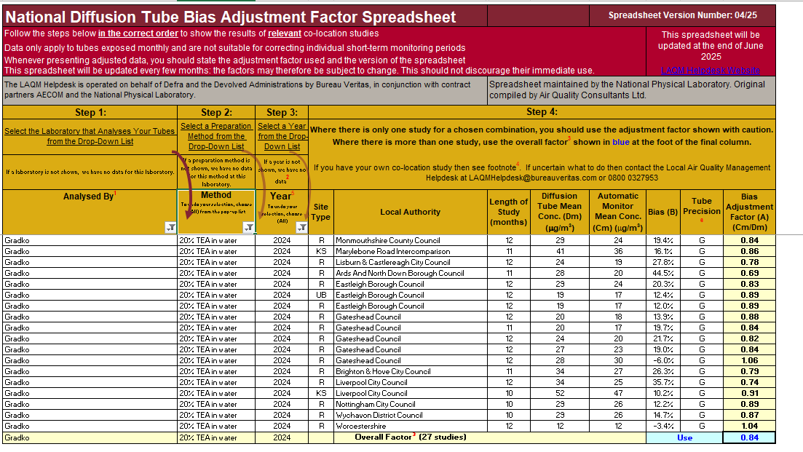
This image shows the National Diffusion Tube Bias Adjustment Factor Spreadsheet for Gradko 20 % TEA in water method for the reporting year 2024. It shows a national adjustment factor of 0.84.
Table C.2 – Bias Adjustment Factor
Monitoring Year | Local or National | If National, Version of National Spreadsheet | Adjustment Factor
2024 | Local | 03/25 | 0.85
2023 | National | 03/24 | 0.81
2022 | National | 03/23 | 0.83
2021 | National | 04/22 | 0.84
2020 | Local | - | 0.84

Table C.3 – Local Bias Adjustment Calculation
 | Local Bias Adjustment Input 1 | Local Bias Adjustment Input 2 | Local Bias Adjustment Input 3 | Local Bias Adjustment Input 4 | Local Bias Adjustment Input 5
Periods used to calculate bias | 9 | - | - | - | -
Bias Factor A | 0.85 (0.68 - 1.14)
Bias Factor B | 18% (-12% - 48%)
Diffusion Tube Mean (µg/m³) | 7.218
Mean CV (Precision) | 3.0%
Automatic Mean (µg/m³) | 6.1
Data Capture | 98 %
Adjusted Tube Mean (µg/m³) | 6 (5 – 8)
Notes:
A single local bias adjustment factor has been used to bias adjust the 2024 diffusion tube results.

NO₂ Fall-off with Distance from the Road
No non-automatic NO₂ monitoring locations within East Devon required distance correction during 2024.

QA/QC of Automatic Monitoring
The Automatic Monitoring site is located at Dove Close, Honiton. It is on a small recreation ground in a residential area in the south west of the town. The Environment Type is Urban Background and the monitoring is part of the Automatic Urban Monitoring Network (AURN).
The UK Air ID is: UKA00566 and the EU Site ID is: GB1017A. The Operator of the site is Bureau Veritas. The site is calibrated once a month and servicing of the equipment is carried out twice a year.

PM₁₀ and PM_{2.5} Monitoring Adjustment

Automatic Monitoring Annualisation
Annualisation was required for the automatic NO₂ data due to data capture being between 20 % and 75 %.
The continuous monitoring background data was therefore taken from AURN sites at Charlton Mackrell (rural background data) in South Somerset and Yarner Wood in Teignbridge (rural background data). Both Charlton Mackrell and Yarner Wood sites are located within 50 miles and have at least 85 % data capture for the year 2024.
Annualization was not required for automatic PM10 or PM2.5 data because data capture was above 75 %.
Table C.5 – Automatic NO₂ Annualisation Summary (concentrations presented in µg/m³
Background Site | Annual Data Capture | Annual Mean (A_{m}) | UKA00566
Background Site | Annual Data Capture | Annual Mean (A_{m}) | Period Mean (Pₘ) | Ratio (Aₘ/Pₘ)
Charlton Mackrell | 100.0 | 3.7 | 3.7 | 1.000
Yarner Wood | 100.0 | 2.4 | 2.4 | 1.000
Average (R_{a}) |  |  | 1.000
Raw Data Annual Mean (M) |  |  | 6.8
Annualised Annual Mean (M x R_{a}) |  |  | 6.8

NO₂ Fall-off with Distance from the Road
No automatic NO₂ monitoring locations within East Devon required distance correction during 2024.

Appendix D: Map(s) of Monitoring Locations and AQMAs
Figure D.1 – 2024 NO₂ Monitoring Locations - Exmouth, Exton and Lympstone
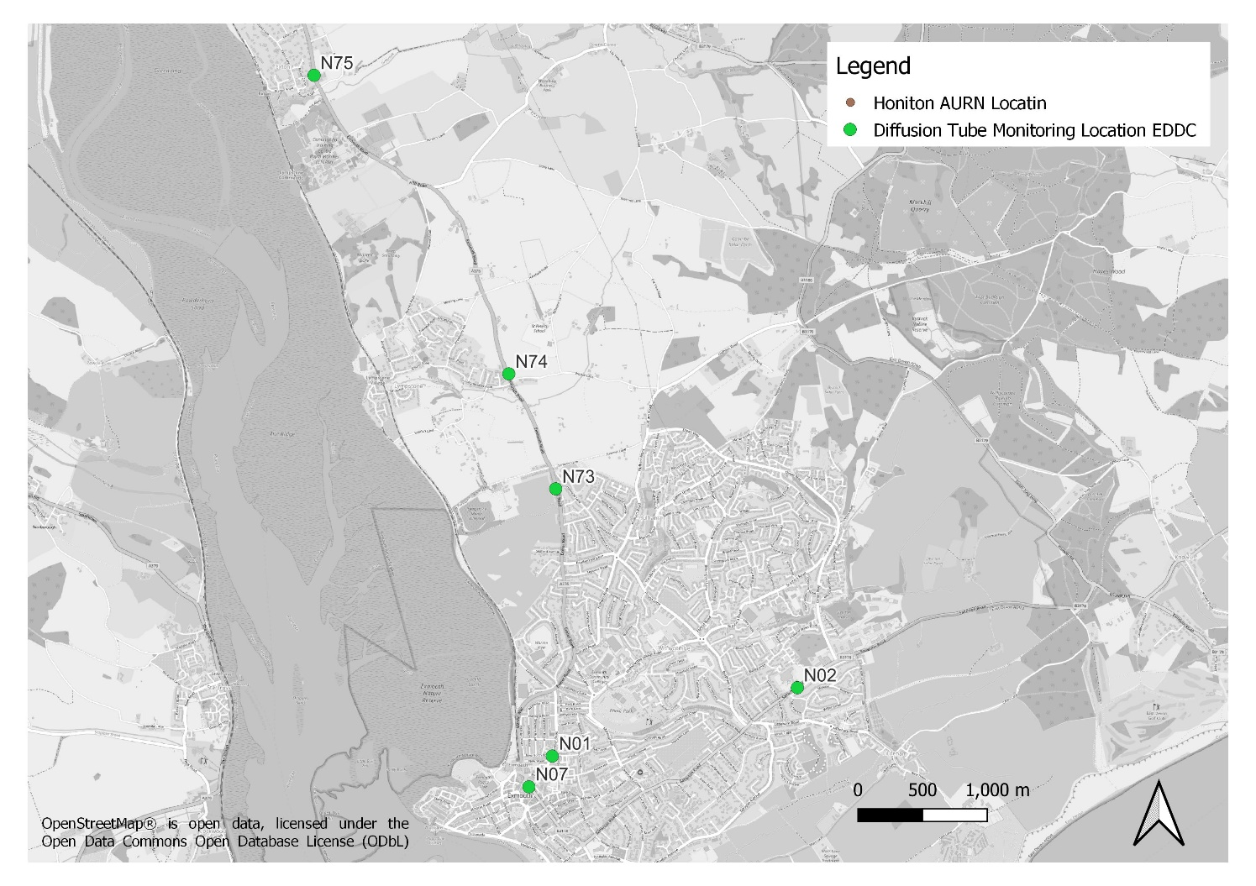
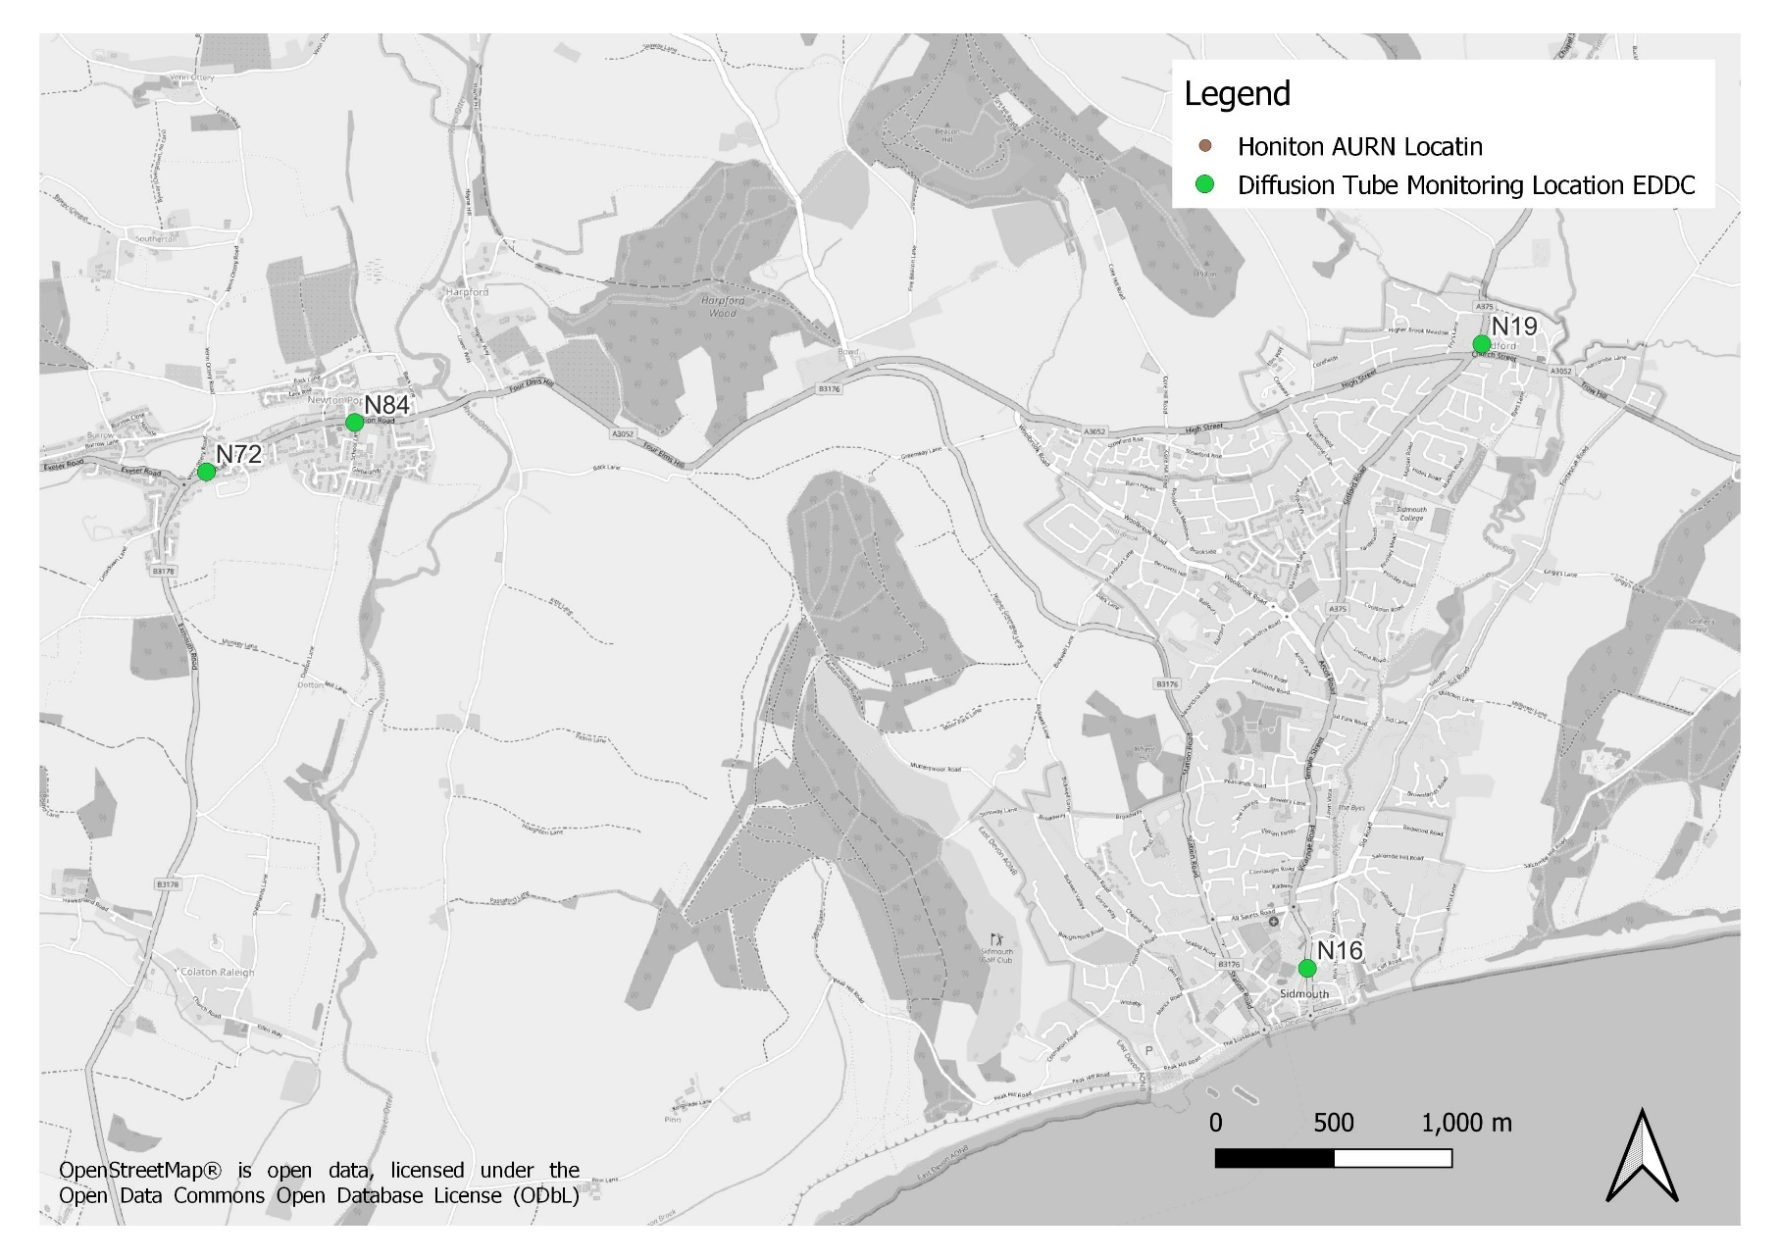
Figure D.2 – 2024 NO₂ Monitoring Locations - Newton Pop, Sidford. Sidmouth
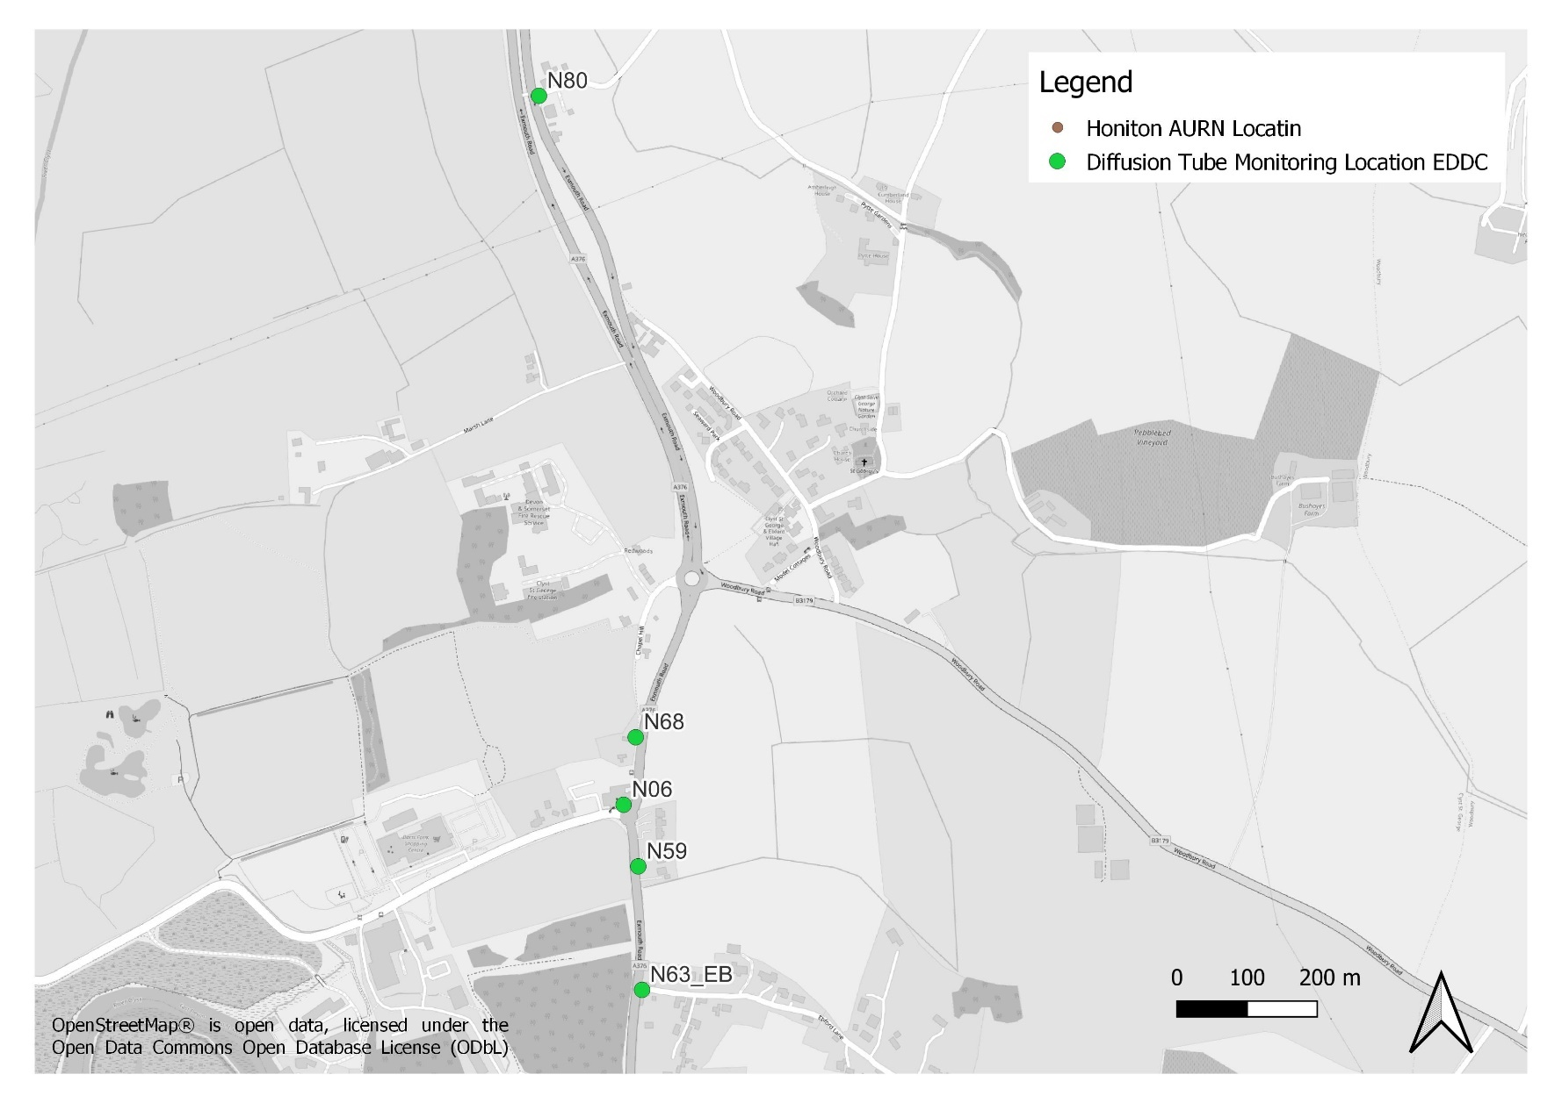
Figure D.3 – 2024 NO₂ Monitoring Locations - Clyst St George

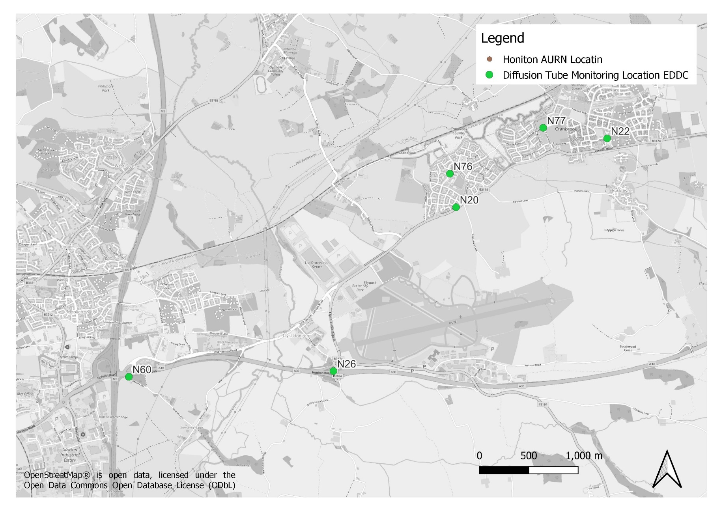
Figure D.4 – 2024 NO₂ Monitoring Locations - East of Exeter, Beare, Broadclyst
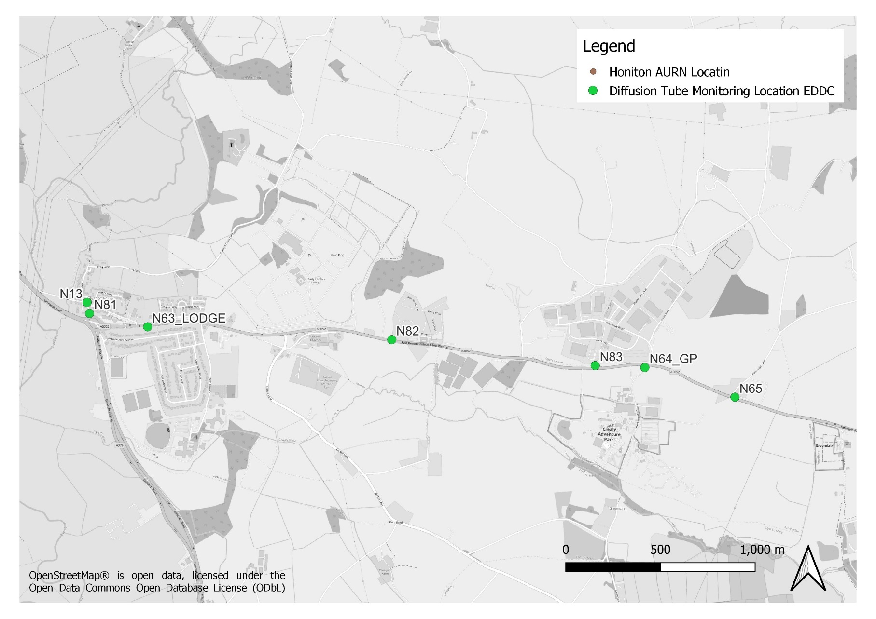
Figure D.5 – 2024 NO₂ Monitoring Locations - Clyst St Mary, Farringdon
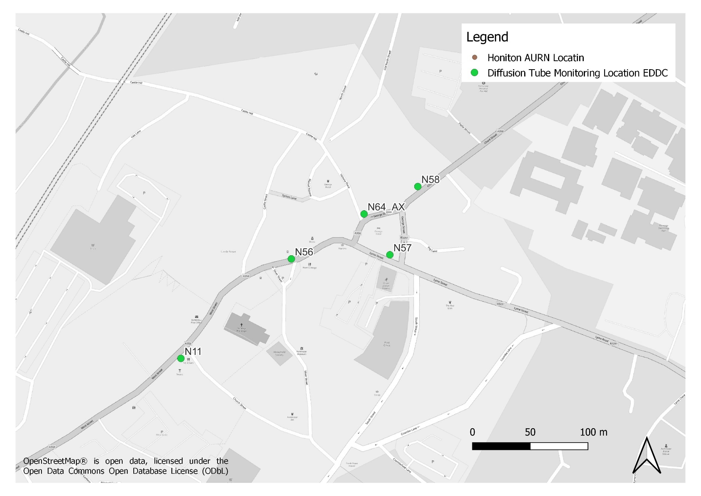
Figure D.6 – 2024 NO₂ Monitoring Locations – Axminster

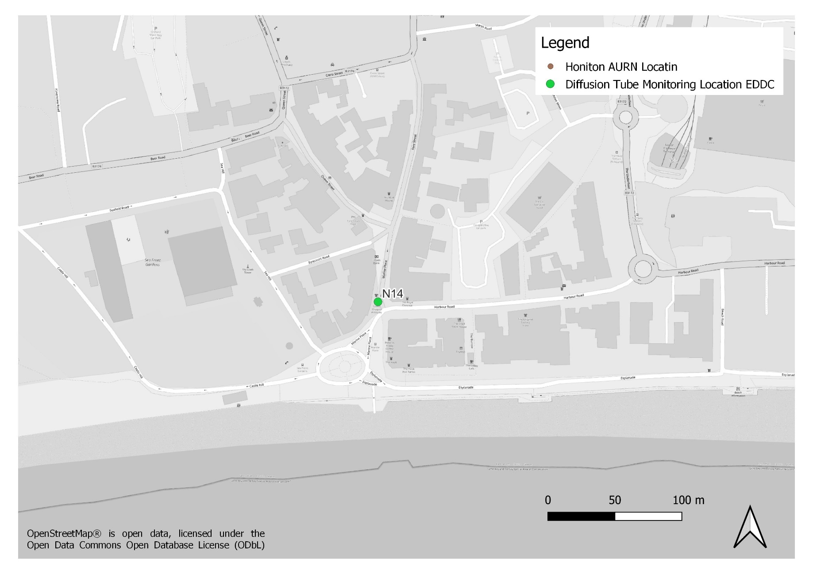
Figure D.7 – 2024 NO₂ Monitoring Locations – Seaton
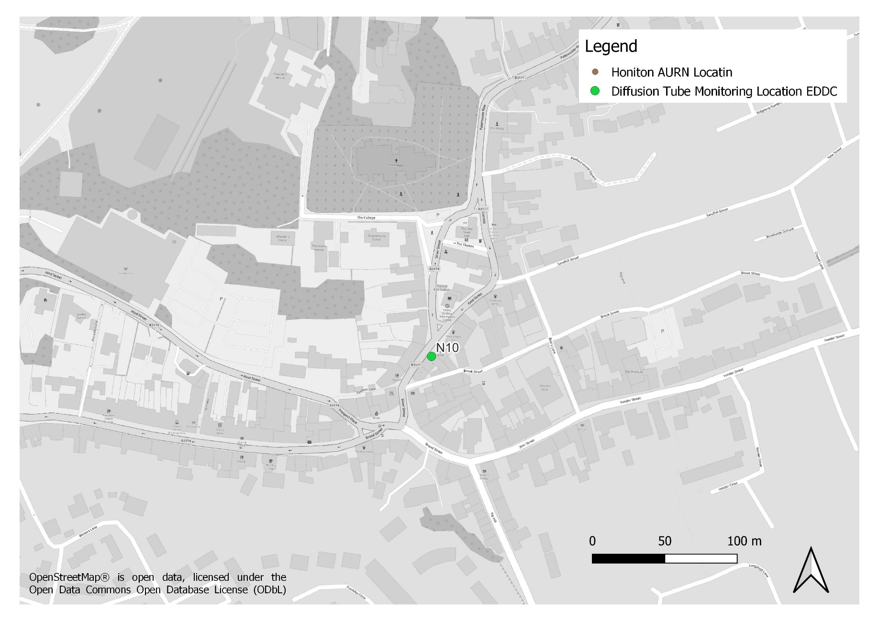
Figure D.8 – 2024 NO₂ Monitoring Locations – Ottery
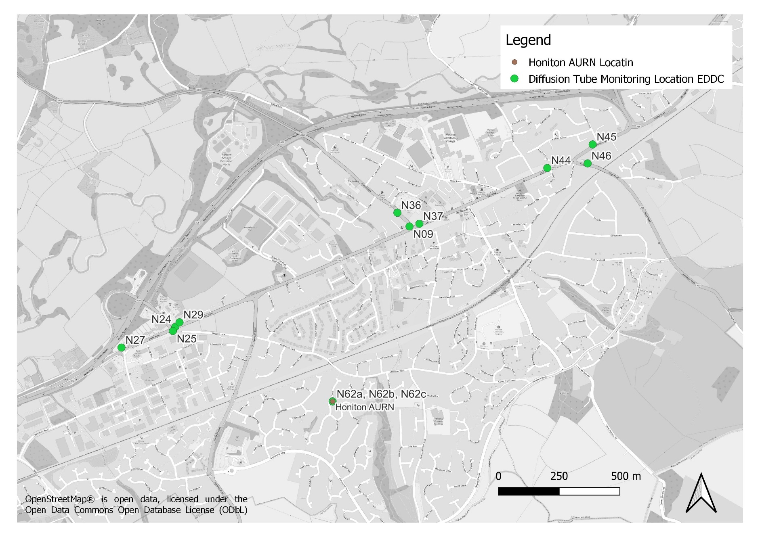
Figure D.9 – 2024 NO₂ Monitoring Locations – Honiton

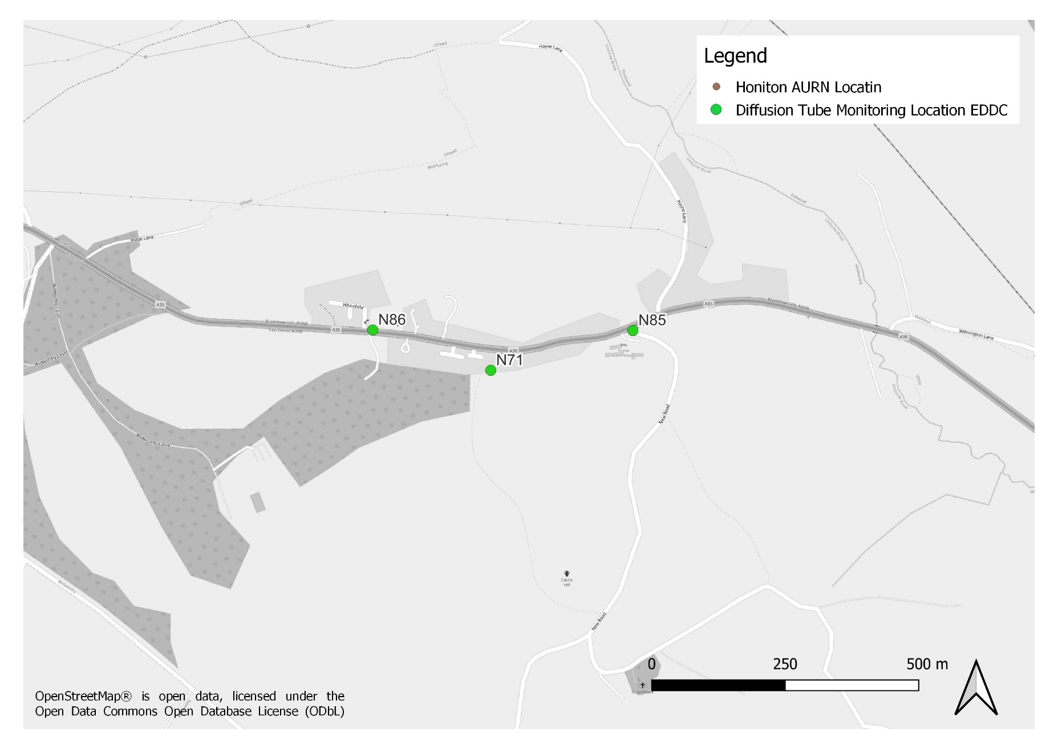
Figure D.10 – 2024 Monitoring Locations - Wilmington
Figure D.11 – 2024 Monitoring Location - Beer
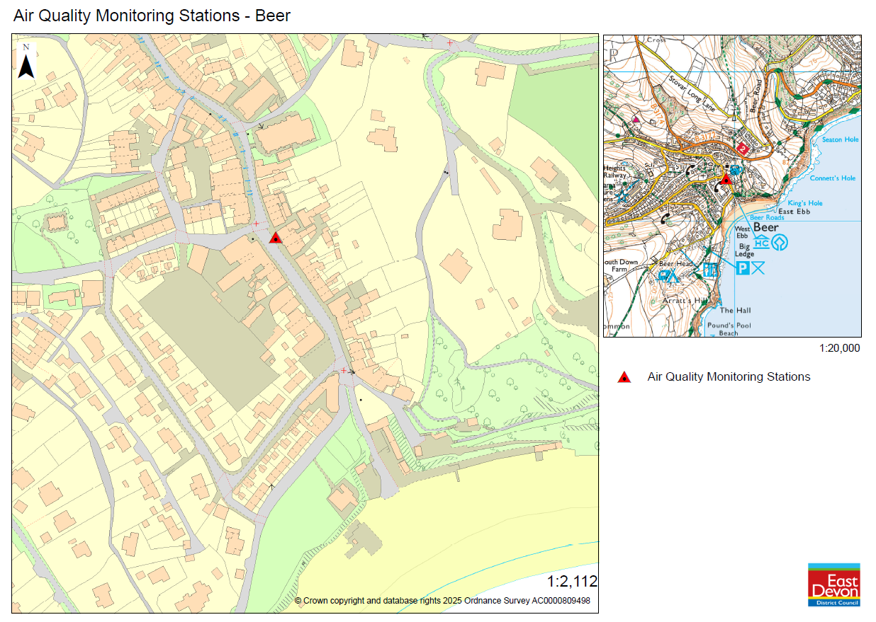

Figure D.12 – 2024 Monitoring Location - Dunkeswell
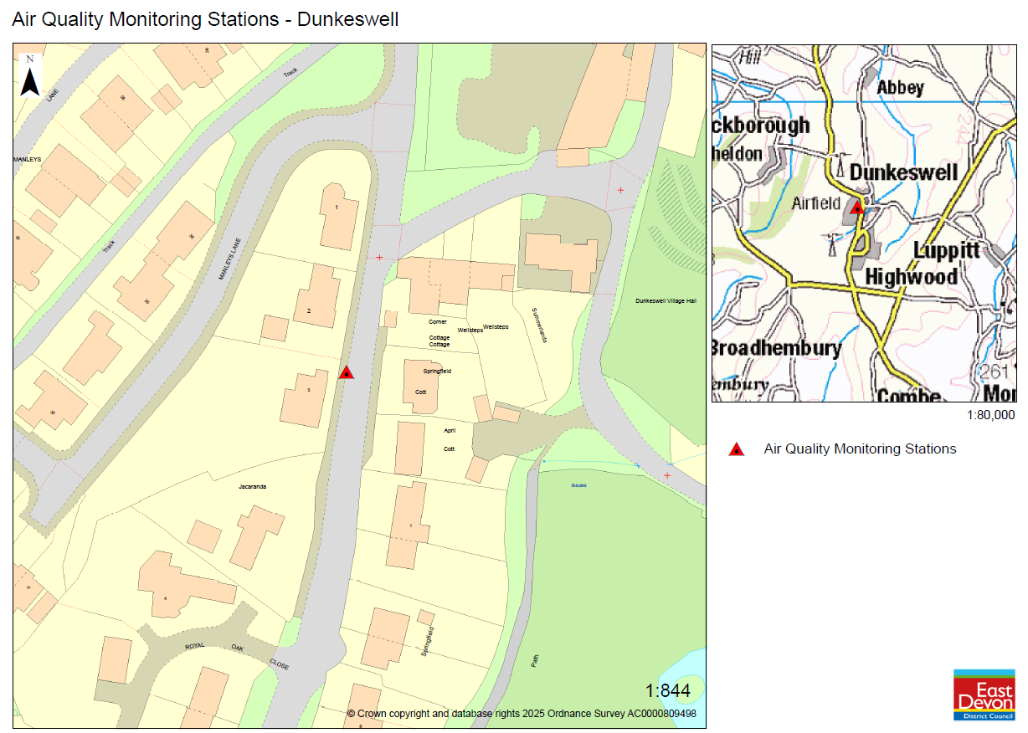

Appendix E: Summary of Air Quality Objectives in England
Table E.1 – Air Quality Objectives in England
Pollutant | Air Quality Objective: Concentration | Air Quality Objective: Measured as
Nitrogen Dioxide (NO₂) | 200µg/m³ not to be exceeded more than 18 times a year | 1-hour mean
Nitrogen Dioxide (NO₂) | 40µg/m³ | Annual mean
Particulate Matter (PM₁₀) | 50µg/m³, not to be exceeded more than 35 times a year | 24-hour mean
Particulate Matter (PM₁₀) | 40µg/m³ | Annual mean
Sulphur Dioxide (SO₂) | 350µg/m³, not to be exceeded more than 24 times a year | 1-hour mean
Sulphur Dioxide (SO₂) | 125µg/m³, not to be exceeded more than 3 times a year | 24-hour mean
Sulphur Dioxide (SO₂) | 266µg/m³, not to be exceeded more than 35 times a year | 15-minute mean

Glossary of Terms
Abbreviation | Description
AQAP | Air Quality Action Plan - A detailed description of measures, outcomes, achievement dates and implementation methods, showing how the local authority intends to achieve air quality limit values’
AQMA | Air Quality Management Area – An area where air pollutant concentrations exceed / are likely to exceed the relevant air quality objectives. AQMAs are declared for specific pollutants and objectives
ASR | Annual Status Report
Defra | Department for Environment, Food and Rural Affairs
DMRB | Design Manual for Roads and Bridges – Air quality screening tool produced by National Highways
LAQM | Local Air Quality Management
NO₂ | Nitrogen Dioxide
NO_{x} | Nitrogen Oxides
PM₁₀ | Airborne particulate matter with an aerodynamic diameter of 10µm or less
PM_{2.5} | Airborne particulate matter with an aerodynamic diameter of 2.5µm or less
QA/QC | Quality Assurance and Quality Control
SO₂ | Sulphur Dioxide

References
- Local Air Quality Management Technical Guidance LAQM.TG22. August 2022. Published by Defra in partnership with the Scottish Government, Welsh Assembly Government and Department of the Environment Northern Ireland.
- Local Air Quality Management Policy Guidance LAQM.PG22. August 2022. Published by Defra in partnership with the Scottish Government, Welsh Assembly Government and Department of the Environment Northern Ireland.
- Chemical hazards and poisons report: Issue 28. June 2022. Published by UK Health Security Agency
- Air Quality Strategy – Framework for Local Authority Delivery. August 2023. Published by Defra.

Defra. Air Quality Strategy – Framework for Local Authority Delivery, August 2023
The units are in microgrammes of pollutant per cubic metre of air (µg/m³).

